H807SA在接入控台时的参数设置
H807SA into control parameter settings
- 设置像素点通道数(PixelChannel), 设置一个点的颜色分量数，默认为3，即RGB。范围是1-4
Set Pixel channel, set one color will be default to 3,it’s RGB.Range of 1-4
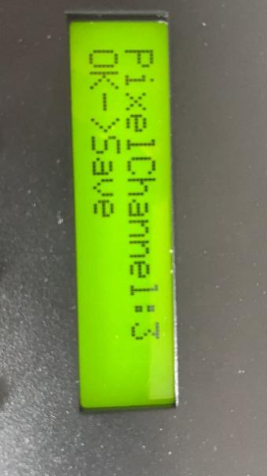

- H807SA在接入灯控、控台等设备时只需在控制器上修改DMX地址码即可
When H807SA into the light control, Control Console need revise the DMX address only.
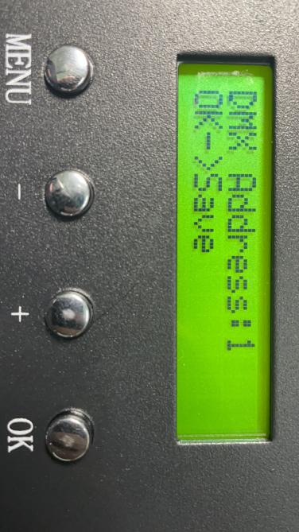
根据灯控、控台给的地址码设置好后按OK键确认
According light control,control console address set be done and press OK key complete.
DMX起始通道地址(DMX Address)，范围是1-512，颜色分量数为4时每台控制器占用8个通道，否则每台控制器占用7个通道。
DMX Start Channel Address (DMX Address) , range 1-512, color component number of 4 when each controller occupies 8 channels, otherwise each controller occupies 7 channels
起始地址默认为1，即占用通道1-7，若起始通道地址为2则占用通道2-8。
The default starting address is 1, which takes up channels 1-7, and 2-8 if the starting address is 2
第1通道是亮度，亮度通道值0-3对应0（不亮），4-7对应1，8-11对应2，…，252-255对应63。
Channel 1 is luminance, luminance channel value 0-3 corresponds to 0(not bright-RRB- , 4-7 corresponds to 1,8-11 corresponds to 2, ... , 252-255 corresponds to 63
第2通道是红色分量。
The seconds channel is Red
第3通道是绿色分量。
The third channel is Green
第4通道是蓝色分量。
The fourth channel is Blue.

颜色分量数小于4时，占用7个通道：When the number of color components is less than 4, it takes up 7 channels

第5通道是DAT文件序号，DMX512控制台通道数值对应文件的关系为，四个数值对应一个文件，即0-3对应第一个文件，4-7对应第二个文件，……，252-255对应第64个文件。Channel 5 is the DAT file number, DMX512 console channel numerical corresponding to the file relationship, four numerical corresponding to a file, that is, 0-3 corresponds to the first file, 4-7 corresponds to the second file, ... , 252-255 corresponds to file 64
第6通道是播放速度，对应速度的关系为，（按键设置的速度）乘以（速度通道值）再除以255，即控制台最大值255对应按键设置的速度。Channel6 is the playback speed, which is determined by multiplying (the speed set by the key) by (the speed channel value) and dividing by 255, which is the maximum console value of 255 for the speed set by the key.

第7通道是方向，0-127是正向，其它值为反向。Channel 7 is the direction, 0-127 is the forward, and the other values are the reverse

颜色分量数等于4时，占用8个通道：When the number of color components is less than 4, it takes up 8 channels

第5通道是白色分量。The fifth channel is white.

第6通道是DAT文件序号，DMX512控制台通道数值对应文件的关系为，四个数值对应一个文件，即0-3对应第一个文件，4-7对应第二个文件，……，252-255对应第64个文件。he sixth channel is DAT NO.,The DMX512 console channel values correspond to the file relationship, four values equivalent one document.0-3 for one document.4-7 for the second ,......,252-255 equivalent the 64 Document.
第7通道是播放速度，对应速度的关系为，（按键设置的速度）乘以（速度通道值）再除以255，即控制台最大值255对应按键设置的速度。
第8通道是方向，0-127是正向，其它值为反向。
Channel 7 is the playback speed, which is determined by multiplying (the speed set by the key) by (the speed channel value) and dividing by 255, which is the maximum console value of 255 for the speed set by the key. Channel 8 is the direction, 0-127 is the forward, and the other values are the reverse.

