和DVI主控配套使用时RGBW灯具在H807SA参数设置
With DVI master supporting the use of RGBW lamps in H807SA parameter settings
- 演播软件设置，先在系统设置里面设置为803tv输出，设置完成后再去设置造型里面将灯具类型设置成RGB然后发送到803tv
broadcast software settings, first set in the system settings to 803TV output, and then set the model to set the lamp type RGB and then sent to 803TV
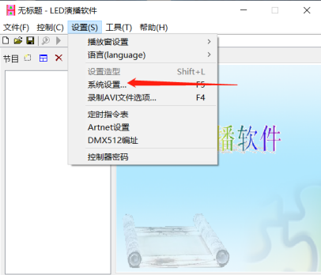
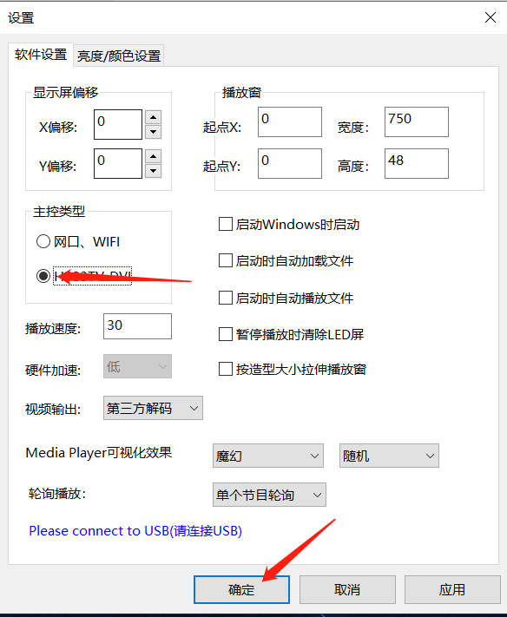
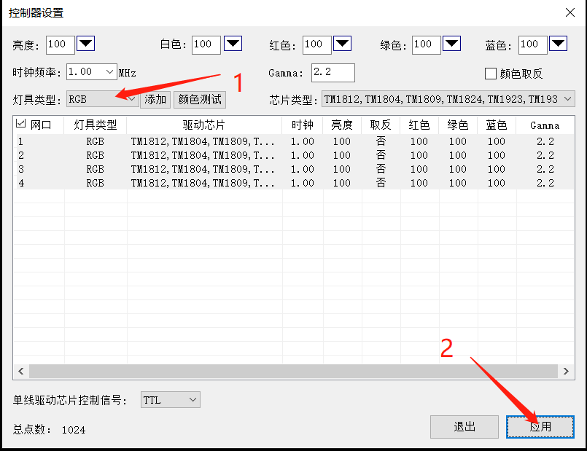。
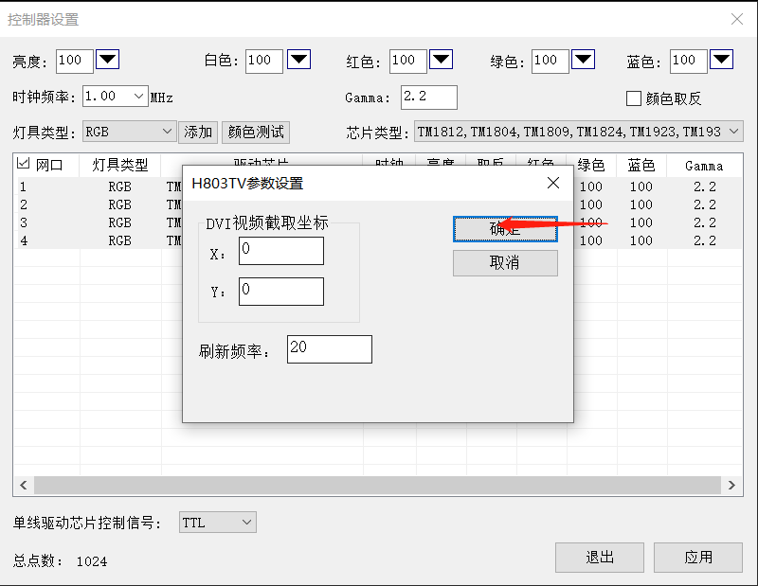
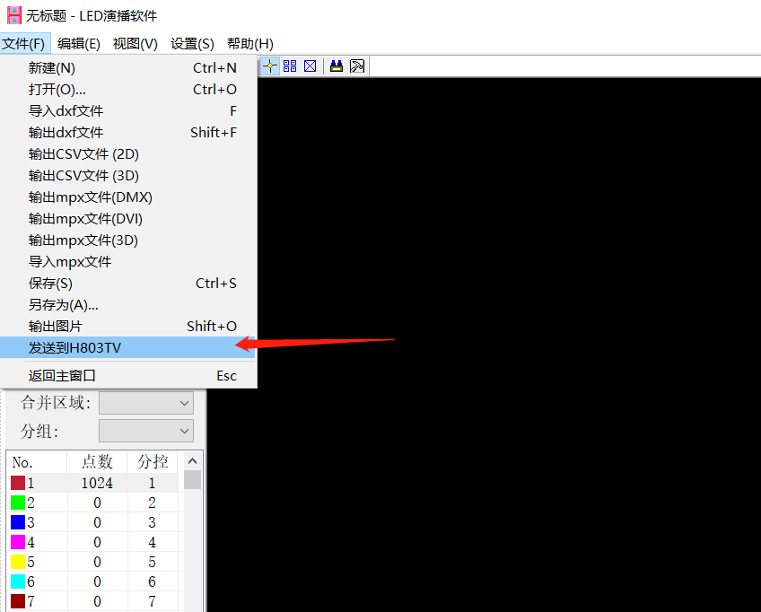
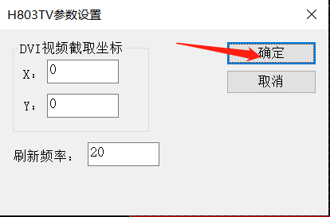

- 找到折叠菜单，按‘+’‘-’键选择菜单(Change menu)
Find to fold menu, press ‘+’‘-’key change menu
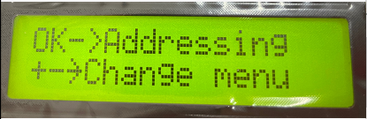
- 找到其他设置（Other set），按OK键进入其他设置子菜单，继续按MENU切换子菜单
Find to other set, press OK key into other set sub-menu and going on press MENU change menu.
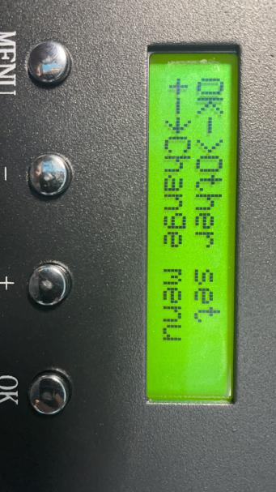
- 找到插入W(Insert W)，通过对RGB格式的插入W来控制RGBW的灯具,包括无(No)、W在前(Front)、W在后(Back)。
Find to insert W,To control RGBW lamps and lanterns by inserting W into RGB format, including No (No) , W in Front, W in Back.
不插入W：Do not insert W refer below picture
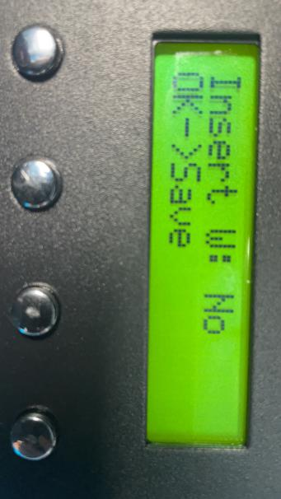
W插前：（WRGB）insert RGBW
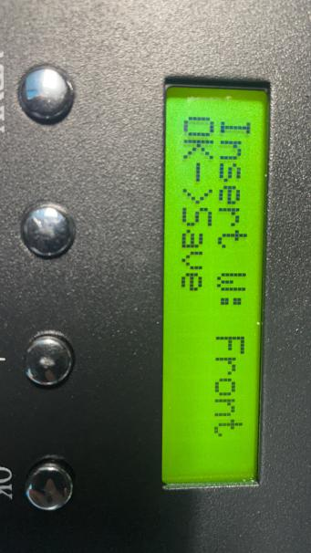
W插后：（RGBW）after insert RGBW
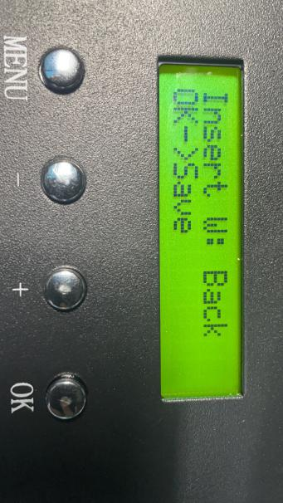
根据灯具情况选择对应的插入选项，按OK键确认。
According to the situation of lamps and lanterns to select the corresponding insert options, press OK to confirm

