H807SA同步使用说明
H807SA Instructions for use of synchronization
- 按MENU切换菜单，找到折叠菜单，按‘+’‘-’键选择菜单(Change menu)，按“OK”进入子菜单，进入子菜单后，继续按MENU切换子菜单。
Press MENU change menu and find the fold menu,press +’‘-’key change menu, press “OK” into the sub-menu when into the sub menu and going on press menu change to sub-menu.

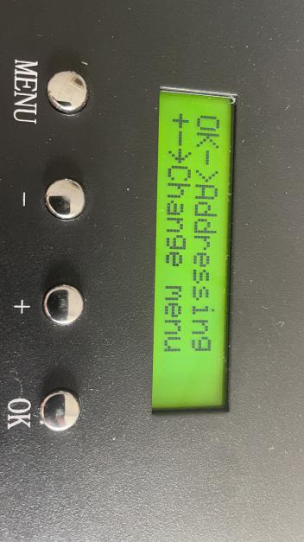
- 找到其他设置（Other set），按OK键进入其他设置子菜单，继续按MENU切换子菜单
Find the other set,press OK key into other set and set sub-menu and going on press menu change the sub-menu.
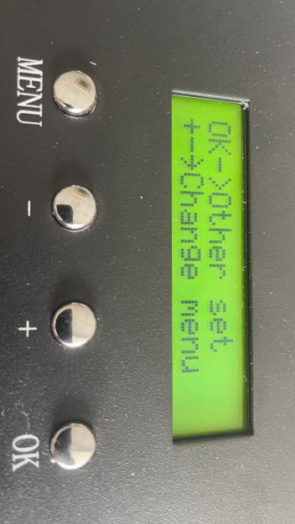

- 找到网口2工作模式，H807SA进行多台级联分控同步时，需要更改网口2的工作模式，一般选择(Net2 Input)。需要局域网同步时，必须将第一个控制器设置为(Net2 Send Sync)，后面的控制器设置为(Net2 Input)默认即可，设置好后按ok键确认。
Find the work mode of network Port 2, H807SA for multiple cascaded distributed control synchronization, need to change the work mode of network Port 2, the general choice (NET2 Input) . When Lan synchronization is required, the first controller must be set to (NET2 Send Sync) , the next controller to be set to (NET2 Input) by default, then press OK to confirm.
不同步时：Out of Synchronization,refer below picture
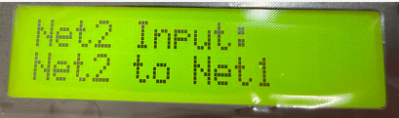
同步时：Synchronization,refer below picture

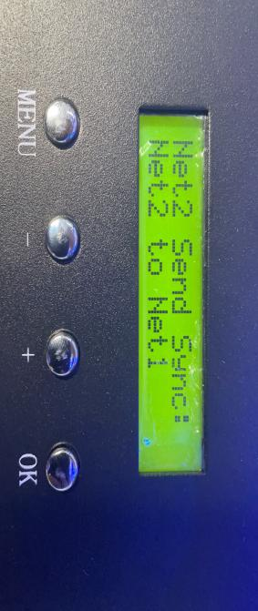

设置好后如图所示
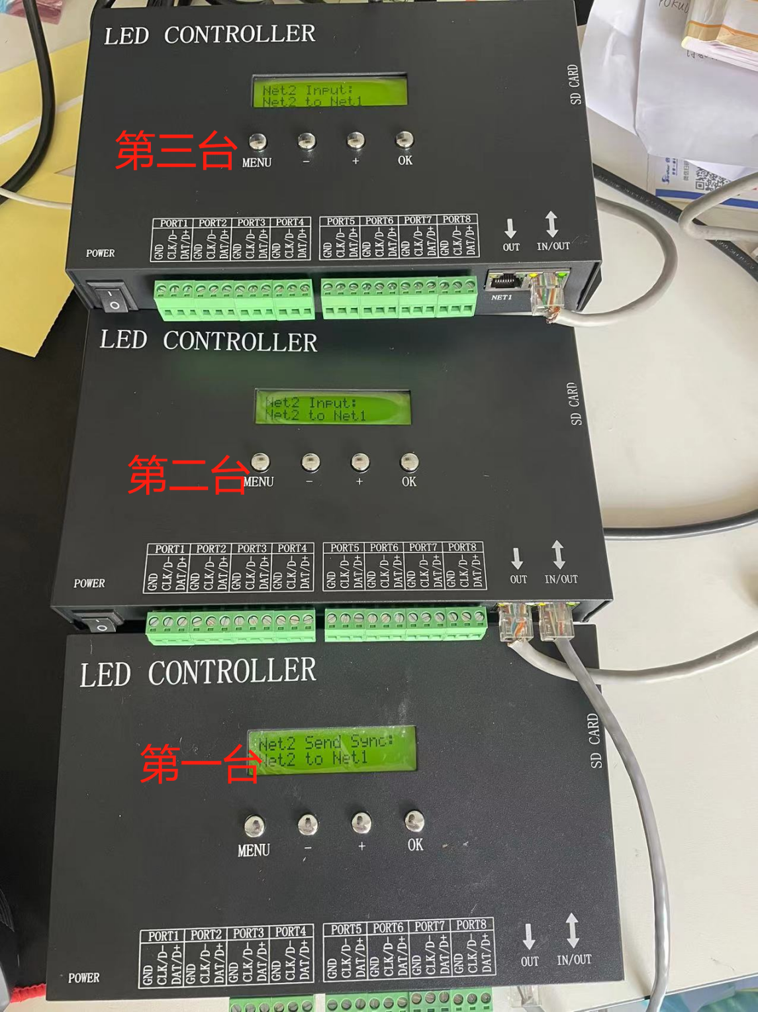

网线串联方式如下The network line in series is as follows
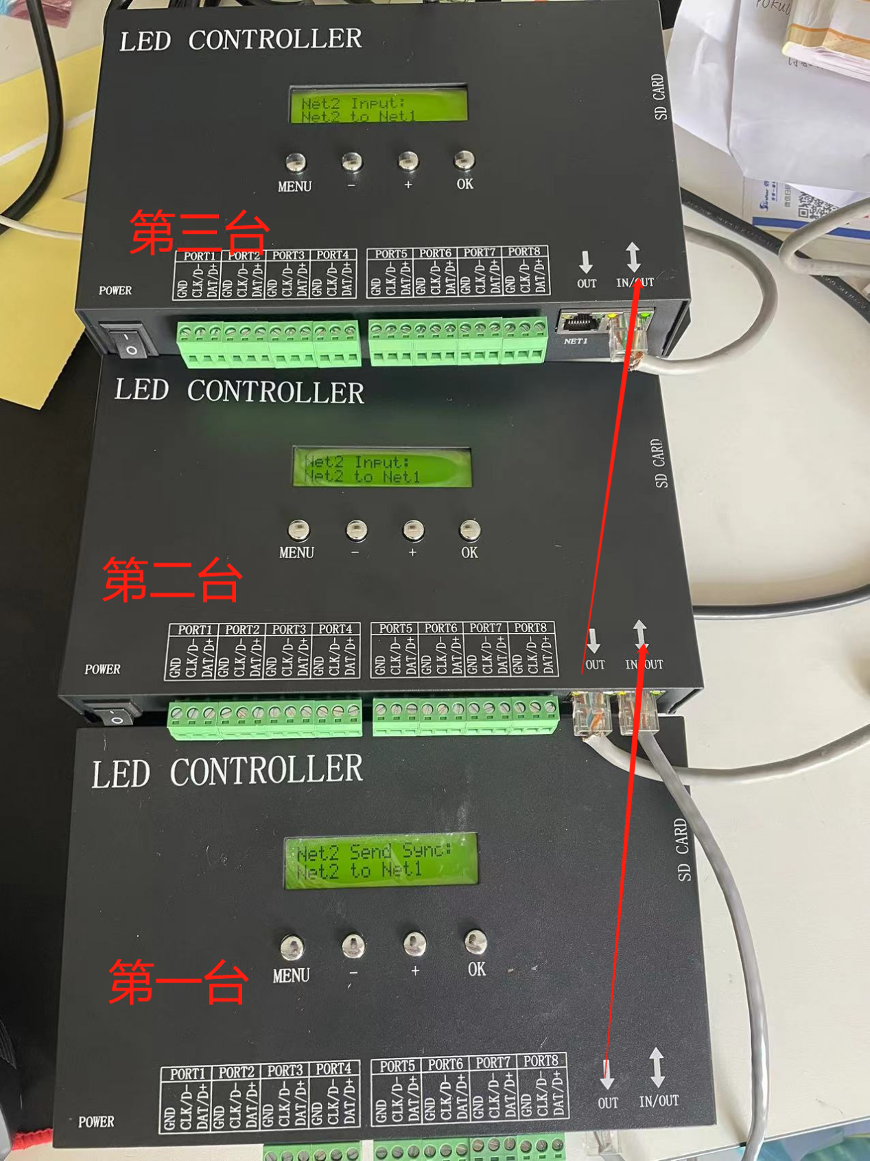
第一台OUT（NET 1）接第二台IN/OUt（NET 2）,第二台OUT（NET 1）接第三台IN/OUT(NET 2)，后面的控制器依此类推串联起来即可。
The first OUT (NET 1) is connected to the second IN/Out (NET 2) , the second OUT (NET 1) is connected to the third IN/Out (NET 2) , and so on

