H807SA说明书
H807SA Instructions
更新日期：2022-8-20

一、简介Introduction
H807SA是八口输出的可联可脱单机控制器，最多控制8192点。支持Art-Net协议，支持对DMX芯片编地址，能接DMX控制台，可通过局域网添加删除DAT文件。
目前可以控制的驱动芯片有DMX512、HDMX、DMX512_RDM、APA102、APA102-65536、WS2801、WS2811、WS2812、WS2813、TM1812、TM1809、TM1804、TM1923、TM1934、TM1925D、TM1926D、TM1803、TM1814、TM1913、TM1914、TM1926、UCSUCS1903、UCS1909、UCS1912、UCS2903、UCS2909、UCS2912、UCS8904、UCS5603、SK9816、SK6812、SM16716、SM16703、SM16709、SM16712、SM16704、LPD6803、LPD8806、LPD1882、LPD1889、LPD1883、INK1003、APA104、P943、LC8812、GW6205、QED3110、D9866E、D9866B、D9865C、D9865E、D9865F、D9864B、D9864C等。
配套软件为《LED编制软件》V4.47及以上版本。
H807SA is the output of eight can be connected off-single controller, the most control 8192 points. Support Art-Net protocol, support DMX chip address, can access DMX console, can add and delete DAT files through LAN.
Now control Driver chip for DMX512、HDMX、DMX512_RDM、APA102、APA102-65536、WS2801、WS2811、WS2812、WS2813、TM1812、TM1809、TM1804、TM1923、TM1934、TM1925D、TM1926D、TM1803、TM1814、TM1913、TM1914、TM1926、UCSUCS1903、UCS1909、UCS1912、UCS2903、UCS2909、UCS2912、UCS8904、UCS5603、SK9816、SK6812、SM16716、SM16703、SM16709、SM16712、SM16704、LPD6803、LPD8806、LPD1882、LPD1889、LPD1883、INK1003、APA104、P943、LC8812、GW6205、QED3110、D9866E、D9866B、D9865C、D9865E、D9865F、D9864B、D9864C and so on.
Supporting software for“LED programming software” V4.47 and above version

二、性能特点Performance characteristics
1、八个输出端口，最多控制8192像素点。每个端口最大控制1024点。
Eight output ports, maximum control 8192 pixels. Maximum control point of 1024 points per port
- SD卡支持FAT32、FAT16格式，最多允许64个DAT文件。
SD card support FAT32, FAT16 format, allows up to 64 DAT files
- 可以局域网同步控制，可通过向网口2发送UDP指令切换文件，或获取当前播放文件序号。
Can be controlled by LAN synchronization, can be transferred to Port 2 by sending UDP instructions to switch files, or to obtain the current play file number
- 能接DMX控制台，支持RGBW，可更换文件，调节速度和亮度，反应速度快。
Can Connect DMX console, support RGBW, replaceable files, adjust speed and brightness, fast response
- 支持Art-Net协议，可直接使用MADRIX、jinx等支持Artnet的软件。
Support Art-Net protocol, you can directly use MADRIX, Jinx and other software support Artnet
- 支持限制上电次数加密功能。
Support to limit the number of power encryption function

- 支持对DMX芯片编址，自带数点、内控测试功能。

Support for DMX chip address, with a number point, internal control test function

- 可联可脱，可以直接连接到电脑网卡、路由器，也可以连接到主控制器。
Connectable and detachable, can be directly connected to the computer network card, router, can also be connected to the main controller
- 支持在线升级固件。
Support for online firmware upgrades
- 设置Sculpt of DAT可支持不同造型的DAT文件。
Setting Sculpt of DAT can support DAT files of different shapes
- 可插入W。
Can be inserted W
- TM1812及同时序芯片可输出16个端口。
TM1812 and timing chip can output 16 ports
三、使用说明 Instructions for use

- SD卡在多次添加、删除文件后需要格式化成FAT32或FAT16格式。支持SDHC（高容量SD卡），最大达64G字节以上。SD卡中最多允许64个DAT文件，播放顺序是根据文件名按字母进行排序。
SD card in multiple add, delete files need to format into FAT32 or FAT16 format. Support for SDHC (high capacity SD card) , up to 64G bytes or more. Up to 64 DAT files are allowed on the SD card, which is played alphabetically by file name
- 八个输出端口，最多控制8192像素点。每个端口最大控制点数为 1024点。也可设置为一个、两个或四个输出端口，每个端口最多控制2048点，剩下的端口可作为使用端口的备份。实际每个端口最大输出1600点，共12800点。
Eight output ports, maximum control 8192 pixels. The maximum number of control points per port is 1024. It can also be set to one, two, or four output ports, each controlling up to 2048 points, and the remaining ports can be used as backup ports. The actual maximum output of each port is 1600 points, a total of 12800 points
- 上电时LCD第一行显示控制器型号，第二行显示版本号，按住“MENU”键再上电，控制器自动升级固件。

Power-on LCD the first line display controller model, the second line display version number, press the“MENU” key and power-on, the controller automatically upgrade firmware
- 按MENU键，切换菜单，按‘-’或‘+’键进行设置，长按‘-’或‘+’键加速参数设置，按OK键保存参数或进入子菜单。
Press the MENU key to switch the MENU, press the '-' or' + ' key to set, press the '-' or' + ' key to speed up the parameter setting, press OK key to save the parameter or enter the sub-menu
- 设置密码，在《LED编制软件》的灯光造型窗，单击菜单“设置”--“控制器密码”，弹出加密对话框，选中控制器加密，加密方法是限制上电次数。在第一次加密后，可以不解密而进行第二次加密，以延长使用次数。
Set password, in the“LED programming software” lighting modeling window, click the menu“Settings”-“Controller password”, pop-up encryption dialog box, select the controller encryption, encryption method is to limit the number of power. After the first encryption, a second encryption can be performed without decryption to extend the number of uses
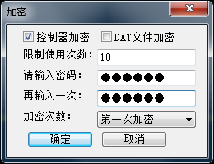

四、控制器按键操作Control button operation
1、上电后显示文件菜单(File01)，后面显示文件序号，第二行显示文件名。
After power-on display file menu (File01) , followed by the display of the file number, the second line shows the file name
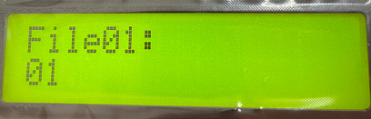
- 按MENU键，切换到速度菜单(Speed)，范围是1 – 100帧每秒。
Press MENU key, change the Speed, range of 1-100/seconds
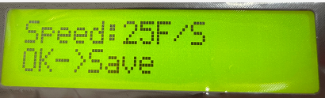
- 下一个菜单是亮度(Bright), 范围是0—16。
The next MUNE is Bright, range of 1-16.
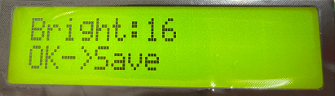
- 第四个菜单是播放模式(Play Mode)：所有文件循环(All)、单一文件播放(Single)、定时播放(Timed Playback)。接收到DMX控制台信号时自动锁定为单一文件播放。
The fourth MUNE is play mode: Move in all Documents、single, Timed Playback.when received the single from the control will be lock the mode for single.
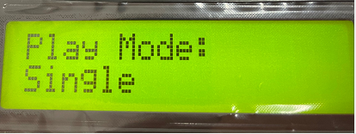

- 第五个菜单是设置IP地址(IP)，前三字节自适应。同一局域网内不能有相同的IP地址。

The fifth menu is set IP address (IP) , the first three bytes adaptive. You can not have the same IP address in the same LAN
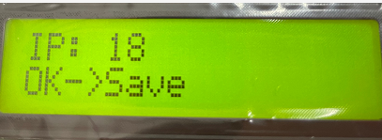

6、第六个菜单是网口2工作模式，一般选择(Net2 Input)。需要局域网同步时，必须将其中一个控制器设置为(Net2 Send Sync)，其它设置为(Net2 Input)。
多台控制器时，用网线走网口信号串联起来，设置为同步模式后只需将第一台控制器的DMX512信号与灯控、控台连接即可（详情见H807SA同步使用说明）
The sixth menu is the netport 2 work mode, the general choice (NET2 Input) . When Lan synchronization is required, one of the controllers must be set to (NET2 Send Sync) and the other to (NET2 Input)When there are many controllers, connect them in series with the network port signal of the network cable, and only connect the DMX512 signal of the first controller with the lamp control and console after setting it in the synchronous mode (see H807SA synchronous instruction for details)
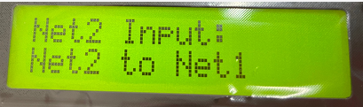

- 第七个菜单是选择端口输出的方式(PortOutMode)，245或485。
The seventh menu is Select how the port outputs(putout mode),245 or 485.
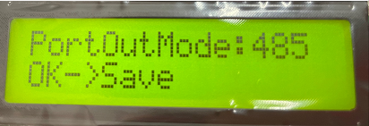
8、第八个菜单是DMX起始通道地址(DMX Address)，范围是1-512，颜色分量数为4时每台控制器占用8个通道，否则每台控制器占用7个通道。
起始地址默认为1，即占用通道1-7，若起始通道地址为2则占用通道2-8。

The eighth menu is the DMX start channel Address (DMX Address) , which ranges from 1 to 512. Each controller takes 8 channels when the color component number is 4, otherwise each controller takes 7 channels.The default starting address is 1, which takes up channels 1-7, and 2-8 if the starting address is 2

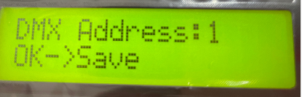
第1通道是亮度，亮度通道值0-3对应0（不亮），4-7对应1，8-11对应2，…，252-255对应63。
The fist channel is light,the light channel is 0-3 equivalent 0(It’s not working)4-7 equivalent 1,8-11 equivalent 2,...252-255 equivalent 63.
第2通道是红色分量。
The seconds channel is Red.
第3通道是绿色分量。
The third channel is Green.
第4通道是蓝色分量。
The fourth channel is Blue.
颜色分量数小于4时，占用7个通道：When the number of color components is less than 4, it takes up 7 channels
第5通道是DAT文件序号，DMX512控制台通道数值对应文件的关系为，四个数值对应一个文件，即0-3对应第一个文件，4-7对应第二个文件，……，252-255对应第64个文件。

第6通道是播放速度，对应速度的关系为，（按键设置的速度）乘以（速度通道值）再除以255，即控制台最大值255对应按键设置的速度。
第7通道是方向，0-127是正向，其它值为反向。
颜色分量数等于4时，占用8个通道：When the number of color components is less than 4, it takes up 8 channels

第5通道是白色分量。
The fifth channel is white.
第6通道是DAT文件序号，DMX512控制台通道数值对应文件的关系为，四个数值对应一个文件，即0-3对应第一个文件，4-7对应第二个文件，……，252-255对应第64个文件。
The sixth channel is DAT NO.,The DMX512 console channel values correspond to the file relationship, four values equivalent one document.0-3 for one document.4-7 for the second ,......,252-255 equivalent the 64 Document.4/2000
第7通道是播放速度，对应速度的关系为，（按键设置的速度）乘以（速度通道值）再除以255，即控制台最大值255对应按键设置的速度。
Channel 7 is the playback speed, which is determined by multiplying (the speed set by the key) by (the speed channel value) and dividing by 255, which is the maximum console value of 255 for the speed set by the key.
第8通道是方向，0-127是正向，其它值为反向。
Channel 8 is the direction, 0-127 is the forward, and the other values are the reverse
- 第九个是设置像素点通道数(PixelChannel), 设置一个点的颜色分量数，默认为3，即RGB。范围是1-4。
The ninth is to set the number of pixel channels and the number of color components of a point, which defaults to 3, or RGB. The range is 1-4.
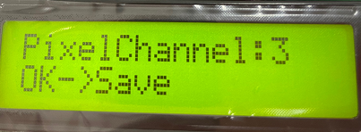
- 第十个菜单是折叠菜单，按‘▲’‘▼’键选择菜单(Change menu)，按“OK”进入子菜单，进入子菜单后，继续按MENU切换子菜单。
The tenth menu is the fold-down menu,press ‘▲’‘▼’key change menu,press “OK”into sub-menu and going on press menu change to the sub-menu.
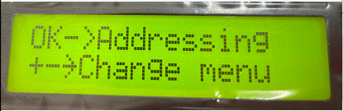
- 、编址菜单(Addressing)（详情见H807SA编址说明）(Reference the H807SA address notes for details)
Ⅰ.选择DMX芯片型号(DMX IC Type)。Choose DX IC Type.
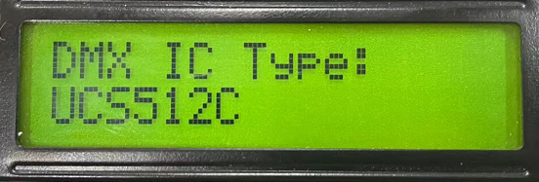
Ⅱ.灯通道数(LightChannel)，设置一个灯具或转码板占用的通道数。若是点光源，此值与颜色分量数一样。
Light Channel,set one light or board on channel.If the point light source,the value same as color point.
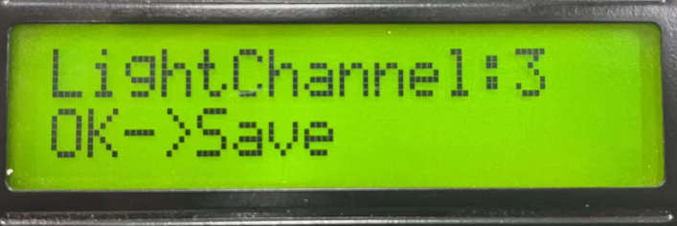
Ⅲ.有些DMX芯片需要设置上电时的颜色值，包括红绿蓝(PowerOn R、PowerOn G、PowerOn B)，有些芯片不需要设置。
The DMX chip needs to set the color value when the power is on,including Power on red\power on green\power on blue. Same chips no need set.
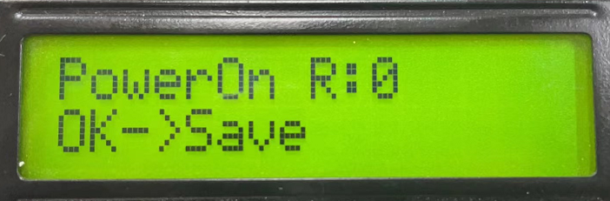
Ⅳ.有些DMX芯片需要设置电流(Current gain), 范围是1—64。
Same DMX chip need set current gain,range of 1-64
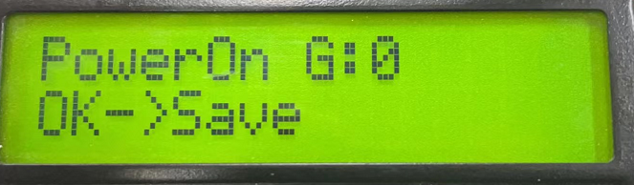
Ⅴ. 有些DMX芯片需要设置输出格式(Output:RZ或Output:DMX512)。
Same DMX chip need set output format (Output:RZ or Output:DMX512)
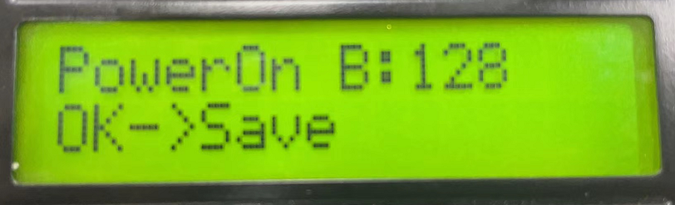
Ⅵ.起始通道(Address)，输入起始通道后按OK键，请耐心等待几秒钟可编码完成。
Start channel (Address) , enter the start channel and press OK, please wait a few seconds to encode.
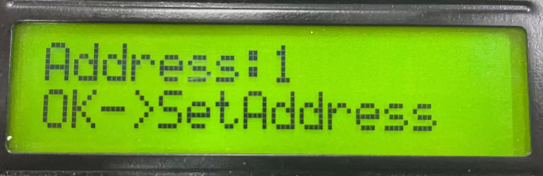
- 、数点内控
Point control
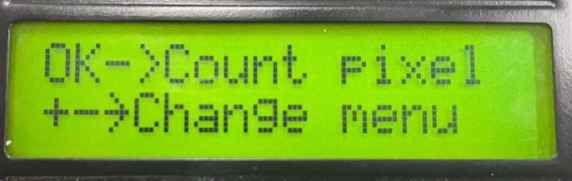
Ⅰ. 数点,长按加速。
Press long to accelerate for point
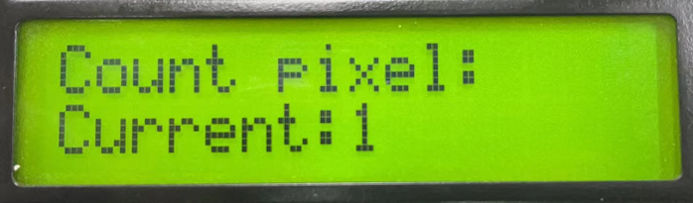
Ⅱ. 内控self control
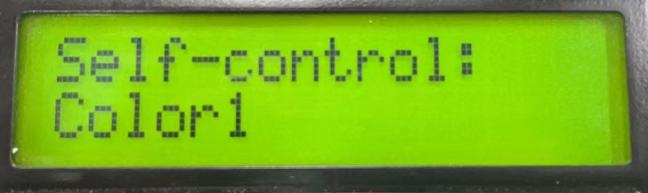
- 、Artnet设置菜单（详情见H807SA artnet使用说明）Artnet set menu Reference the H807SA artnet for details)

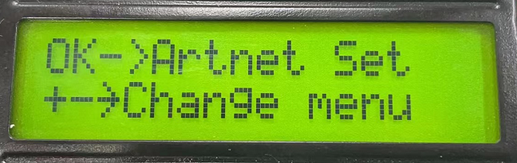
Ⅰ. 设置起始空间。Set the starting space
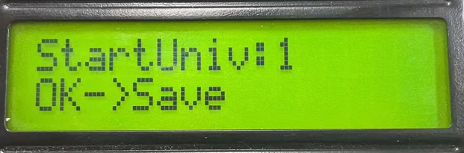
Ⅱ. 设置一个端口带载多少个通道。Sets how many channels a port carries
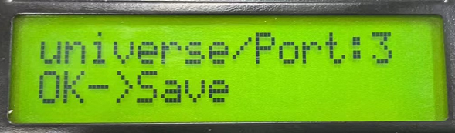
Ⅲ. 设置Artnet分控数，这一路一共串了多少个分控。Set Artnet sub-control number, this way a total number of sub-control series.
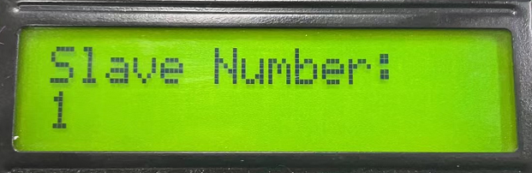
- 、定时时钟设置，需要焊接圆柱晶振和电池才有此功能，格式为年月日时分秒(201026 09:30:01),年份只输入后两位，必须按OK键才能保存。
Timing clock settings, the need to weld cylindrical crystal oscillator and battery to have this function, the format is time, time and seconds (20102609:30:01) , only the last two years input, you must press the OK key to save
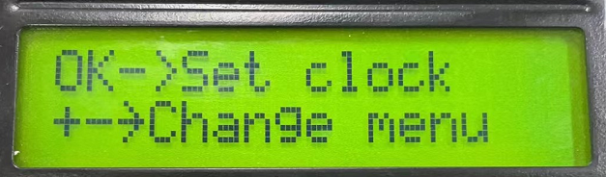
(5)、其它设置other set
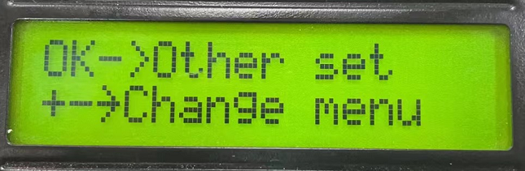
Ⅰ.分控编号(Slave No.)，用路由器或交换机组成多分支网络时需设置分控编号，编号为1时请选择自动。级联在后面的分控可设置为自动，出厂默认是自动。Slave number (Slave No.) , with routers or switches to form a multi-branch network need to set the Slave number, number 1, please choose automatic. Cascading in the following sub-control can be set to automatic, factory default is automatic.
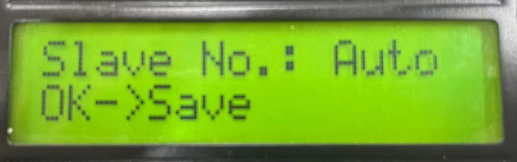
Ⅱ. 插入W(Insert W)，通过对RGB格式的插入W来控制RGBW的灯具,包括无(No)、W在前(Front)、W在后(Back)。Insert W, through the RGB format of the Insert W to control the RGBW lamps, including No (No) , W in Front, W in Back
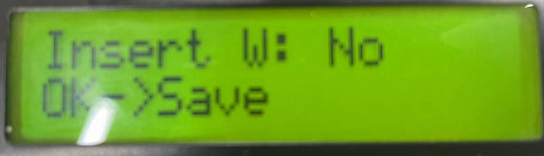

Ⅲ.芯片型号选择(IC Type)，若不指定芯片型号(Do not choose)，则以DAT文件指定的芯片型号来控制；若指定了芯片型号，则DAT文件中的芯片型号无效。在Artnet控制时，若不指定芯片型号(Do not choose)，则以第一个分控的芯片型号来控制，否则以自己设置的为准。IC Type, if Do not choose, is controlled by the IC Type specified in the DAT file; if the IC Type is specified, the IC Type in the DAT file is invalid. In Artnet control, Do not choose the chip model, the first sub-control of the chip model to control, or to their own settings.
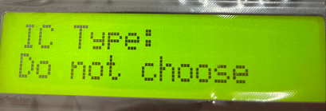

Ⅳ.测试发送帧率Test the sending frame rate
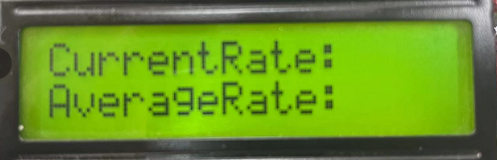。
Ⅴ.按+键恢复出厂设置(+->Reset)。Press + key for reset.
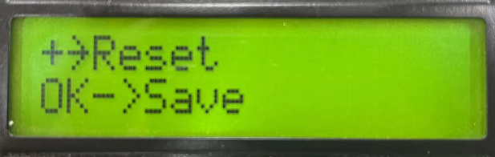

五、局域网同步Local area network
1、若干H807SA，通过路由器和交换机组成局域网，注意IP地址要设置在同一网段。（支持此功能的控制器，不同型号混用也可同步，只需要一个发送，但DAT文件数，及每个DAT文件的帧数必须一样）。
A number of H807SA, through routers and switches to form a local area network, note that the IP address to be set in the same network segment. (the controller that supports this feature, different models can be synchronized, only need one send, but the number of DAT files, and the number of frames per DAT file must be the same) .
- 其中一台H807SA设置为“Net2 Send Sync”，其它H807SA设置为“Net2 Input”，在脱机时可同步。
One H807SA is set to“NET2 Send Sync” and the other H807SA is set to“NET2 Input” to synchronize offline
- 将电脑接入到此局域网，能实现可联可脱控制。
Connecting the computer to this LAN can realize connectable and detachable control
- 懂UDP的编程人员可通过UDP协议来切换文件, H807SA的UDP端口为8216(0x2018)。

A programmer who understands UDP can switch files through the UDP protocol, and H807SA has a UDP port of 8216(0x2018)

发送： 0xA8,0x20,file三个字节内容，file为节目序号，从0开始。
Send: 0xA8,0X20, file three bytes of content, file is the program number, starting from 0.
回复： 0xA8,0x21,file

Reply:0xA8,0x21,file
见下图：红框1和2要选择HEX，红框3设置好H806SA的IP和端口，发送十六进制A8 20 00表示切换到节目1。
For below picture:Red Box 1 and 2 to select HEX, Red Box 3 set the IP and port H806SA, send HEX a 82000 means to switch to program 1
若要查询H806SA当前播放节目序号， 发送：0xA8, 0x30
To query the current play program number for H806SA, send: 0xA8,0X30
H806SA回复：0xA8,0x31,file，file为节目序号，从0开始，即0表示节目1、1表示节目2、…。
H806SA replies: 0xA8,0X31, file, file for the program number, starting from 0, that is, 0 for program 1,1 for program 2
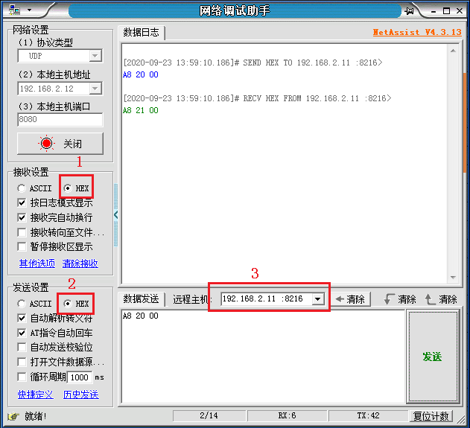

六、固件升级Firmware upgrade
将升级包放入SD卡内，按住“MENU”键不放再上电，控制器自动升级，升级完成后会自动重启，版本号也会改变。
Will upgrade package into the SD card, press the“MENU” key do not put power again, the controller automatic upgrade, upgrade will be completed automatically restart, version number will change.

七、控制器接口定义：Controller interface definition
GND  CLK1  DAT1 | GND  CLK2  DAT2 | GND  CLK3  DAT3 | GND  CLK4  DAT4 | GND  CLK5  DAT5 | GND  CLK6  DAT6 | GND  CLK7  DAT7 | GND  CLK8  DAT8
GND  D-1  D+1 | GND  D-2  D+2 | GND  D-3  D+3 | GND  D-4  D+4 | GND  D-5  D+5 | GND  D-6  D+6 | GND  D-7  D+7 | GND  D-8  D+8

八、规格参数Specification parameter
输入电压working voltage | AC220V
功耗Power | ？W
带载点数 | 8192点
重量weight | ？Kg
工作温度working temperature | -20C°--85C°
外形尺寸shape size | L？x W？x H？
纸箱尺寸Carton size | L？x W？ x H？

