T-790K operation manual
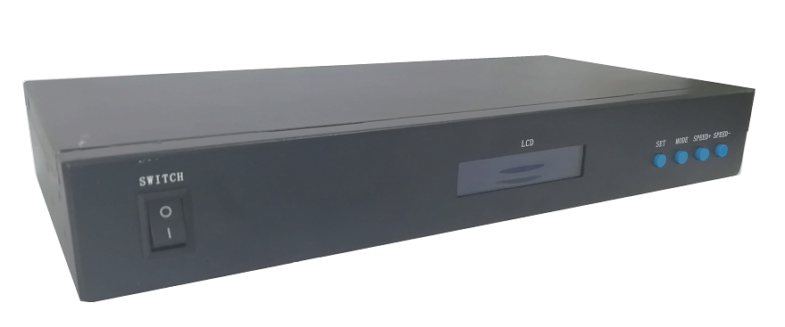
一、T-790K system features:
1、The controller has 8 output ports, each port can carry up to 170/512/768 pixels(Different pixels for different chips).
2、The controller port output two kinds of signal protocol: ①DMX512/1990 international standard protocol and DMX512 extended protocol; ②SPI/TTL serial protocol.
3、The controller output port provides three protections to ensure that the controller output port is not burn out in the case of short circuit or reverse connection in the controlled lamp.
4、Controller ID automatic/manual numbering function, which can be numbered together with multiple controllers, or individual controller numbers.
5、The controller comes with built-in effects to test on-load luminaires (all supported by RGB/RGBW luminaires).
6、The controller has DMX512 write function and address test. The single port or all ports carry the DMX512 IC write address and perform address test on the luminaire.
7. The communication between the controllers adopts the international standard TCP/IP network protocol. The optional transmission rate supports 100M/Gigabit adaptation, and the transmission speed is more stable and fast. The maximum transmission distance between each two controllers can reach 100 meters. More than this distance can increase the switch or use fiber for long-distance transmission.
8、The controller provides an LCD screen display that shows the model, ID, and operating status of the controller.
9、When connected with our online video software LedPlayer for computer control, the connection status of the controller is monitored in real time on the computer. Using the online video software LedPlayer for computer control can realize: program timing playback, program segment selection, effect brightness adjustment, white balance online adjustment, program playback speed adjustment, display text, picture loop playback, etc., which greatly satisfy the customer's application and Multiple needs in debugging.
10、The online video software LedPlayer comes with Gamma correction, which makes the color display more delicate and vivid.
11、When the controller is connected to the computer, the IP address is set. The controller supports online and offline integrated control. The online priority is the highest. When there is no online signal, it automatically switches to the offline effect.
Note 1: The DMX/1903 IC on the controller can be controlled by MADRIX software. The maximum normal 3 unit (3 Univ) lamps per port, that is 3*170 pixels; multi-controllers combined into the largest control system Compatible with 2048 units.
Note 2: The controller supports rack-mounting. If necessary, please contact the relevant business personnel before placing an order.

二、Support chips：（Software select T-790K）
Support chips | Max. support light | Reamrks
International standard DMX512（like: UCS512, SM512, TM512, GS512 etc） | 4096 pixels | Suggest to carry 2400 pixels
UCS19**，ucs29**，ucs89**，ucs1603，ucs5603(UCS full series TTL/SPI signal IC) | 6144 pixels | Suggest to carry 4096 pixels
SM16703,09,12,SM16716,16726(SM full series TTL/SPI signal IC) | 6144 pixels | ——
TM18** series, TM19** series | 6144 pixels | ——
WS28**(WS full series TTL/SPI signal IC) | 6144 pixels | ——
GS8205,8206,8208 | 6144 pixels | ——
P9813,9823,9883 | 6144 pixels | ——
APA102 | 6144 pixels | ——
SK6812 | 6144 pixels | ——
MY9231 | 6144 pixels | ——
GW6205 | 6144 pixels | ——
INK1003 | 6144 pixels | ——
LX1003,1103,1203 etc | 6144 pixels | ——
NOTE: More ICs are not listed one by one. For details, please refer to the on-board chip of the PCEdit software of the PC software, or consult our sales and technical staff.

三、Product picture
T-790K front view
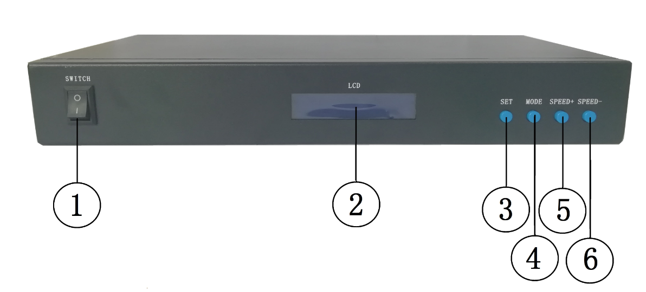
T-790K reverse view
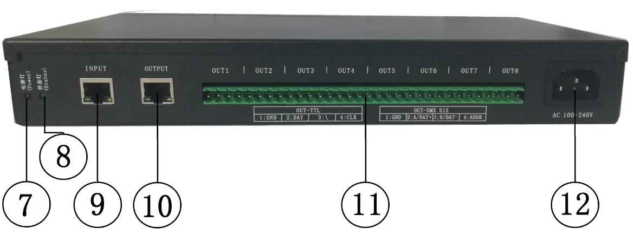

1.OFF/ON | 2. LCD display screen | 3. SET | 4. MODE
5. SPEED+ | 6. SPEED- | 7. Power indicator | 8. Status indicator
9. Cascade input network port INPUT | 10. Cascade output network port OUTPUT | 11. Output port OUT1-OUT8 | 12. AC100-240V power interface
四、Indicator and button definition
1. Indicator
Power | Power indicator (always light after power on)
Status | Status indicator(Always on during normal operation /Strobe when writing)
2. Cascaded signal input and output port
Cascaded signal |  | NOTE
INPUT | Cascaded signal input network port | The upper output is connected to the controller IN;  OUT is connected to the next level controller | INPUT: Strobe with signal input
OUTPUT | Cascaded signal output network port |  | OUTPUT Strobe with signal output
3. Signal output port
OUT1--OUT8 | Port definition  Signal type | 1 | 2 | 3 | 4
OUT1--OUT8 | Signal output  （TTL/SPI Signal） | GND(Negative） | DAT data | ---- | CLK clock
OUT1--OUT8 | Signal output  （DMX512 signal） | GND(Negative） | A/DAT+  Signal positive | B/DAT-  Signal negative | ADDR address writing
4. Button function
 | SET | MODE | SPEED+ | SPEED-
Play/Regular mode | / | / | / | /
Numbering mode | Numbering start button | / | Number up | Number down
Parameter setting mode | Paramter setting/enter | Item selection | Parameter adjustment + | Parameter adjustment -
MADRIX control setting | Chip selection | Mode selection | Speed + | Speed -
Remarks | Normally boot into normal mode, the button has no effect | Press "SET" to boot and enter parameter setting/function setting | Press“+” to bootand enter MADRIX control setting | Press “—” to boot and enter numbering mode
5. Display definition:
Display |  | Definition
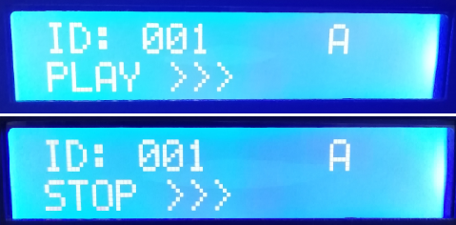 | Playback mode | ID: 001（ number is 1）  PLAY >>> online/ master control playback  STOP >>> Online/master control- pause
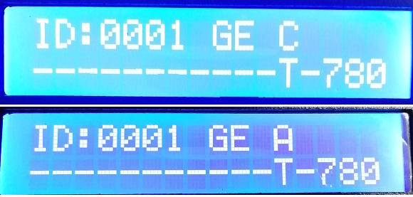 | Regular mode | ID: 001( number is 1)  A/C: Automatic/manual coding  T-800K controller model
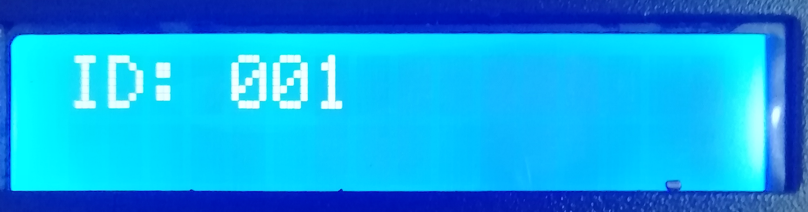 | Numbering mode | ID：*** Starting number
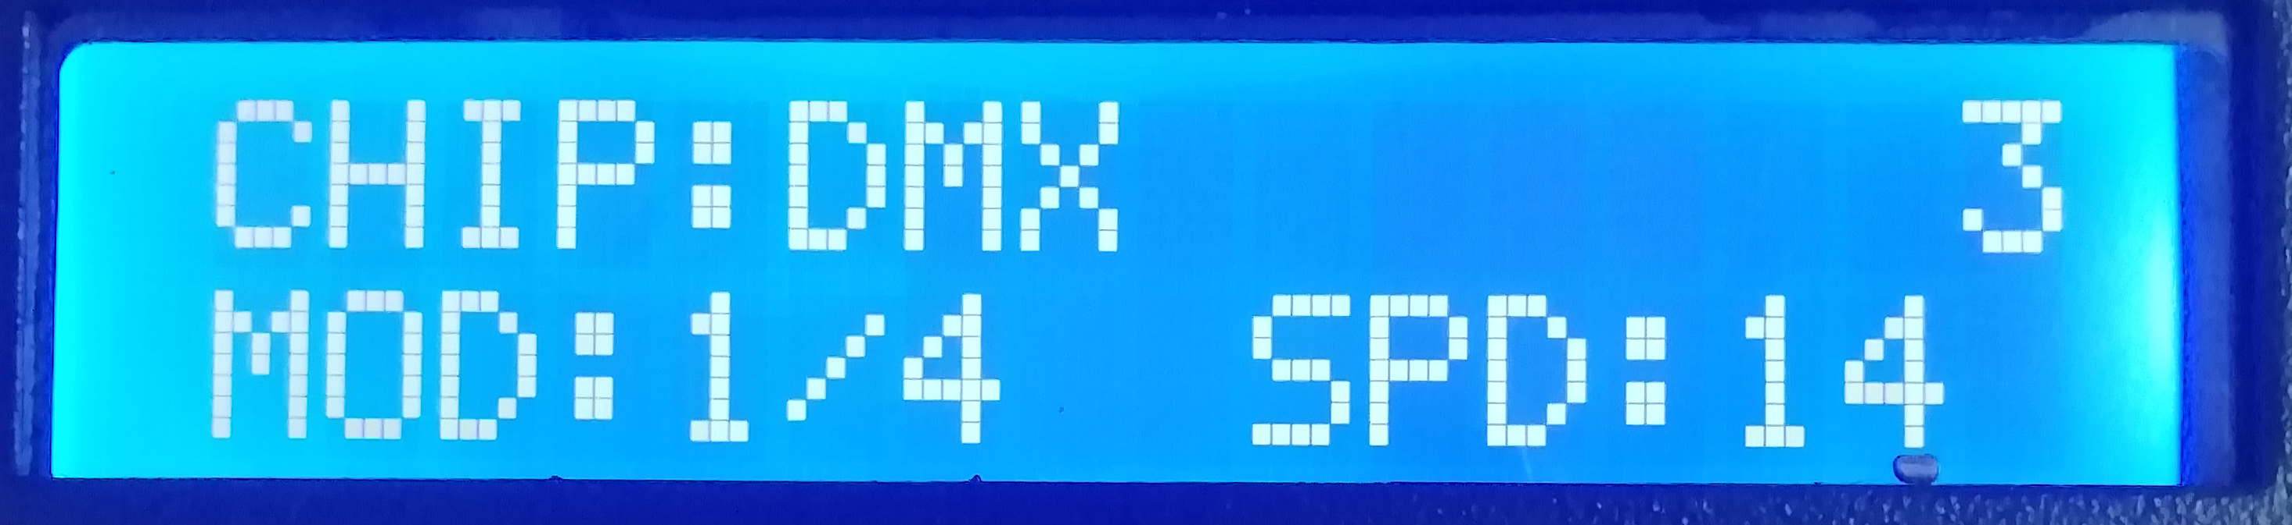 | Build-in playback effects | CHIP: chip 3： light channel  MOD: built-in effects SPD: Playback speed
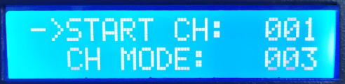 | DMX512IC  Address writing mode | The definition refer to 7.2 DMX512IC Addressing Mode and Test
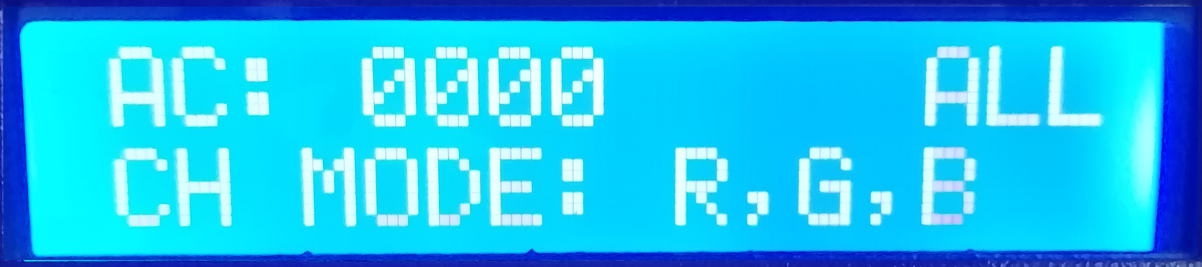 | Lamp address test mode | See 7.3 Lamp Address Test Mode for definition in this book.
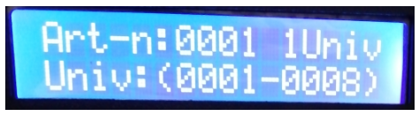 | MADRIX control | The definition refer to this book 8 MADRIX control mode.
五、Wiring diagram
1、Computer online wiring diagram
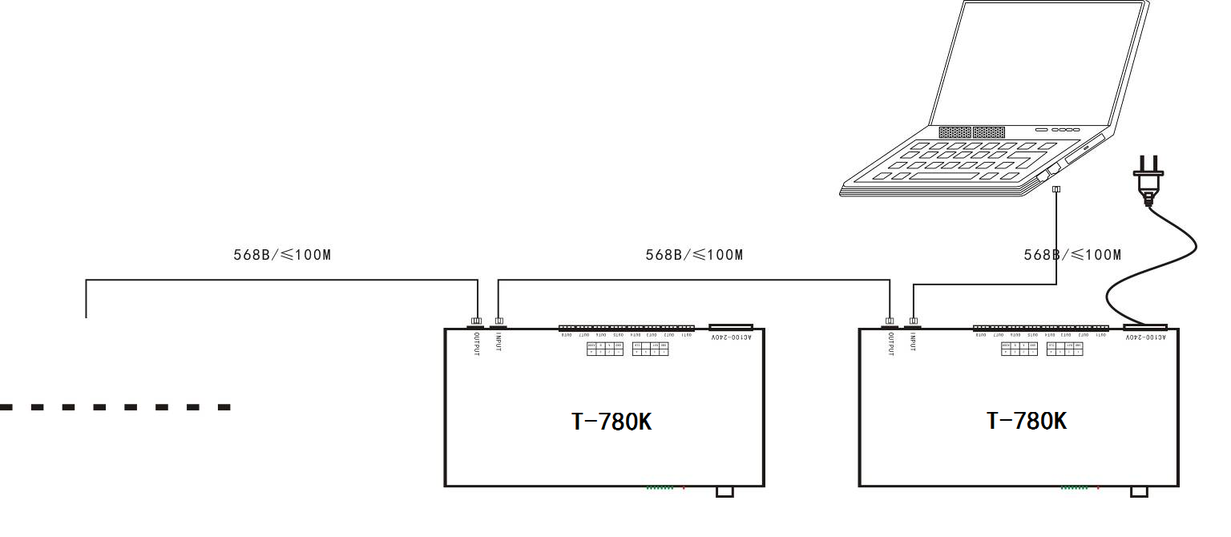
2. Offline master control wiring diagram
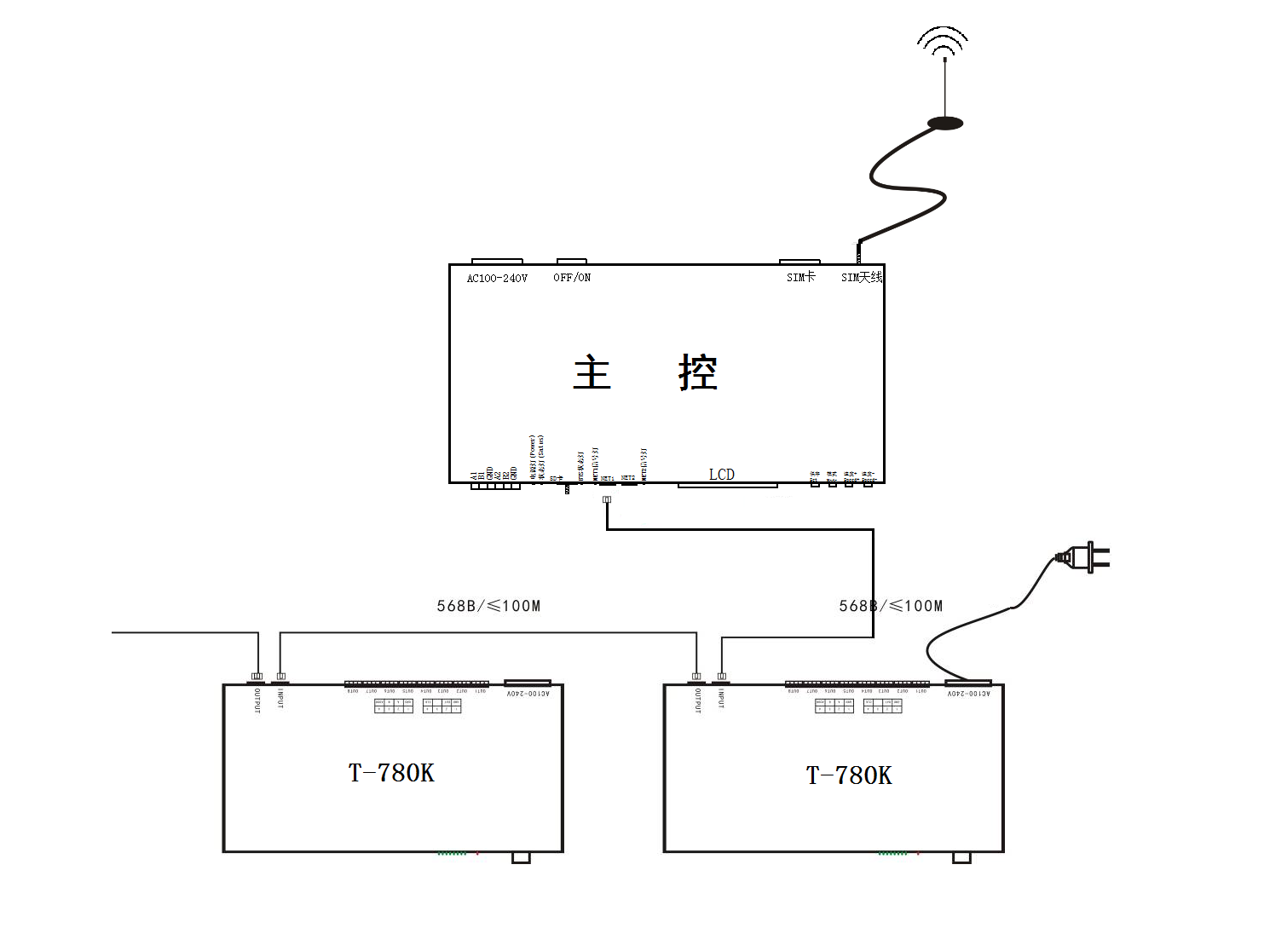

3. Online and offiline use wiring diagram
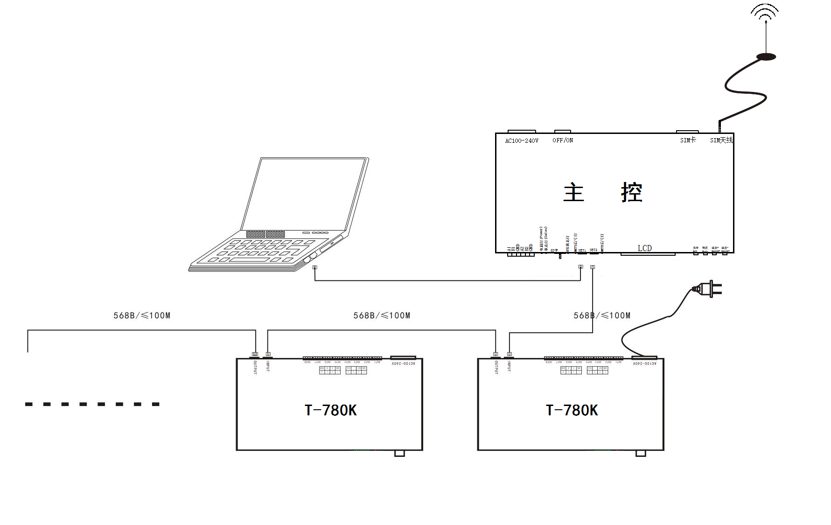
4. Controller signal output pirt wiring diagram
①. Regular laight wiring diagram ②.DMX512 differential signal wiring diagram
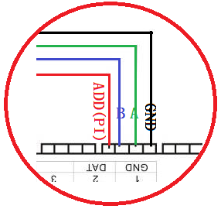
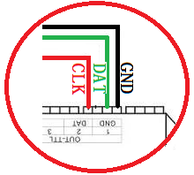

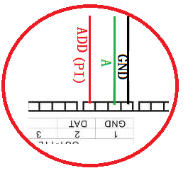
③. DMX512 single signal line wiring diagram ④. DMX512 differential signal wiring diagram
(AB wire to write address)
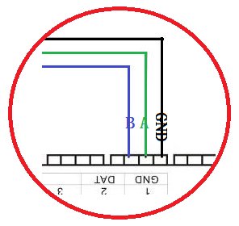

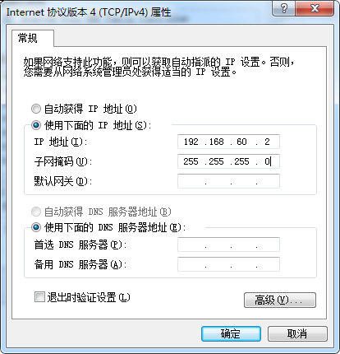
5. Controller--Online mode--Computer IP address setting
1. Turn on the computer --- network and sharing center;
2. Click to change the adapter settings;
3. ight click on Local Area Connection - Properties;
4. Click on "Internet Protocol Version 4 (TCP/IPV4)";
5. Change IP
IP：192.168.60.2
Subnet mask：255.255.255.0
6. Click OK to complete the IP address setting.

Note: This IP setting is applicable to regular online/Madrix software control.

六、T-790K numbering function operate
T-790K numbering has three methods: Computer number (recommended), master number, and branch number.
1. Controller (computer software port) numbering
1.1. The computer and the controller are connected by a network cable (using the international standard TCP/IP network protocol, and the network cable is 568B through)
1.2. Open the software LedPlayer-k and click on "Project Configuration" as shown in Figure 1.
1.3. Click on "Online Code", as shown in Figure 2.
1.4. Set the controller start number, click the online number button, start numbering, as shown in Figure 3.
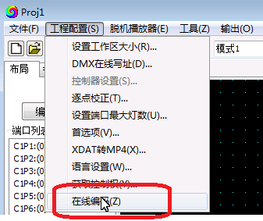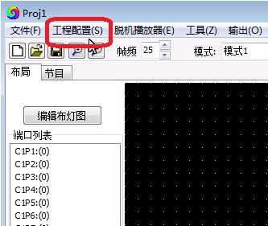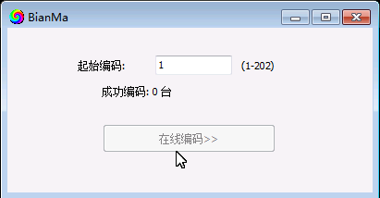
Figure 1 Figure 2 Figure 3
1.5. Complete the online code and check the controller number.
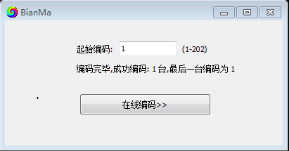

2. Conttoller(master control operation ) numbering function
The main control and sub-control (T-790K) are connected through the network cable (using the international standard TCP/IP network protocol, and the network cable is 568B through).
2.1. The master control presses the “SPEED-/speed-” button to power on, and the “MODE” button adjusts the arrow to “Set Slave ID” as shown in the figure:
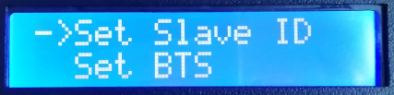
2.2. Press the “SET” button again, the main control display enters the numbering page, the “SPEED+” button and the “SPEED-” button adjust the number of the starting sub-control, as shown below:
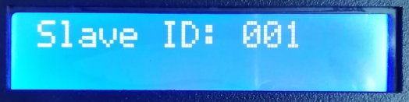
2.3. After completing the number setting, press the “SET/Save” button to start the numbering.
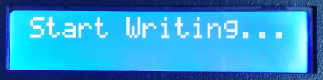
2.4.The first step of the controller number is to automatically count the number of sub-controls. The display "Write OK: 003" (take 3 sub-control numbers as an example)
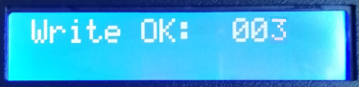
2.5. The number is completed, the main control display: As shown in the figure "Write Num: 003", 3 controllers are programmed.
“ Last ID: 003” means the last controller number is 3
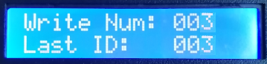
Sub-control T-790K display as below:
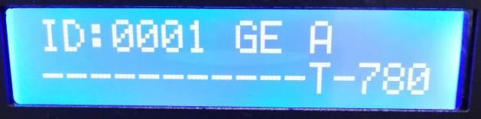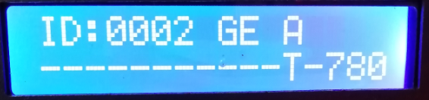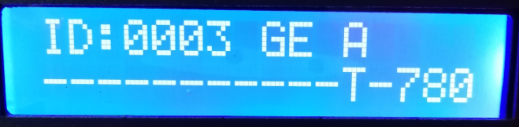
First set ID：0001 Second set ID：0002 Third set ID：0003
2.6. Check the controller number. If you need to renumber, press and hold the “SPEED-” button to restart the numbering. If you do not need to renumber, press any button—the master restarts and returns to the playback mode.
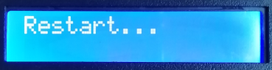
Note 1: When the controller is numbered, the level network port must be connected in strict accordance with the controller silkscreen prompt (IN/OUT); the maximum sub-control number is 203. .

3. Controller (T-790K sub-control) numbering
The T-790K and the T-790K use network cable connect (using the international standard TCP/IP network protocol, the network cable is 568B straight)
3.1. The first T-790K controller, press and hold the “SPEED-” button, the controller will be powered on and enter the manual coding mode. The display shows: “ID: 0001” as shown in the figure, ie the current number of the controller is No. 1, press the “ SPEED+” and “SPEED-” keys adjust the starting number.
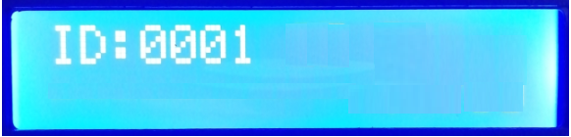
Button silk screen | SET | MENU | SPEED+ | SPEED-
Button function | Numbering start button | / | Digital plus | Digital subtraction
NOTE | Numbering mode, "MODE" button is not available |  | Press "-" to power on, enter the numbering mode
3.2. After completing the start number adjustment, press the “SET” button to start the number start number and display: “Writing...”
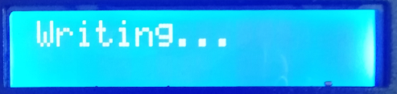
3.3. During the numbering process, the controller detects the number of connected controllers (the number of connected controllers). As shown in Figure 003, a total of three controllers are detected.
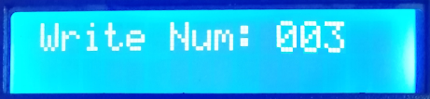
3.4. The number is completed, the first controller displays: as shown in the figure "Write Num:003": 3 controllelers are searched
" Last ID: 003" The last one is numbered 3

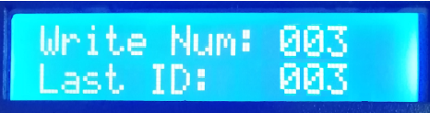
Other controller display, as show in the figure:
“ID:0002 A” ；ID:0002 means the controller number is No. 2 A: Indicates that the number is automatically generated
The second set: A-0002 The third set: A-0003
3.5.Check whether each controller number is correct or needs to be renumbered. Then the first T-790K controller long time presses the “SPEED-” button to return to the manual numbering; the end numbering can be exited by pressing the button (any button is ok). The first T-790K controller restarts “Restart...” and returns to normal play mode.
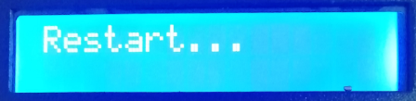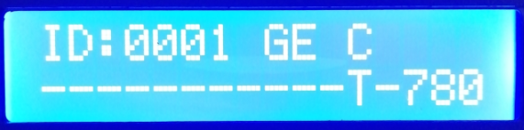

Note: When the controller is numbered, the cascaded networking ports must be connected in strict accordance with the controller silkscreen prompt (INPUT/OUTPUT).

七、T-790K parameter setting and function operation
Press the “SET” button, and the controller will start up and enter the parameter setting and other function interfaces.
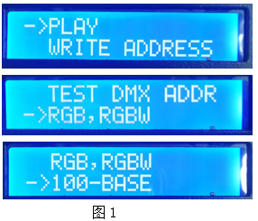
①. PLAY Built-in effect playback mode
②. WRITE ADDRESS Address writing mode
. TEST DMX ADDR Lamps address testing mode
④. RGB,RGBW Lamps channel selection mode
⑤. 100-BASE Transmission rate selection mode
1. Built-in effects mode (support RGB/RGBW these two kinds channel lamps)
1.1. Press the “SET” button, and the controller will start up, enter the parameter setting and other function interfaces, as shown in the figure:
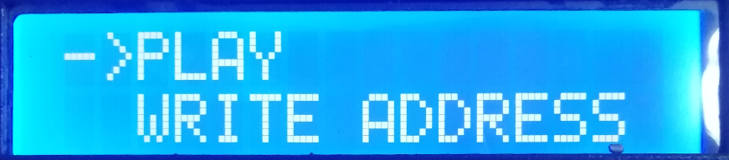

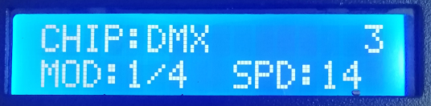
1.2. Press the “MODE” button to move the arrow to select “PLAY”, then press the “SET” button to enter the built-in effect playback mode interface. As shown in the figure:
①. CHIP chip model（refer to the IC model list）
②. 3 Channel selection（3/4）
③. MOD Built-in effects（refer to the built-in effects list）
④. SPD Playback speed（refer to the speed level corresponding frame list）
Note: When the built-in effect is played, the supported lamp channel is set by the “Lamp Channel Selection Mode”.
1.3. Button function list
Button silk screen | SET | MODE | SPEED+ | SPEED-
Function | Chip selection | Mode selection | Speed up | Speed down
NOTE | Press “SET” to power on, and enter the built-in effects mode

1.4. Press “SET” to switch the IC model
IC model list
1 | DMX (standard 250Kbps) | 5 | TM1803
2 | UCS1903 | 6 | GS8205
3 | SM16703 | 7 | DMX 500K
4 | WS2811

1.5. Press “MODE” to switch the built-in effects
Built-in effects list
1 | Colorful jump | 3 | Colorful change
2 | Colorful gradient | 4 | White light gradient

1.6. Press “SPEED+” and “ SPEED- ” to switch the speed;
Speed lever corresponding frame rate list
Speed | Frame rate/second | Speed | Frame rate/second | Speed | Frame rate/second | Speed | Frame rate/second
1 | 4 frame | 5 | 8 frame | 9 | 14 frame | 13 | 23 frame
2 | 5 frame | 6 | 9 frame | 10 | 16 frame | 14 | 25 frame
3 | 6 frame | 7 | 10 frame | 11 | 18 frame | 15 | 27 frame
4 | 7 frame | 8 | 12 frame | 12 | 20 frame | 16 | 30 frame

1.7. After completing the built-in effect playback, shut down and restart to return to normal mode.

2. DMX512 IC address writing mode and test
2.1. Press “SET” button, and power on the controller, enter the parameter setting and other function interface, as how in figure 1.
2.2. Press “MODE” button to move the arrow to select “WRITE ADDRESS” as shown in the figure.
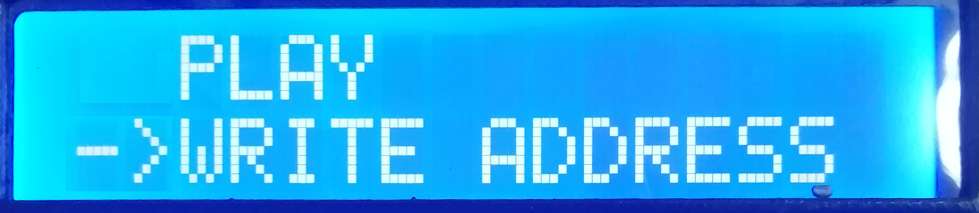

2.3. Press “SET” button to select “WRITE ADDRESS”，enter into address writing mode interfac, as show in the figure:
①. START CH: Start channel
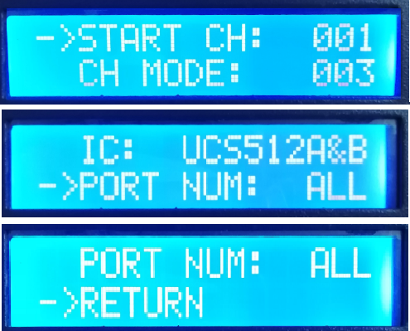
（The starting address is set in the range of 0-512, and the regular is 001.）
②. CH MODE: Interval channel
（Interval channel setting in the range of 0-255）
③. IC : Chip model
（Rfer to DMX512 IC list）
④. PORT NUM: Address port
（Refer to the port list）
⑤. RETURN Return to the main interface
2.4. Press the “MODE” button to move the corresponding item of the arrow, and press “SPEED+” and “SPEED-” to set the start channel/interval channel/IC option/address port respectively.
1.DMX512 IC list
UCS512A*/B*,TM512AL1/AB | WS2821 | DMX512AP | UCS512C*，TM512AC*
SM1651*-3 | SM1651*-4 | UCS512D*/TM512AD* | UCS512-E
SM17512* | SM17522* | UCS512-F | TM512AC*
GS8512 | SM17500

2. port code list
1 | Port OUT1 | 5 | Port OUT5
2 | portOUT2 | 6 | Port OUT6
3 | Port OUT3 | 7 | Port OUT7
4 | Port OUT4 | 8 | Port OUT8
ALL | All ports OUT1-8
NOTE: the contorller supports all ports write address, also supports single port write address.

2.5. Select down each project, press “SET” start to write the address; then the screen display as “Writing Addr...”， the port indicator flashing.
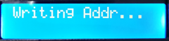
2.6. After complete the address writing, the controller automatically switch to the address testing function, then the screen display
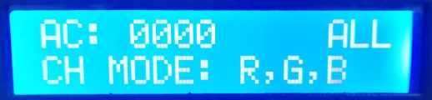
①. AC: **** Automatic test
②. MC: **** Manual test
③. ALL All ports OUT1-8
④. CH MODE： Channel （Interval channel is not adjustable）
Note: The address port is set by the “PORT NUM port number” when writing the address.

2.7. Press “MODE” enter “AC” automatic testing mode, the luminaires begin to run in succession; the controller displays the following picture:
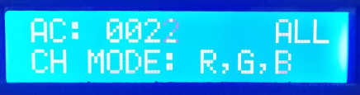
2.8. Press the “MODE” button again to enter the “MC” manual test mode. “SPEED+” and “SPEED-” can adjust the pixel points (long press “speed+” or “speed-” can be quickly incremented or decremented), and the lamps will light up one by one; The controller displays the following picture:
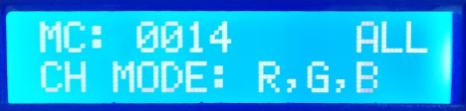
2.9. After the test is completed, press “SET” to exit the channel test and return to the write address interface.
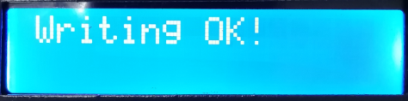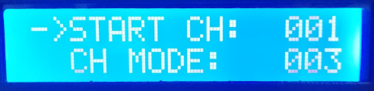
2.10. After completing the address, restart and restart, return to the normal mode.

3. Lamps address tecting mode（test all the ports carry lamps of the controller）
3.1. Press “SET”, and at the same time power on the controller, enter the parameter setting and键，同时other function interface 1.
3.2. Press “MODE” button to move the arrow corresponding selection “TEST DMX ADDR”。
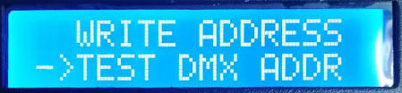
3.3. Press “SET” enter the lamps testing interface, as show below in the figure:
①. AC: **** Automatic test
②. MC: **** Manual test
③. ALL： All ports
④. CH MODE： Channel(can amnually select)
3.4. Press “MODE” to start the test, as show in the figure:
3.5. Press “MODE” to switch the testing channel slection;
Press “SET” to switch the manual and automatic channel testing mode;
Press “SPEED+” and “SPEED-” to adjust the lamp numbers under the manual channel testing mode.

Lamp test vocabulary definition
Automatic mode:AC | Definition | Manual mode:MC | Definition
AC：**** ALL  CH MODE: RGBW | 1 channel automatic test | MC：**** ALL  CH MODE: RGBW | 1 channel manual test
AC：**** ALL  CH MODE: RG,BW | 2 channel automatic test | MC：**** ALL  CH MODE: RG,BW | 2 channel manual test
AC：**** ALL  CH MODE: R,G,B | 3 channel automatic test | MC：**** ALL  CH MODE: R,G,B | 3 channel manual test
AC：**** ALL  CH MODE: R,G,B,W | 4 channel automatic test | MC：**** ALL  CH MODE: R,G,B,W | 4 channel manual test
Note 1: Automatic and manual test mode switching: AC is the automatic test mode, MC is the manual test mode, and is switched by the “SET” key;
Note 2: luminaire channel switching, RGBW is a monochrome single-channel luminaire; RG, BW is a two-color two-channel luminaire; R, G, B are three-color luminaire; R, G, B, W are RGBW four-color luminaire, by "MODE ”Key switch;
Note 3: **** is the lamp number; in the automatic test mode, after the number is automatically incremented to the maximum value, the test starts again from 0001; in the manual test mode, the number is manually adjusted by “SPEED+” and “SPEED-”.
3.6. Complete the test, power off and restart, the controller can enter the normal mode.
4. Lamp channel selection mode (built-in effect playback supports RGB/RGBW IC channel selection)
4.1. Press the “SET” button, and the controller will start up, enter the parameter setting and other function interface 1.
4.2. Pess “MODE” move arrow corresponding select “RGB,RGBW”。
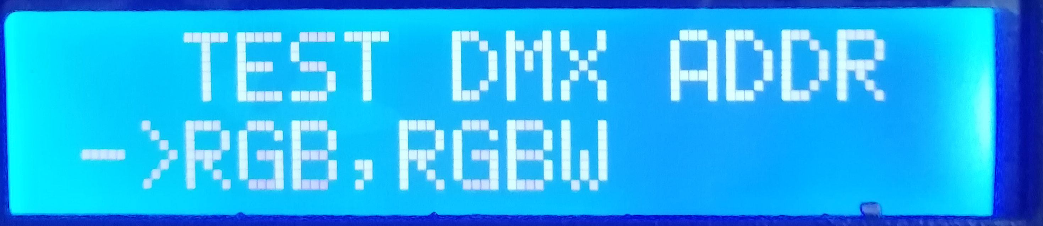
4.3. Press “SET” to enter lamps channel selection interface, as show in the below figure:
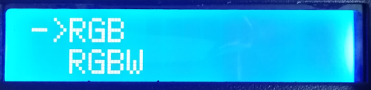
① RGB Three channel lamps
② RGBW Four channel lamps
4.4. Press “SPEED+” and “SPEED-” to move the arrow up and down, to select the RGB/RGBW channel selection.
4.5. Press “MODE” confirm the selection, the two settings as show below:
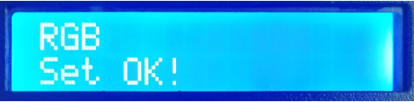 Or 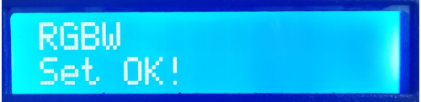
4.6 Select to complete the lamp channel selection, press “SET” to exit and return to the main interface.
5. Transmission rate selection mode（100-BASE 100M rate / 1000-BASE Gigabit rate ）
5.1. Press the “SET” button, and the controller will start up, enter the parameter setting and other function interface 1.
5.2. Press the “MODE” button to move the arrow to select “100-BASE”.
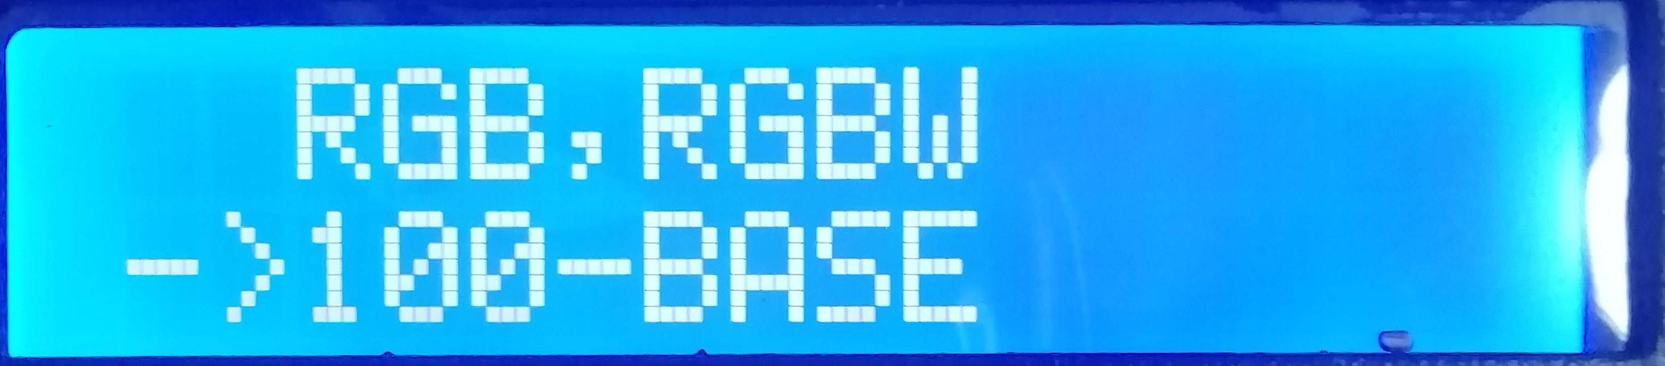
5.3. Press “SET” to enter the signal transmission rate selection mode interface, as shown in the figure:
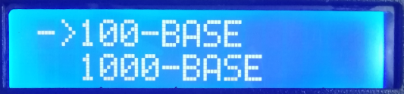
① 100-BASE 100M rate
② 1000-BASE Gigabit rate
5.4. Press the “SPEED+” and “SPEED-” keys to move the arrow up and down to select the 100-BASE /1000-BASE option.
5.5. Press the “MODE” button to confirm the selection, as shown in the two settings:
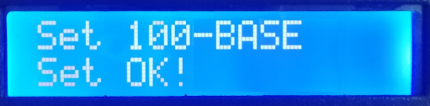 OR 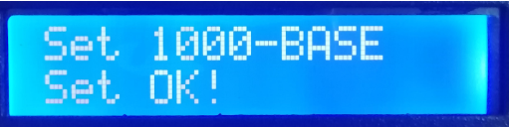
5.6. Select to complete the transmission rate selection, press “SET” to exit and return to the main interface.
5.7. When the controller is in regular program, it shows: GE Gigabit rate / FE 100M rate, as shown below:
八、T-790K controller ---MADRIX SETTING
Three methods of this setting:
1. Computer software LedEdit-K setting（suggest to use）
2. Computer software setting LedPlayer-K
3. The controller manual setting
1、LedEdit-k software setting MADRIX parameter
1.1. Open LedEdit-k V4.9.4 and above edition software.
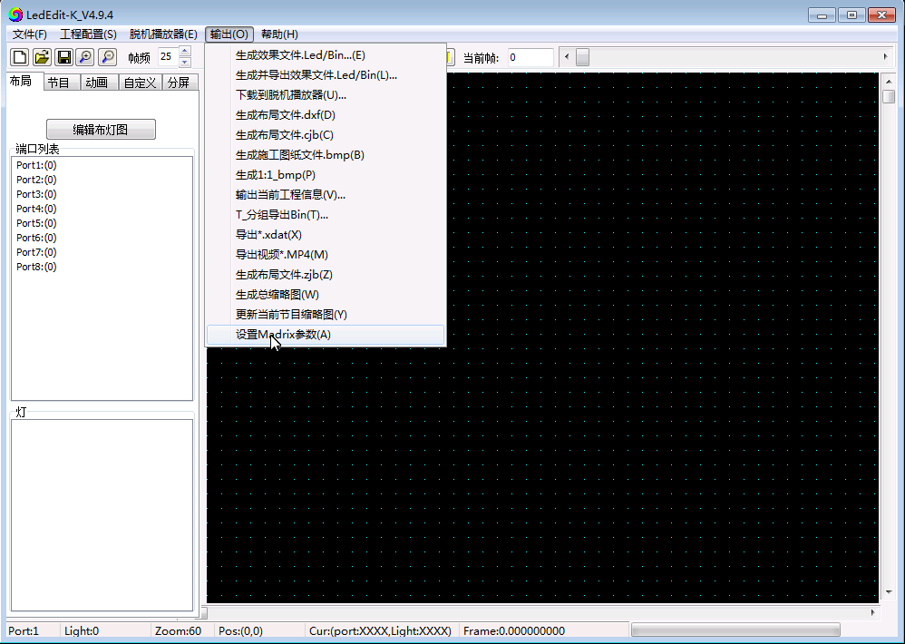
1.2. Click <output>--<Set Madrix parameter>

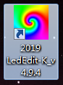

1.3. Enter the setting parameter interface
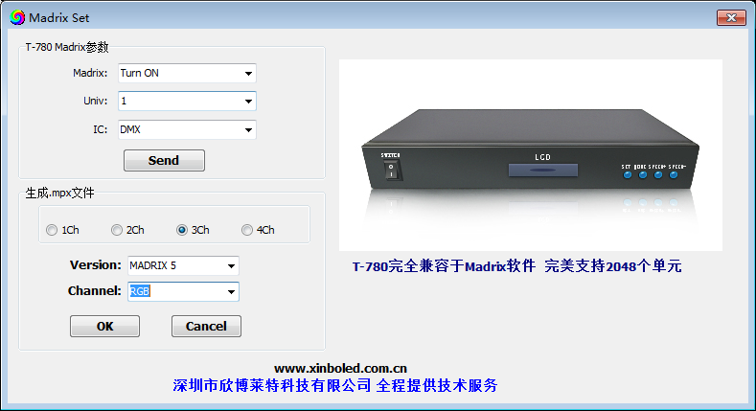
1.4. Parameter setting
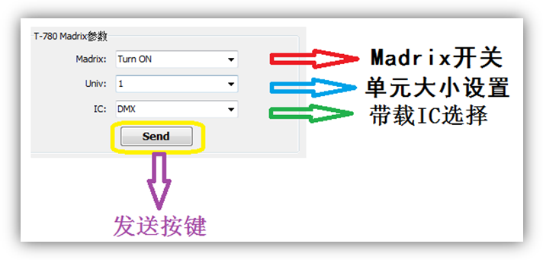
Turn ON/OFF MADRIX
Click the drop-down arrow under this option and select Turn ON to turn on /Turn OFF to turn off the MADRIX mode.
Set the carry light units number
Click on the drop-down arrow for this option and select 1/2/3 unit, which is the number of units loaded on the controller per port.
NOTE 1：If the controller is set to carry 1 unit per port, the controller 8 port occupies 8 units;
The first controller occupies 1-8 units, as shown in the figure:
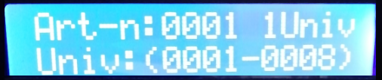
The second controller occupies 9-16 units, as shown in the figure:

And so on.
NOTE 2：If the controller is set to carry 2 units per port, the controller 8 port occupies 16 units; the first controller occupies 1-16, the second controller occupies 17-32, and the third controller occupies 33-48 ,And so on.
NOTE 3：If the controller is set to carry 3 units per port, the controller 8 port occupies 24 units; the first controller occupies 1-24, the second controller occupies 25-48, and the third controller occupies 49-72 ,And so on.
NOTE 4： The T-790K control system supports up to 2048 units of output, 170 pixels per unit.
Support lamps IC model
Click on the drop-down arrow for this option and select DMX /1903, DMX512 chip fixtures or regular 1903 fixtures.
After setting, click the <SEND> send button to send the parameters to the controller.
2. LedPlayer-K software set MADRIX parameter
2.1. Open LedPlayer-k V4.9.2 over edition software.
2.2. Click <Project configuration>--<set Madrix parameter>
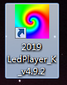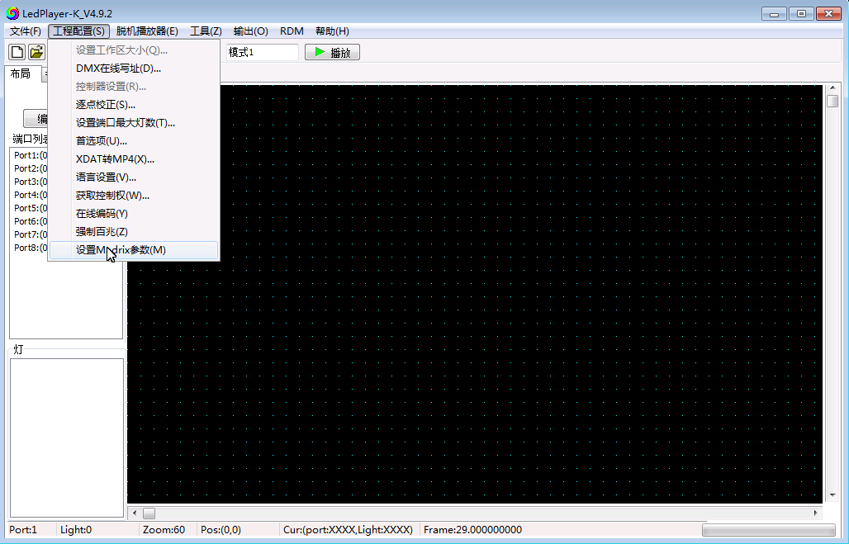
2.3. Enter parameter setting interface ( Setting method is same with LedEdit)
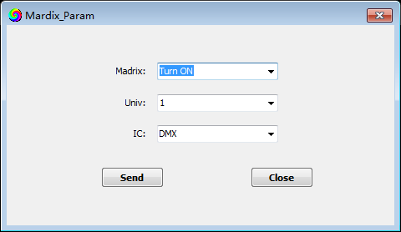

3、T-790K controller set MADRIX parameter
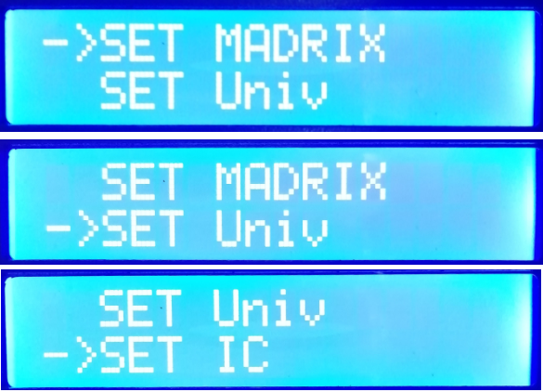
Press “SET”, and power on the controlller at the same time, enter MADRIX setting interface, as shown below:
SET MADRIX Turn on/off MADRIX software
SET Univ Set support lights quantity
SET IC support IC selection
Note: The parameters need to be set and set in order of 1, 2, 3, and the controller will be restarted after completion.
3.1. Turn on/off MADRIX function
1. Press “SET”, and turn on the controller at the same time, enter the MADRIX setting parameter interface.
2. Press the “MODE” button to move the arrow to select “SET MADRIX” to enable/disable the MADRIX function, as shown below.
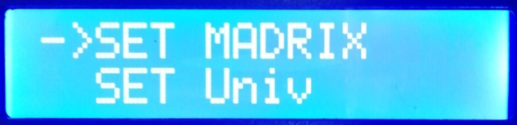
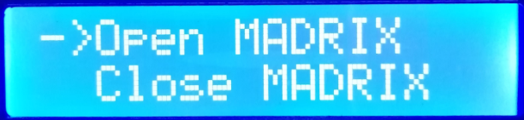
3. Press “SET” to confirm entry, open/close Mai Jue; as shown below;
1. Open MADRIX function
2. Close MADRIX function

4. Press the “SPEED+” and “SPEED-” buttons to move the arrow up and down to select the On/Off option.
5. Press the “MODE” button to confirm the selection and display the following picture:
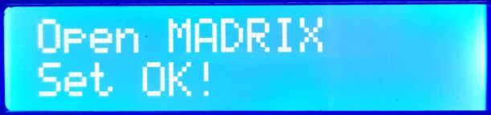 OR 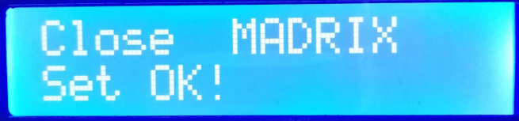
6. Select to complete the selection, press the “SET” button to exit, and return to the MADRIX setting interface.
3.2. Set the number of lamps on board
1. Press the “SET” button, and the controller will start up and enter the Mai Jue set parameter interface.
2. Press the “MODE” button to move the arrow and select “SET Univ” to set the number of lamps on the load, as shown below.
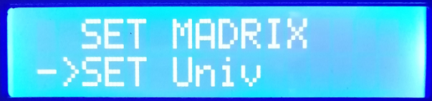
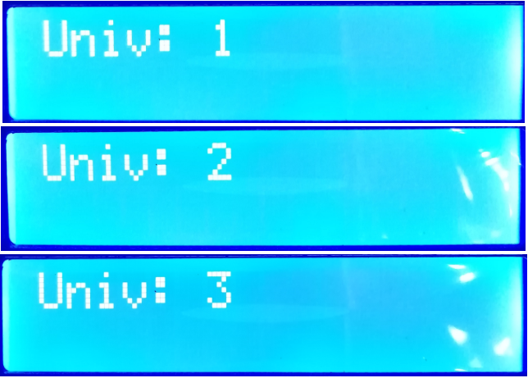
3. Press “SET” to confirm the entry and set the number of lamps on load; as shown below; Univ 1 1 unit（170 pixels）
Univ 2 2 units（340 pixels）
Univ 3 3 unites（510 pixels）

4. Press the “SPEED+” and “SPEED-” keys to adjust the number and select the controller load unit option.

5. Press the “MODE” button to confirm the selection and display the following picture.：
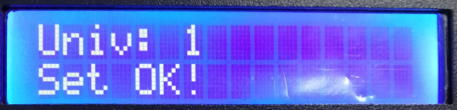OR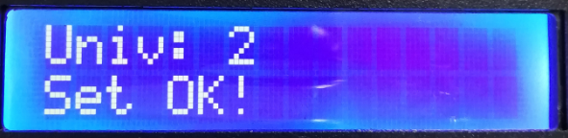OR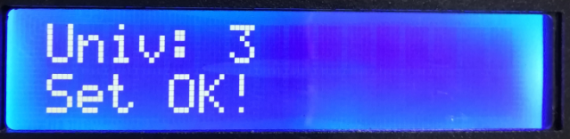

6. Select to complete the selection, press the “SET” button to exit, and return to the MADRIX setting interface.

3.3. Support IC selection（ UCSS1903/ DMX512）
1.
Press the “SET” button, and the controller will start up and enter the MADRIX set parameter interface.

2. Press the “MODE” button to move the arrow to select “SET IC” and select the model of the loaded IC, as shown below.
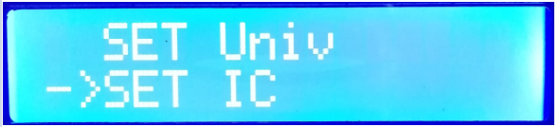
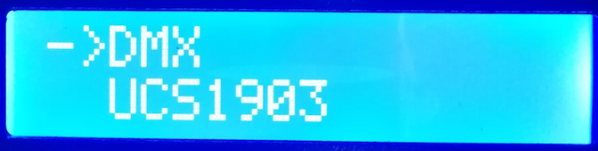
3. Press “SET” to confirm the entry and set the number of lamps on load; as shown below;
DMX DMX512 IC lamps
UCS1903 UCS1903 IC lamps
4. Press the “SPEED+” and “SPEED-” buttons to move the arrow up and down to select the IC option.
5. Press the “MODE” button to confirm the selection and display the following picture:
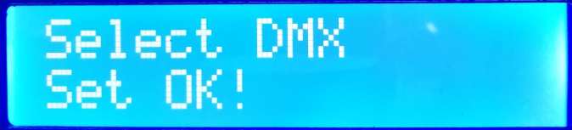 OR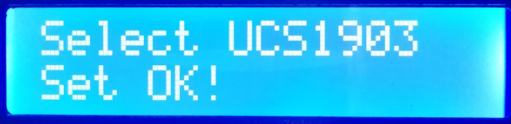
6. Select to complete the selection, press the “SET” button to exit, return to the MADRIX setting interface, restart the controller to complete the settings.

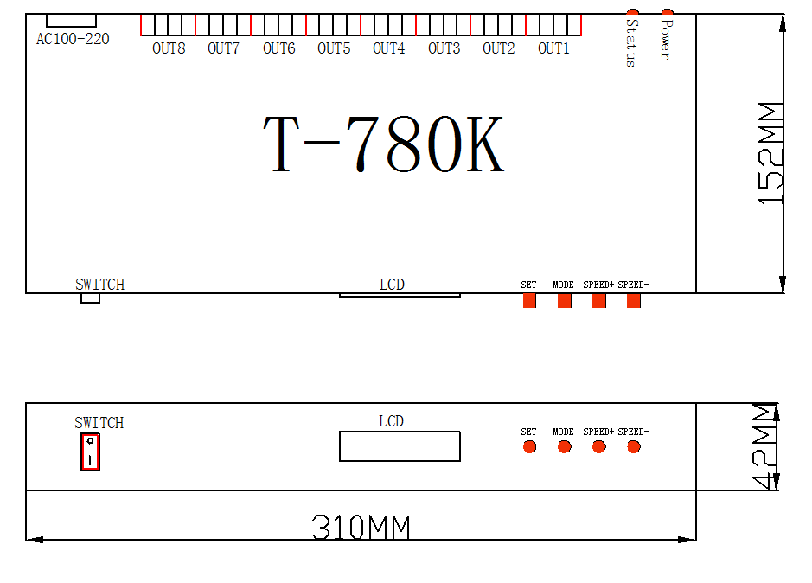
九、Physical parameter
Working temperature: -20 ° C - 85 ° C
Working power supply: AC 100-240V input
Power consumption: 5W
Weight: 1.8Kg
Output type: 4pin terminal block
Appearance size: L310 * W152 * H42
Outer packaging: (4pin terminal block *8; power cord *1; paper box *1)
十、Precautions:
1. Controller and controller, controller and master, controller and computer. The network cable of more than five types of specifications between each two nodes can be cascaded up to 100 meters. Over this distance, can add switch or use fiber for long distance transmission.
2. The cable crimping mode is 568B straight through.


