LED演播软件联机描点
LED On-line tracing point of broadcast software
以下用H807SA为例价绍该软件的应用：
H807SA is used as an example to introduce the application of the software
。
首先用网线电脑与分控的NET2连上，把灯具接到分控的输出端。把电脑的网卡固定一个IP地址。（断开WiFi）
First of all, with the network line computer and the NET2 connected to the sub-control of the lamp connected to the output of the sub-control. The computer network card fixed an IP address(Disconnect WiFi)
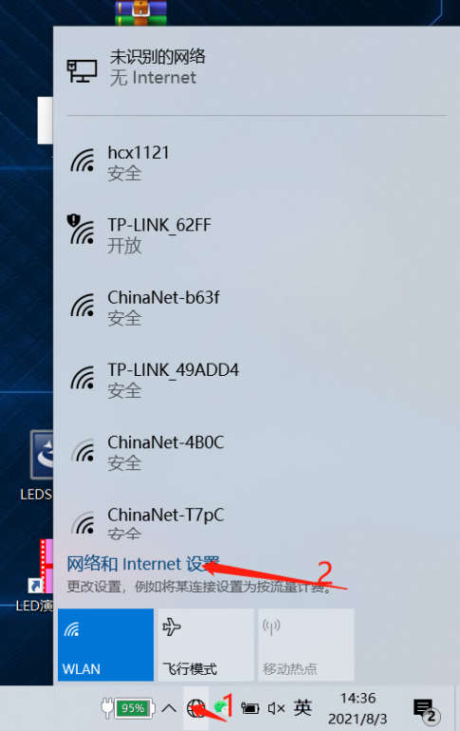
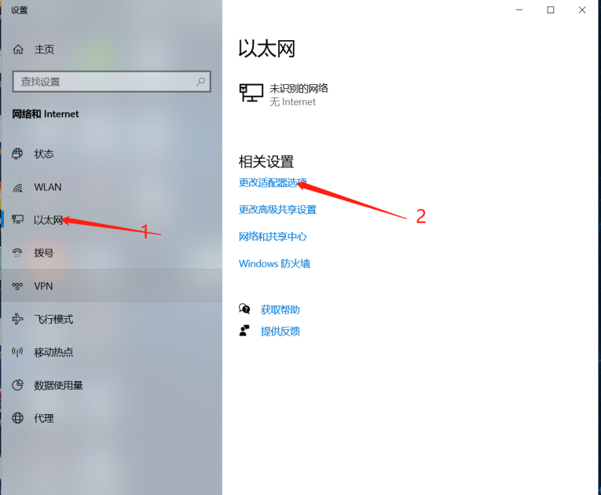
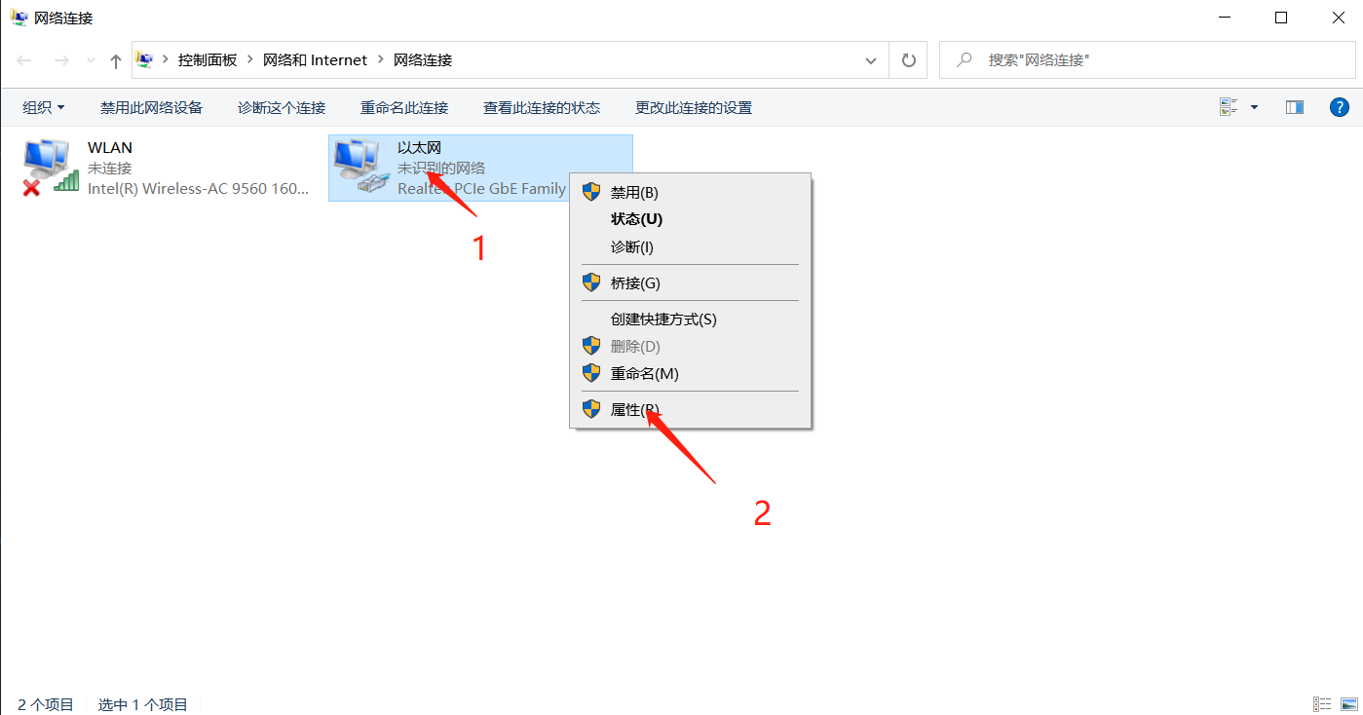
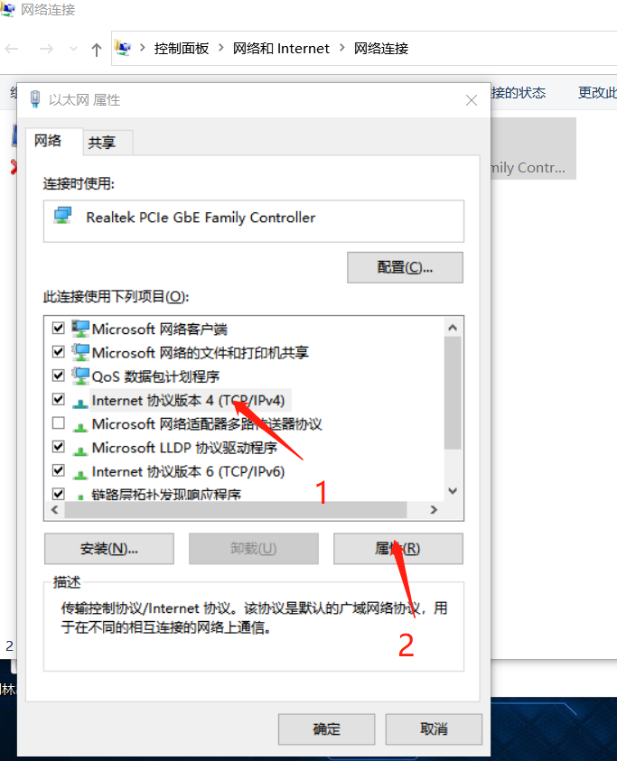
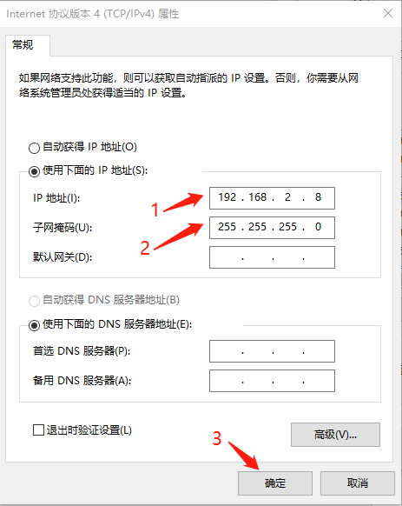
看到电脑与H807SA连接上之后，控制器网口的提示灯都会亮起来
When computer and H807SA connected, the controller port of the prompt lights will be up
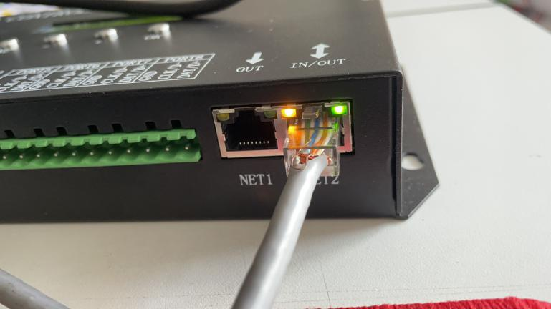

Controller setup
H807SA进行多台级联分控同步时，需要更改网口2的工作模式When H807SA carries on many cascades to divide the control synchronization, needs to change the net port 2 work mode
第五个菜单是网口2工作模式，一般选择(Net2 Input)。需要局域网同步时，必须将其中一个控制器设置为(Net2 Send Sync)，其它设置为(Net2 Input)，设置好后按ok键确认。The fifth menu is the net 2 work mode, the general choice (NET2 Input) . When Local area network synchronization is required, you must set one of the controllers to (NET2 Send Sync) and the other to (NET2 Input) , and then press OK to confirm
不同步时：Not synchronization
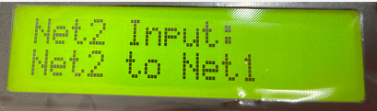
同步时：synchronization
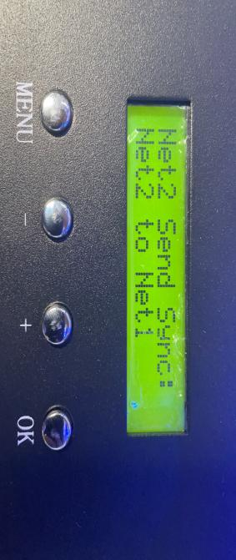
继续按MENU键找到IC Type界面选择灯具IC，按OK键确认
Press MENU key find to IC Type and choose samp IC, Press OK key complete.
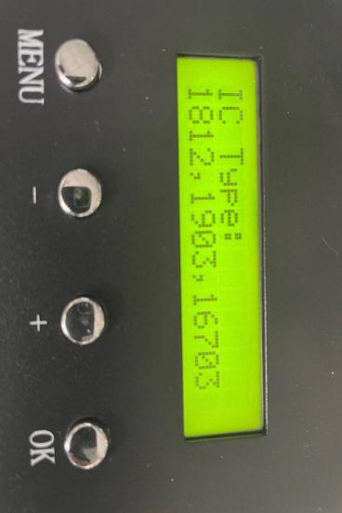
选择好灯具IC后继续按MENU键找到设置像素点通道数(PixelChannel), 设置一个点的颜色分量数，默认为3，即RGB。范围是1-4。（RGBW为4）
，如图：When Choose lamp IC go ahead press MENU key and find to set pixel channel. And set one point color pixel. Default to 3,it’s RGB. Range of 1-4.(RGB is 4). please reference for below picture.
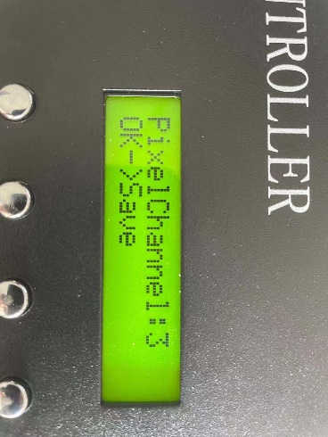

控制器设置完成
Finished the controller setup.

打开演播软件，点设置——系统设置，
Open the broadcast software, point settings-system settings
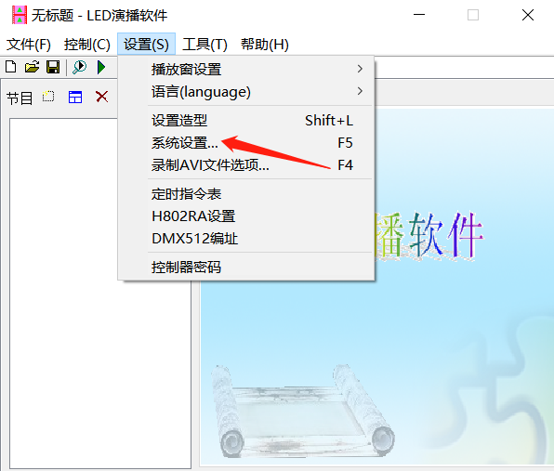

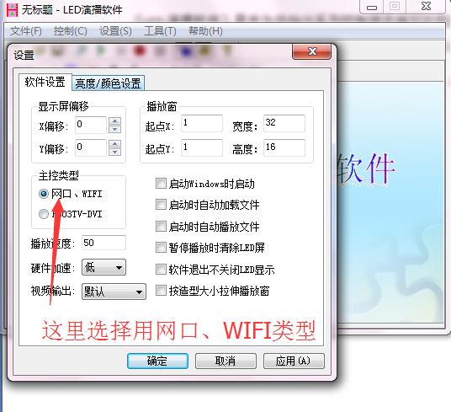

点击应用——确定。Click on application -- complete

回到主界面后继续点击设置——设置造型——输入密码（没有密码直接按确定）进入到造型设置窗口,按以下步骤操作Go back to the main screen and continue to click settings-settings-enter the password (no password directly press OK) to enter the styling settings window, follow these steps
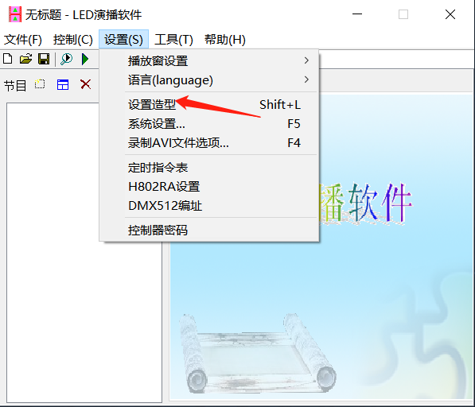
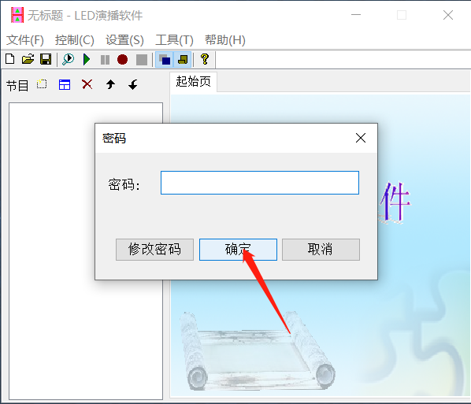

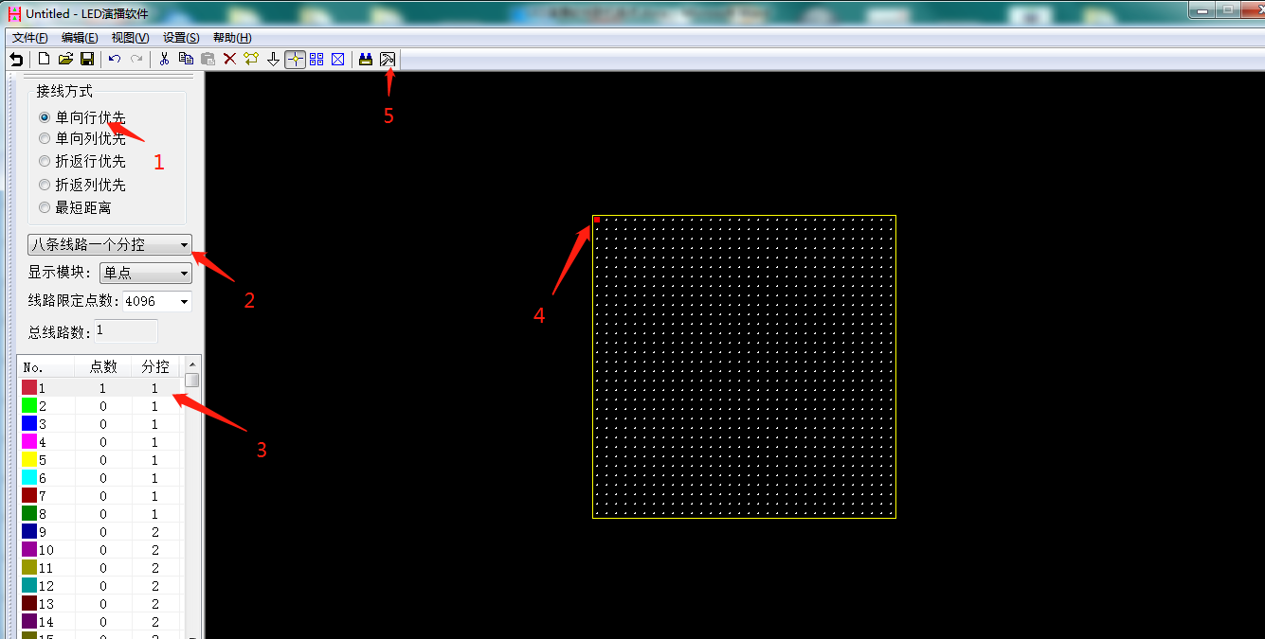
第二个步骤 八条线路一个分控意思是连接的控制器是八个信号端口In the second step, eight lines of one sub-control means that the connected controller is eight signal ports
第三个步骤 因为是八条线路一个分控， 所以1-8就是控制器的1到8个端口，这里选中的控制器的第一个端口The third step, because it is eight lines a sub-control, so 1-8 is the controller 1 to 8 ports, here selected the first port of the controller
（如果有多个控制器那么9-16就是第二个控制器的1-8端口 后面的控制器以此类推）If there are multiple controllers, then 9-16 is port 1-8 of the second controller, and so on
下一步 NEXT
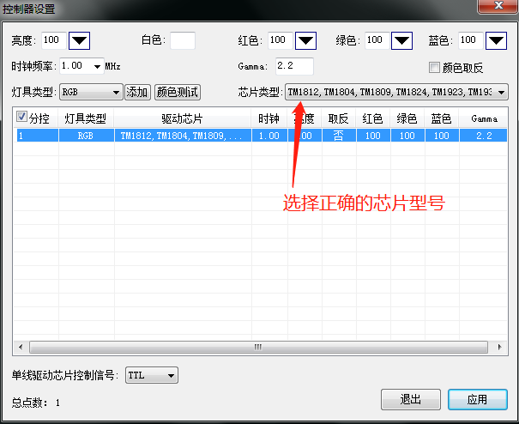
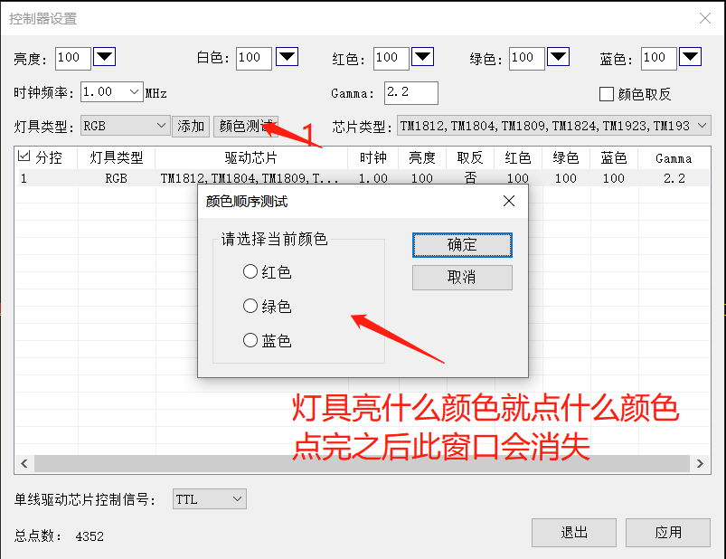
都设置完后，按应用后会有信号输出，控制器网口的黄灯会开始闪烁
After done the settings of all, according to the application will have a signal output, the controller network port of the yellow light will start flashing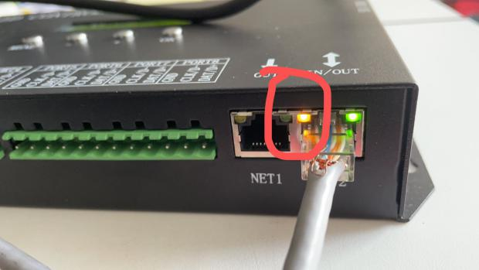
然后打开设置里面多网口设置查看是否有多个网口，如果有多个网口就选择对应控制器的网口确定。（没有多个网口就不要设置）Then open the settings inside the multi-port settings to see whether there are multiple ports, if there are multiple ports on the choice of the corresponding controller to determine the port.(Do not set up without multiple ports)
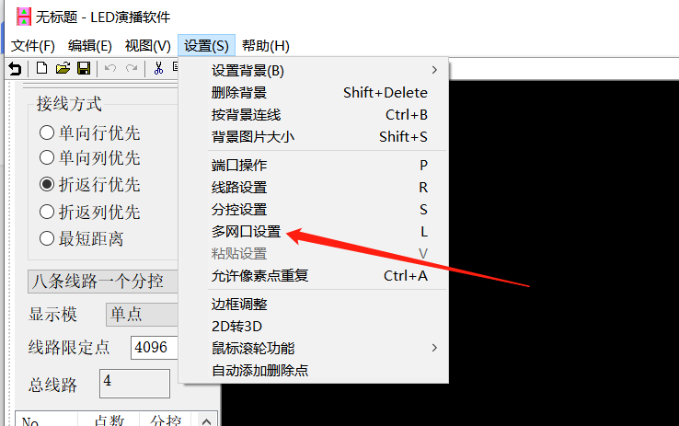

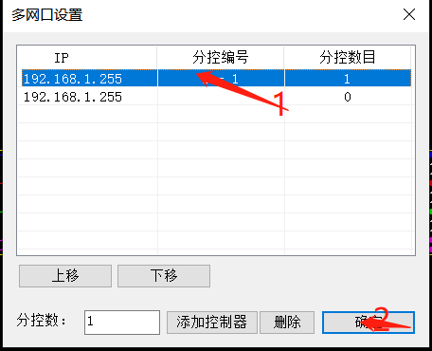

用鼠标添加点，如下图Add points with the mouse, refer to below picture. 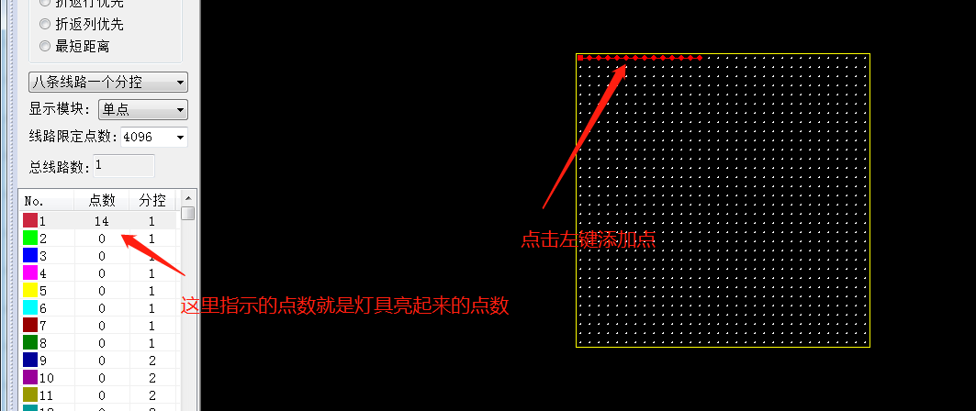
这里的点数是指像素点（单点单控的灯具一个像素点亮一个灯珠，三点一控的灯具一个像素点亮3个灯珠）Here the number of points refers to the pixel point (single-point single-control lamp a pixel light a bead, three-point one-control lamp a pixel light 3 beads)
添加点时鼠标按键功能：Add point when the mouse button function
左键：添加单点 left key: add single point
右键：添加多点 right key:add multiple point

