H807SA编地址操作使用说明
H807SA Address Operation Instructions
设置像素点通道数(PixelChannel), 设置一个点的颜色分量数，默认为3，即RGB。范围是1-4。
Sets the number of pixel channels and the number of color components of a point, which defaults to 3, or RGB. The range is 1-4
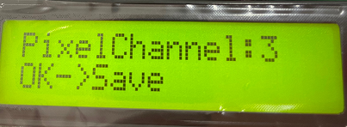

第十一个菜单是折叠菜单，按‘+’‘-’键选择菜单(Change menu)，按“OK”进入子菜单，进入子菜单后，继续按MENU切换子菜单。
The eleventh MENU is the collapsed MENU, press' + ' ' ' to select the MENU (Change MENU) , press 'OK' to enter the sub-MENU, into the sub-MENU, continue to press the MENU to Change the sub-MENU
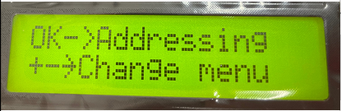
- 子菜单第一个选项是选择DMX芯片型号(DMX IC Type)，找到对应的IC后按OK键确认，然后继续按MENU切换子菜单
Submenu the first option is to select DMX IC Type, find the corresponding IC and press OK to confirm, then continue to press MENU to switch submenu
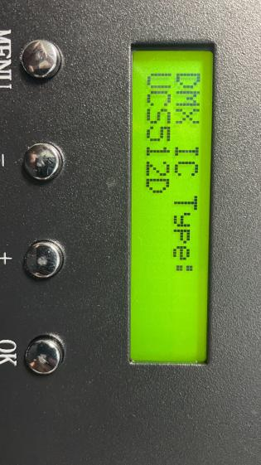
- 进行第二个选项，灯通道数(LightChannel)，设置一个灯具或转码板占用的通道数。若是点光源，此值与颜色分量数一样。（假设一米8段RGB的灯就是3*8=24）设置完成后按OK键确认，然后继续按MENU切换子菜单Go to the second option, the number of light channels, to set the number of channels occupied by a light or transcoding board. For a point light source, this value is the same as the number of color components. (suppose the 1.8 meter RGB lamp is 3 * 8 = 24) after the completion of the setup press OK key to confirm, then continue to press MENU to switch sub-MENU
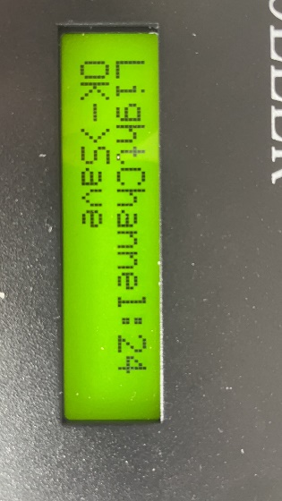
- 进行第三个选项，起始通道Address)，从第一个通道值开始编址，输入后按OK键，请耐心等待几秒钟可编码完成。（注意：RGB3通道值，RGBW4通道值）
Go to the third option, start the channel Address) , Address from the first channel value, type and press OK, please wait a few seconds to encode. (note: RGB3 channel value, RGBW4 channel value)
