807SA多台同步描点
807SA multiple synchronous trace points
- 设置控制器IP，多个控制器之间IP不要冲突也不要与电脑IP冲突
Set up controller IP, No IP conflicts between multiple controllers and no computer IP conflicts
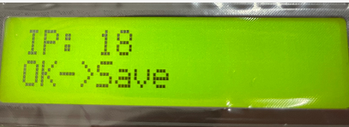
- 打开演播软件，新建造型
open the broadcast software, new modeling

- 设置造型大小，设置造型大小范围为当前控制器满载，便于将灯具全部点亮（宽度设置1024对应一个端口满载1024个ic，高度设置16对应两台控制器16个信号端口，每个控制器8个信号端口，依此类推）
Set the shape size, set the shape size range to the current controller full load, easy to light all lamps (width set 1024 corresponding to a port loaded 1024 IC , height set 16 corresponding to two controllers 16 signal ports, each controller 8 signal ports, and so on)
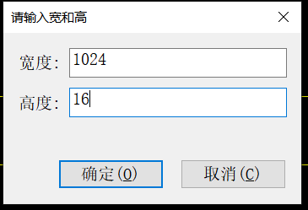
- 将设置的造型布满像素点，接线方式选择单向行优先，限定点数设置为1024，然后鼠标单击按住不松从造型框左上角朝造型框右下角拉，如下图每一行就是一个信号端口。
Will set the shape full of pixels, wiring select one-way row priority, set the limit points to 1024, and then click and hold down from the top left corner of the shape box to the lower right corner of the shape box pull, each line in the diagram below is a signal port
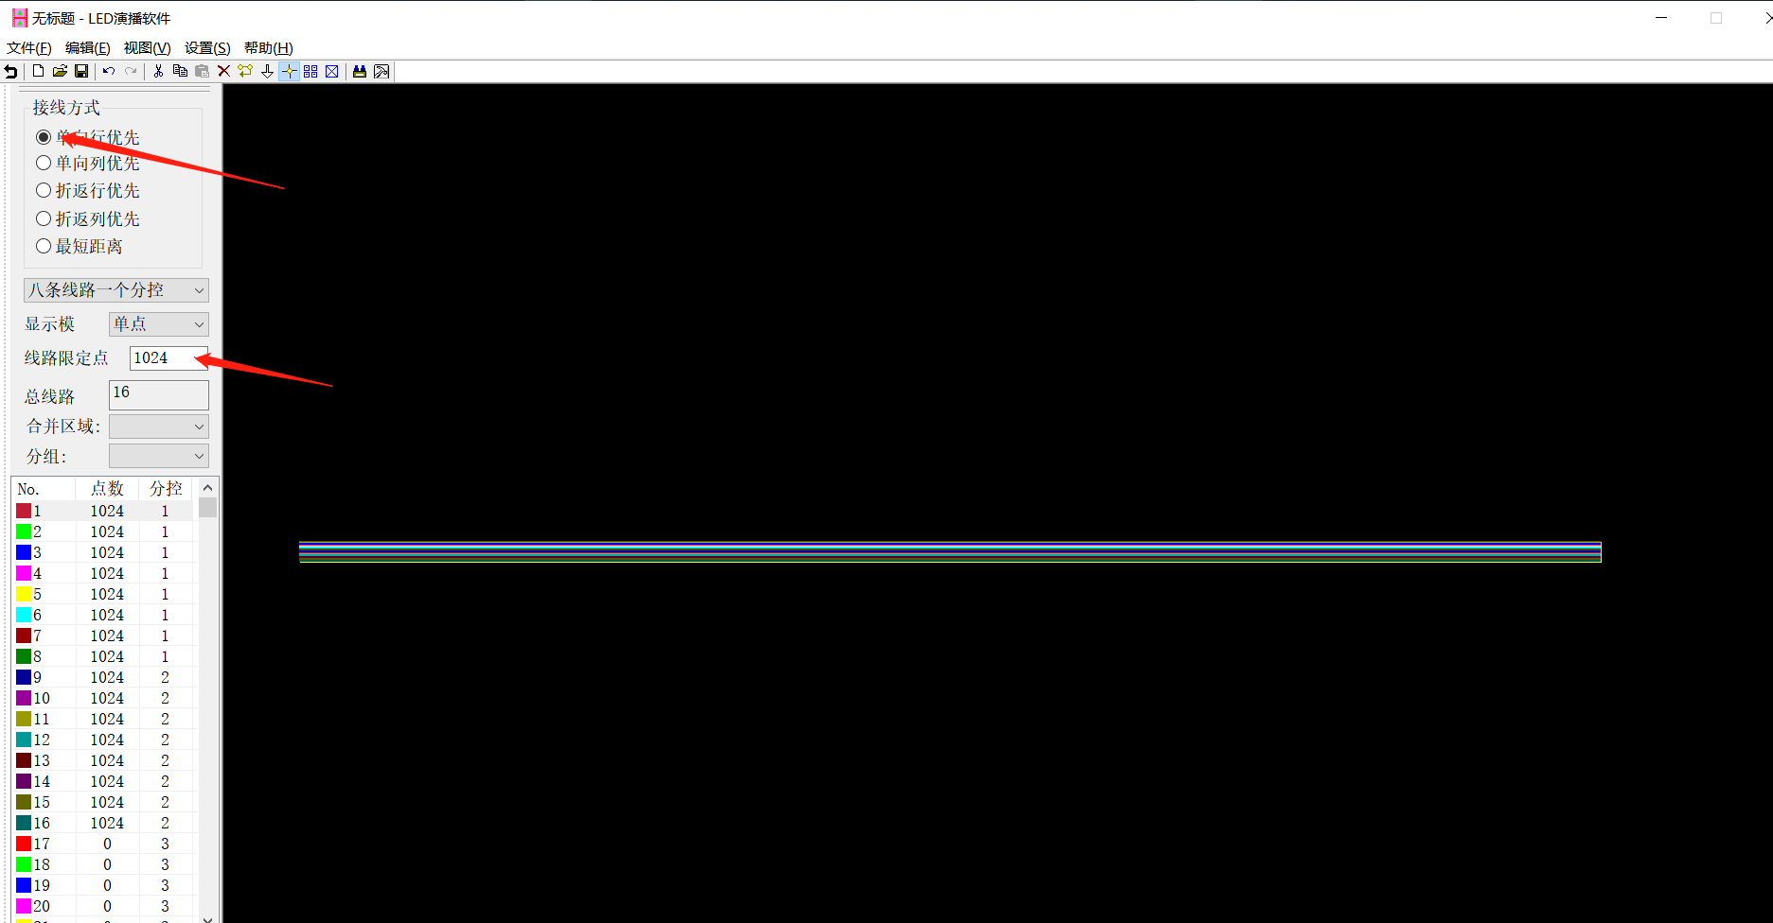

- 在设置里面选择多网口设置分配控制器，选中第一个控制器分控数设置1给每个IP都分配一个分控，然后确定。
In the settings inside select multi-port settings allocation controller, select the first controller settings 1 for each IP allocation of a split-control, and then determine 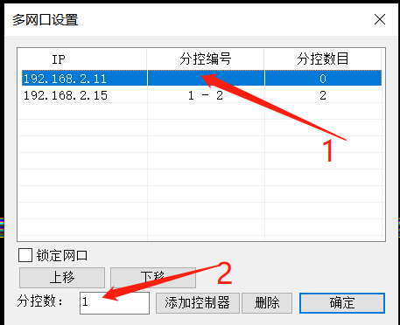
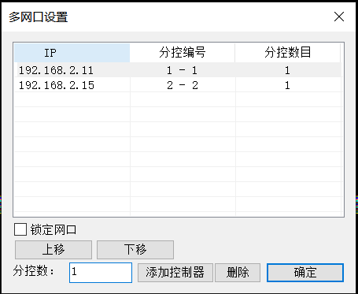

- 在设置里面打开设置造型选择芯片类型和RGB顺序（RGB顺序点击颜色测试看灯具亮什么颜色就点什么颜色，RGB顺序就会设置完成）然后应用即可。
In the settings open the settings styling select the chip type and RGB order (RGB order click on the color test to see what color lights light what color, RGB order will be set to complete) and then apply
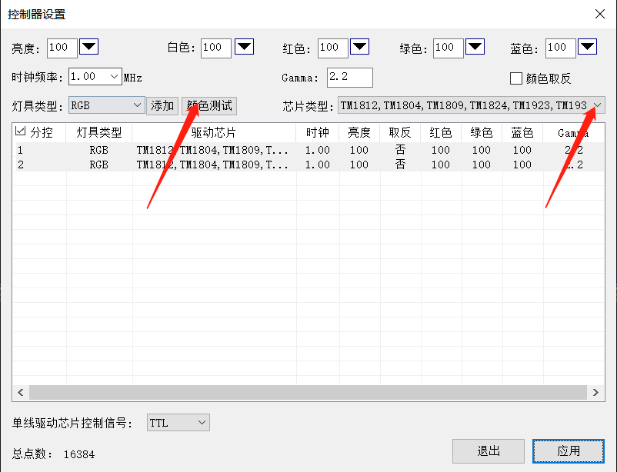
- 根据现场造型描点According to the scene modeling points
第一步点击设置然后选择边框调整（+是增加，-是减少），将造型框增加便于进行造型描点
Step 1 click on the settings and select the border adjustment (+ is increase,-is decrease) to add the styling frame to make it easier for modeling points.
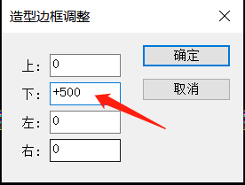

第二步找到灯具对应的信号端口（端口1就是第一台控制器的第一个端口，端口9就是第二个控制器的第一个端口）
Step 2 locate the signal port(port 1 is the first port of the first controller and port 9 is the first port of the second controller)
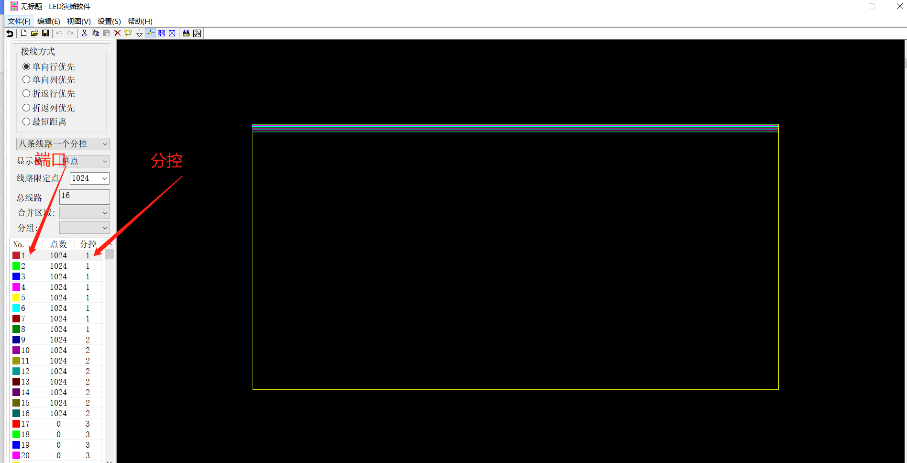

第三步找到第一个端口，点击线路操作删除这个端口。

step 3 find the first port, click on the line operation to delete this port
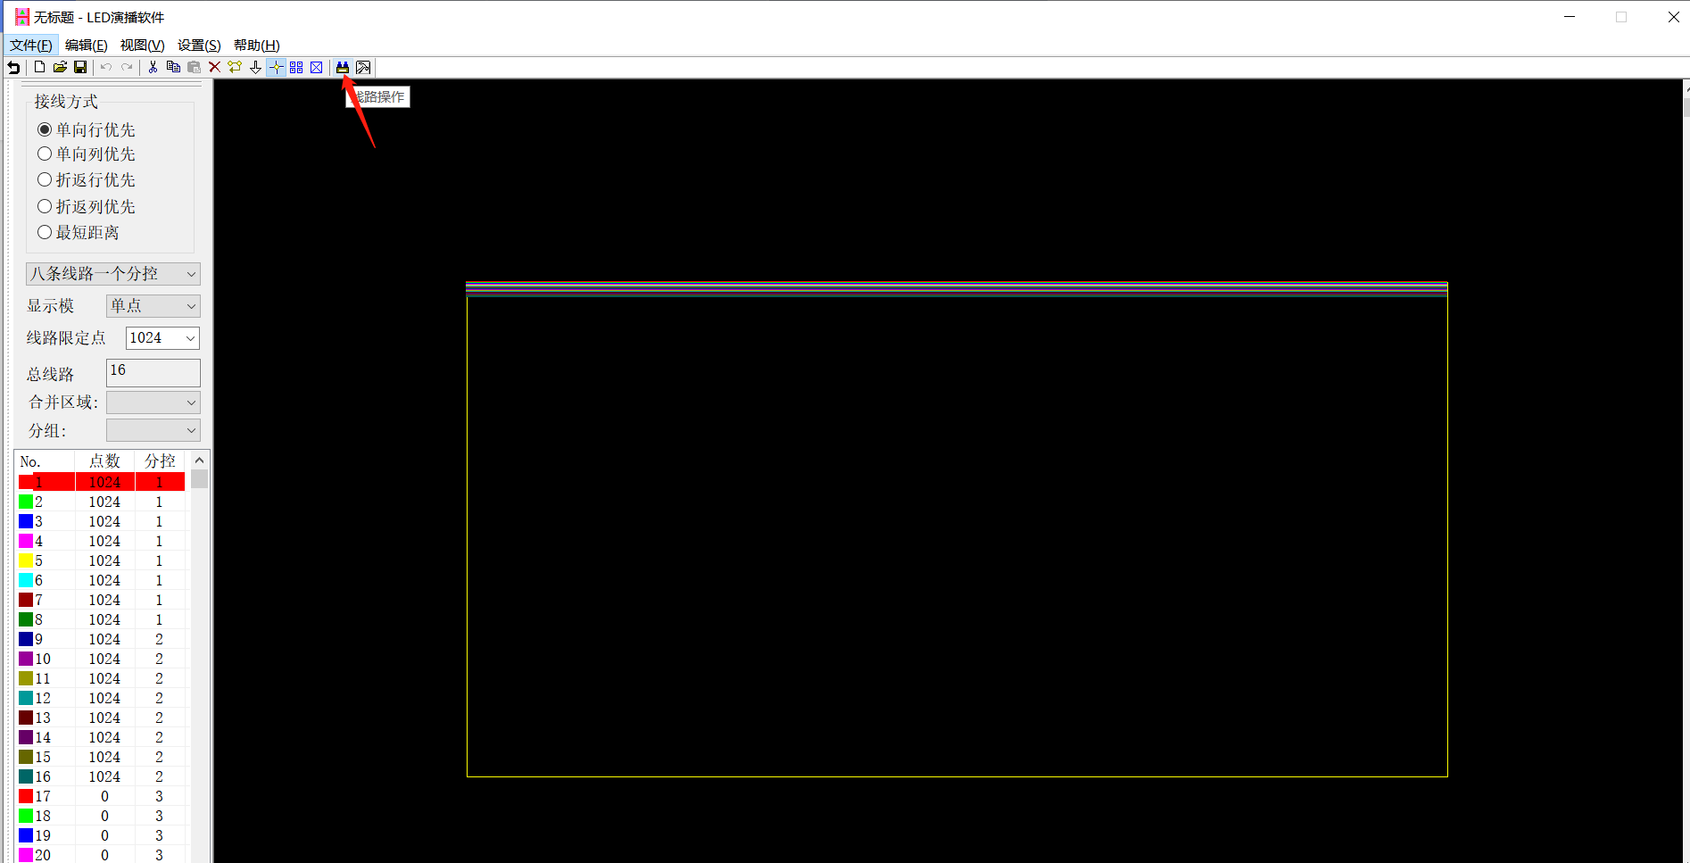

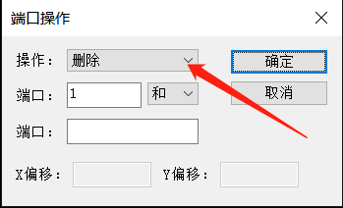
然后一个一个端口如下图根据现场灯带信号走向描点
Then one by one the ports as shown in the following diagram according to the scene lights with the signal to trace points
