H807SA art-net功能使用说明
H807SA art-net Functional instruction
- 开启控制器电源,按MENU键找到IP界面修改机器IP，按OK键确认
（注意：每台机器的IP都要不一样）
1. turn on the power of the controller, press the MENU key to find the IP interface to modify the machine IP, press OK key to confirm( Attention:Each machine has a different IP address)
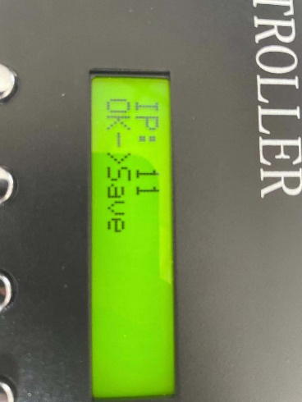
继续按MENU键找到IC Type界面选择灯具IC，按OK键确认
Continue to press the MENU key to find the IC Type interface select lamps IC, press OK key to confirm.

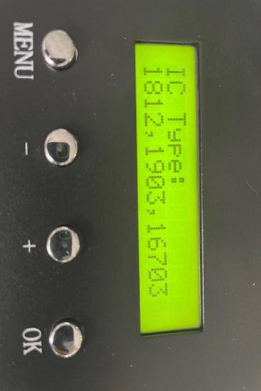
选择好灯具IC后继续按MENU键找到设置像素点通道数(PixelChannel), 设置一个点的颜色分量数，默认为3，即RGB。范围是1-4。（RGBW为4）
，如图：
When choose the lamps IC go ahead to press the MENU key to find set up pixel channel, Sets the number of color components for a point, the default is 3 and as same as RGB. Range of 1-4.(RGBW is 4) please refer below picture:
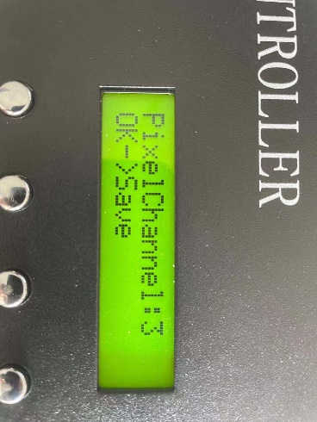
继续按MENU键找到折叠菜单，如图：
Continue press MENU key to find the fold MENU,please refer below picture:
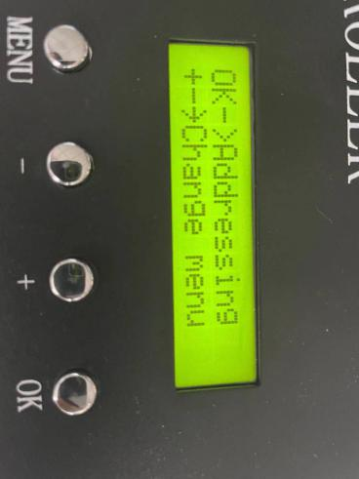

按 + 键找到art-net选项，然后按OK键确认
Press + key to find art-net and press OK key to confirm

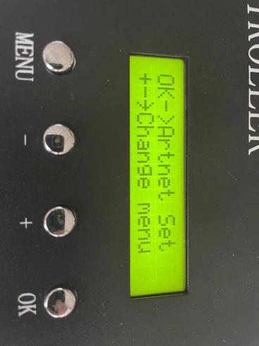
按OK键之后第一个第一个设置是 ：设置起始空间
The first setting after the OK key is: set the start space
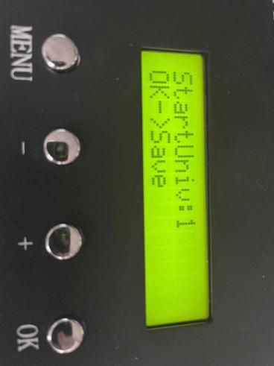

起始空间指在使用ArtNet控制时，从这个空间开始控制。此台控制器作为第一台控制器起始空间设置为1，设置为1之后按OK键确认

确认之后按MENU键进行第二个设置：设置一个端口带载几个空间，如图这里设置为4(一般设置为4)
Starting space refers to the space from which control begins when Artnet control is used.This controller is set to 1 as the starting space of the first controller, set to 1 and then press OK to confirm,After confirmation, press the MENU key for the second setting: set a port with several spaces, as shown here set to 4(General set to 4)
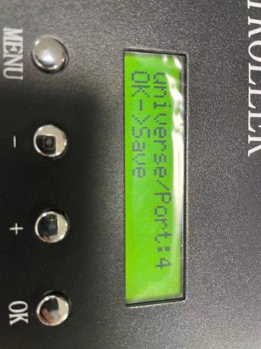
设置完成后按OK键确认进行第三个设置：设置Artnet分控数，这一路一共串了多少个分控。一台就设置1然后OK键确认

（注：一个端口最大空间为6，八个端口为48，所以第二台控制器起始空间就为49，第三台控制器以此类推）
After setting the OK key to confirm the third setting: Setting Artnet sub-control number, this way a total of how many sub-control string. Set one to 1 and then OK key to confirm
(Attention:The maximum space for one port is 6, for eight ports is 48, so the starting space for the second controller is 49, for the third controller, and so on)
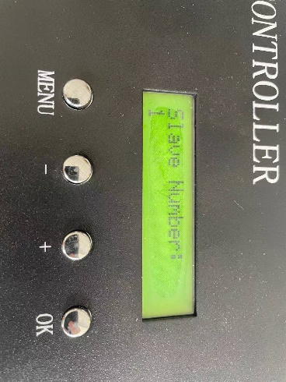

控制器设置完成
打开演播软件可以查看在控制器上的设置
Controller setup complete.Open the broadcast software to view the settings on the controller

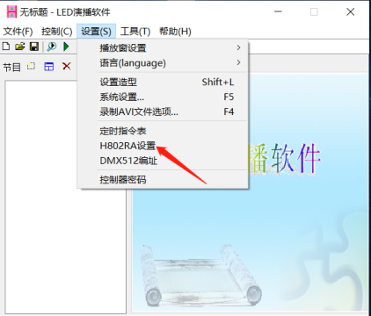
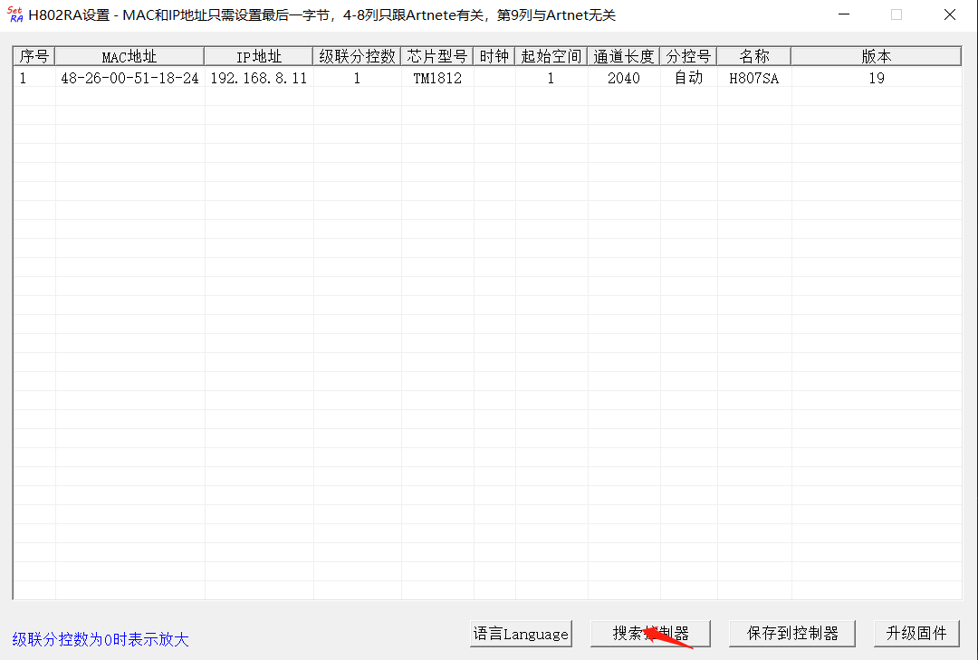

- MAC地址只允许修改最后一字节，一般不用修改
MAC address only allows to modify the last byte, generally do not need to modify
- IP地址前三字节自适应，就是说H807SA连接到电脑时，会变得与电脑IP地址前三字节一样，只可修改第四字节。使用路由器分几路网线时，直接连接路由器的分控需要设置不一样的IP地址，后面分控不用设置
The first three bytes of the IP address are adaptive, meaning that when H807SA connects to a computer, it becomes the same as the first three bytes of the computer's IP address, only the fourth byte can be modified. When the router is divided into several network lines, direct connection to the router's sub-control needs to set a different IP address, the sub-control does not need to set the following
- 级联分控数是指在使用ArtNet控制时，这一串共有多少个分控
Cascading sub-control number refers to the use of ArtNet control, this series of a total number of split control
- 芯片型号指使用ArtNet协议控制的芯片型号
Chip type refers to the use of the ArtNet protocol controlled chip type
- 时钟有三种选择：250K、500K和750K，只在使用ArtNet协议控制DMX512时有效
The clock has three options: 250K, 500K, and 750K, and is only available when using the ArtNet protocol to control DMX512
- 起始空间指在使用ArtNet控制时，从这个空间开始控制。例如，20个分控要通过路由器分成四路，每路5个分控，每路的第一个分控的起始分控号分别为1、6、11、16
Starting space refers to the space from which control begins when Artnet control is used. For example, 20 sub-control to be divided into four routes through the router, each route 5 sub-control, each route of the first sub-control starting sub-control number 1,6,11,16
- 长度是指在使用ArtNet控制时，每个端口控制点数；510表示分控的一个端口对应一个空间，1020表示一个端口对应两个空间，1530表示一个端口对应三个空间，2040表示一个端口对应四个空间
The length is the number of points each port controls when using ArtNet; 510 means one port for one space, 1020 means one port for two spaces, and 1530 means one port for three spaces, the 2040 represents four spaces for one port

2、madrix设置 madrix set up
运行MADRIX软件，按F4键，弹出“设备管理器”窗口。选择“Art-Net”标签，勾选Art-Net选项，打开启用，选中ArtNet Remote，单击“搜索”来查找Art-Net设备。
Run the MADRIX software, press the F4 key, and a “Device Manager” window appears. Select the“Art-Net” tab, check the Art-Net option, turn it on, select ArtNet Remote, and click search to find Art-Net devices

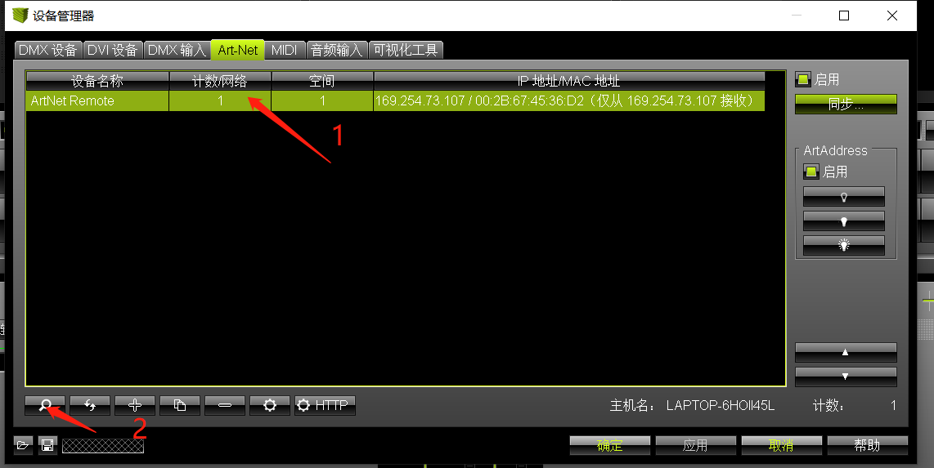

查找完毕后窗口如下图：
When the finished windows to refer below picture:
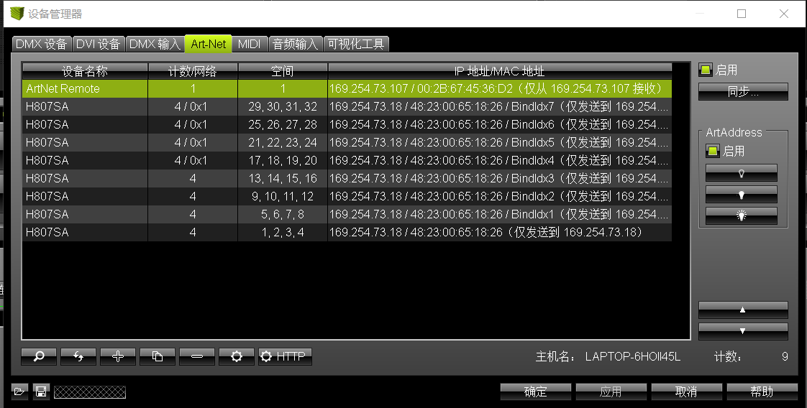
搜索完成后，将搜索到的所有设备全部选中点击同步弹出同步设置窗口，然后选中同步窗口的地址点击启用
When the search is complete, select all the devices searched and click sync to bring up the sync settings window. Then select the address of the sync window and click enable
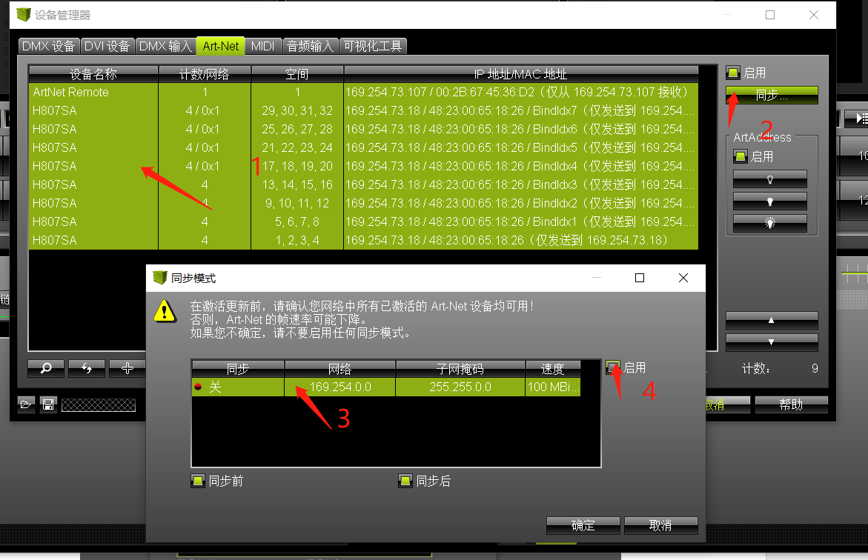

选择“DMX 设备”标签，选中所有H807SA端口，勾选右边的“启用”，单击下面的“应用”然后确定，使能DMX输出。
Select the“DMX devices” tab, select all H807SA ports, check“Enabled” on the right, click“Applications” below and OK, enable DMX output.
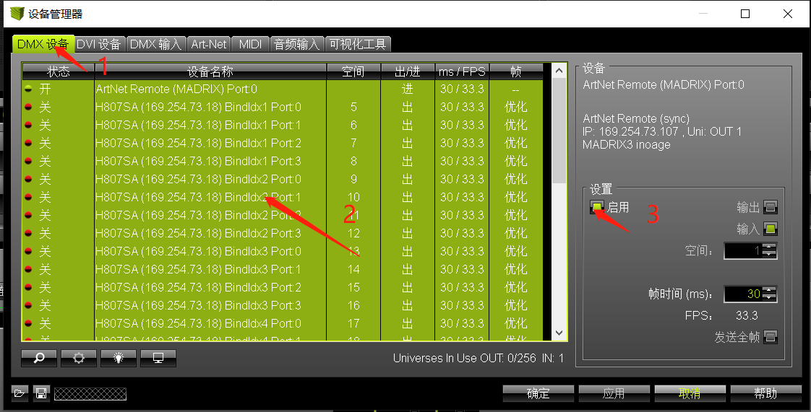

Madrix设置全部完成Madrix setup complete

