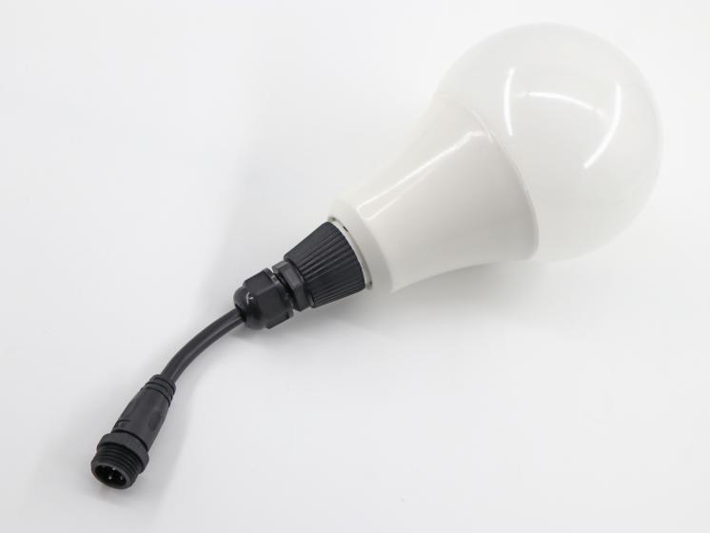
Parameter
Product Name | RL-95mm-ICRGB
Product size | Φ95mm*180mm
The LED type | epistar
The LED Quantity | 7 PCS
The beam Angle | 120°
The input voltage | DC24V
Color | RGB addressable
The IP rating | IP65
Rated power | 2W
Regular line length | 180mm
Product appearance | Ball shape
Lamp lifetime | ≥50000 hour
Working temperature | -40℃~60℃
Control | Dmx512 /SPI optional

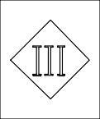
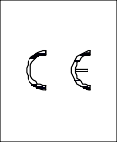
Product Advantages
Flreproof
Grade
V-0
Protect Grade
lP65
1. The appearance is exquisite and compact, and the spinning cone setting can effectively control the width of the lamps.
2. The bottom shell is made of flame-retardant ABS material, which is resistant to high temperature, and the light-transmitting surface is a UV-resistant and high-transmitting PC lampshade.
3. The light source adopts high-efficiency waterproof LED with long life, high brightness and pure color.
4. Applicable to 3D modeling lights, Internet celebrity halls, KTV decorations, supermarket 3D screens, hotel decorations.
5. Small size, light weight, exquisite appearance, suitable for indoor and outdoor use

