2019Ledplayer_K_v4.6 operation manual
V1.0

LedPlayer-k is our latest program playing software, compatible with WindowsXP, Vista, Win7, Win8, Win10. At the same time, if it works with online controllers will have unprecedented functions. This manual is intended for software beginners who are familiar with the use of software and hope to be helpful to beginners.

2019
Technical department
Shenzhen Singba Light Technology Co., Ltd
2019/1/1

Catalogue

Chapter One Software installation and uninstallation 3
一、Software installation 3
二、Software uninstallation 5
Chapter Two New Project 6
一、New project 6
二、Parameter setting 6
Chapter Three Layout 7
一、Layout interface: 7
二、Manual layout： 8
三、Automatic layout 8
四、Importing .dxf files： 10
五、Importing .cjb files： 11
六、Lock the layout 11
七、Hot key 11
八、Enable debugging 12
Charpter Four Parameter setting 13
一、Computer net IP setting 13
二、Network monitoring panel 14
三、Controller setting 15
Charpter Five Programs recording 18
一、Programs recording 18
二、Timed playback Loop playback 23
Charpter Six Other functions settting 24
一、Point-by-point correction 24
二、Online coding 25
三、Configuration parameters(Controller parameters, encrypt and decode) 26
Charpter Seven Computer boot software starts automatically 27
一、 Software setting 27
二、 Computer setting (Windows7/10) 27
三、 Computer setting (Windows XP) 29

Charpter One Software installation and uninstallation

一、Software installation
1. Package decompression
Right click on the archive and extract the file; generate a software folder.

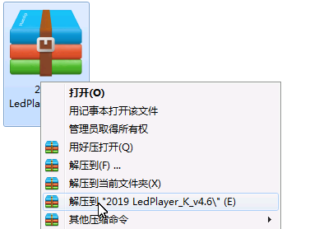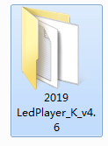
2. Double left click on the 2019 LedPlayer-K-v4.6 folder to open the folder.
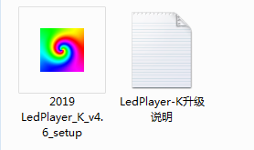
3. Double-click the setup file (setup) to start the installation.
① Select the installation language and click Next.
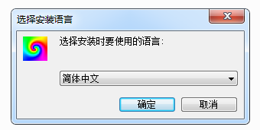
② Click NEXT;
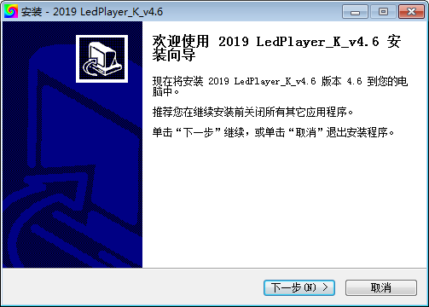
③ Select the installation save path and click Next.；
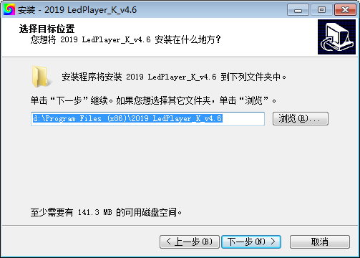
④ Select the start menu (effect file) storage path and click Next.；
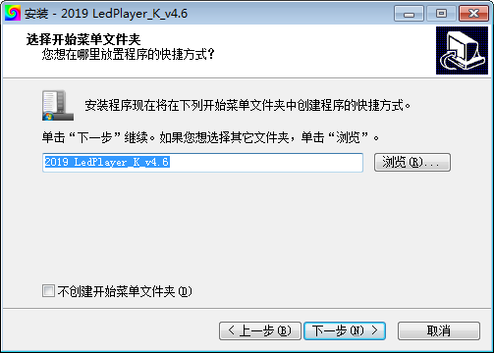
⑤ Select an additional shortcut and click Next；
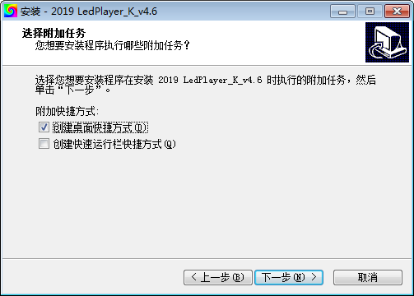
⑥ Check the previous settings and click Install；
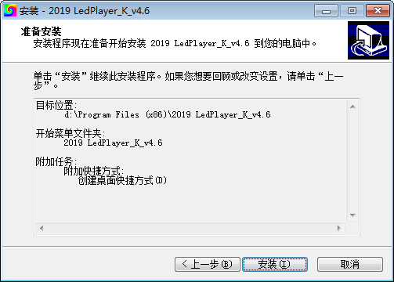
⑦ Software installation, please wait for the progress bar to complete
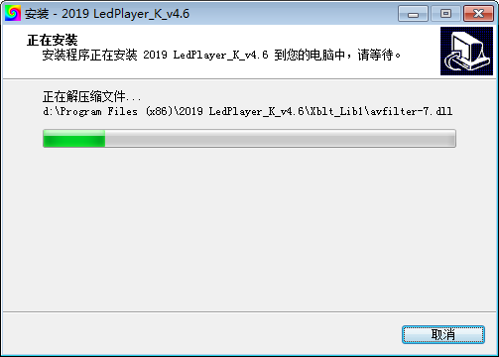
⑧ Finish the installation and click Done
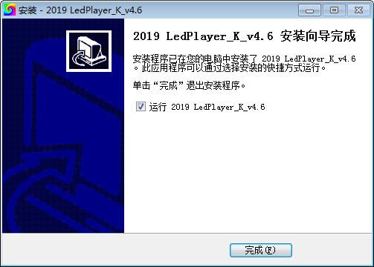

二、Sofetware uninstallation
1. Open "Control Panel" ==》 "Programs and Features" ==》 "Uninstall Software"
2. Left click to select 2019 LedPlayer-K-v4.6, right click on Uninstall.
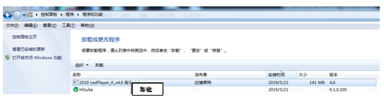

Chapter Two: New project

一、New project
The File (F) menu contains New, Open, and Exit.
New ------ choose to use when the new project first edits the effect;
Open ------- need to re-edit, preview, add, change the existing effect, by directly finding the save path of the original file
Open (you must find the save path of the original file, open the *.PJB file inside the file)
Exit ------- exit editing state, software is closed
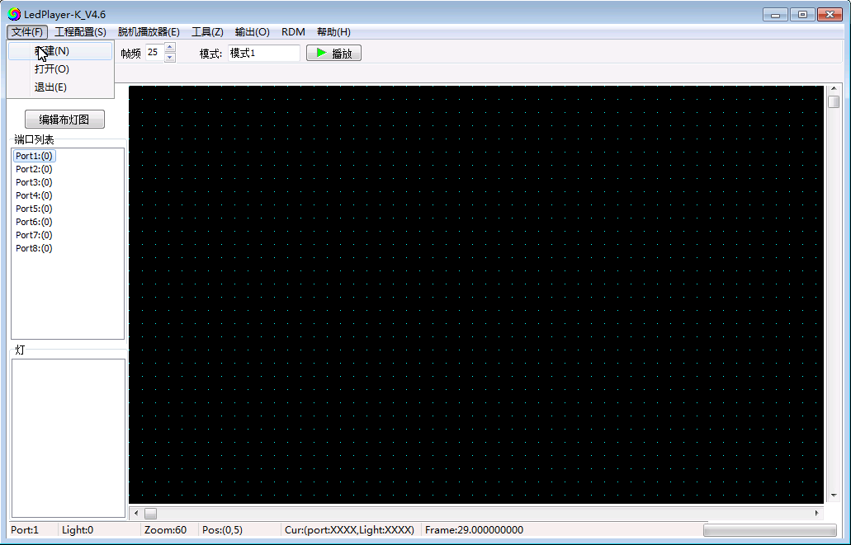

Click "File"; then click "New" to jump out of the new popup.

二、Parameter setting
In the new popup window, after setting each selection, click OK.
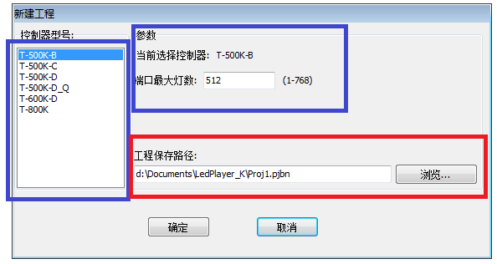
Note 1. Controller model selection: Online controller model
Note 2. The maximum number of loaded lamps on the controller port does not exceed the range in parentheses.
Note 3. Project save path: It is the path where the source file is saved. You can click “Browse” to re-select/set the save path. If you do not change the save path, the software will delete the previous project empty folder, and then complete the new.

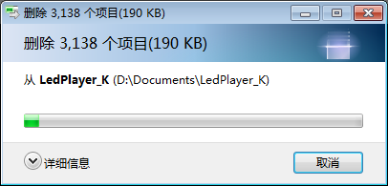

Chapter Three: Layout

一、Layout interface
1. Click the "Edit Light layout" on the layout interface.
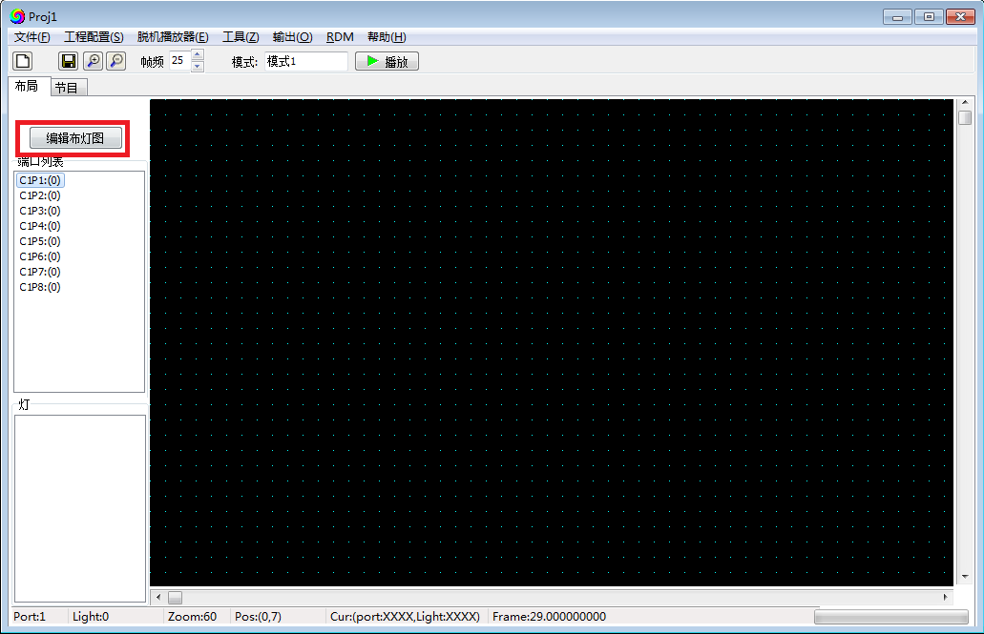
2. Enter the light layout interface

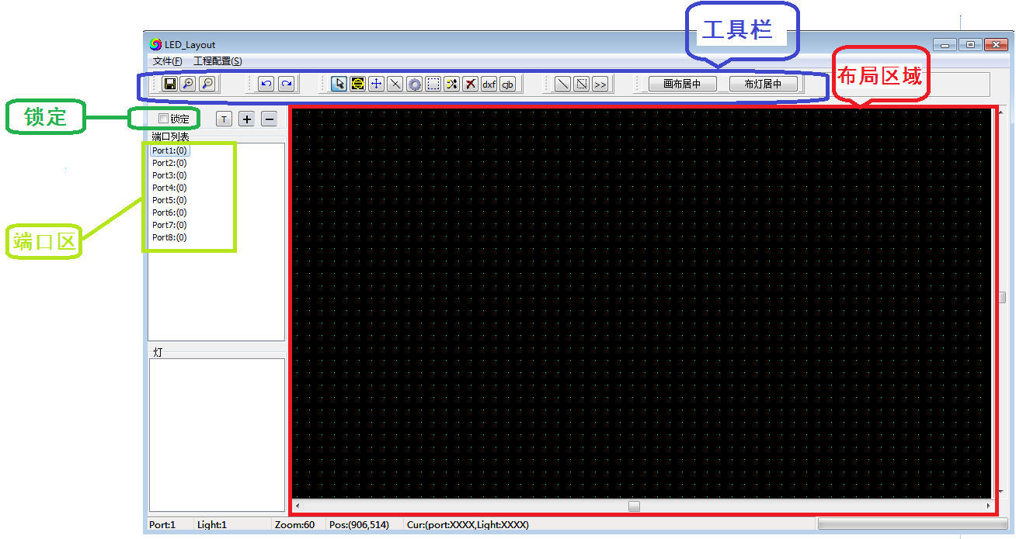
Layout area: the black zone, layout and operation.
Port Area：Display the layout port conditions, can click to display the port/pixels location.
Toolbar: Operation tool list, the definiation name of each tool as below:

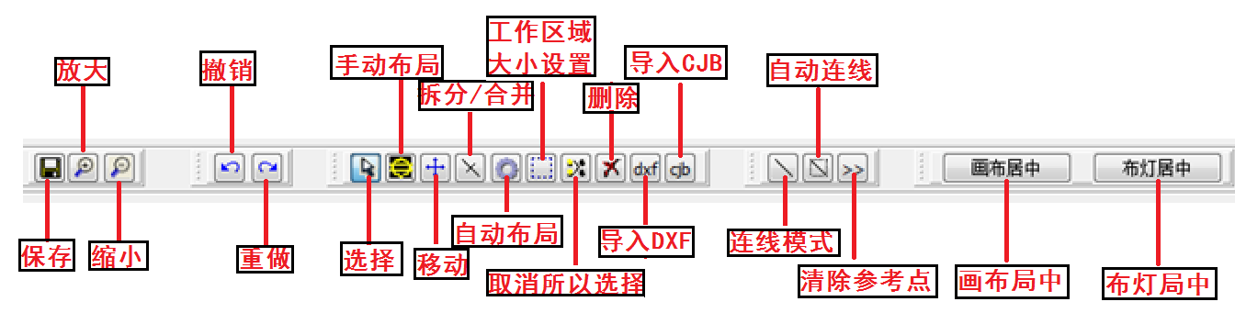

The lighting diagram can be implemented in any of the following four ways, as follows:

二、Manual layout:
For profiled, simple fixture layouts, manual layout is available.
1. Click the "Manual Layout" button
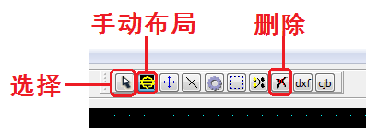
2. Clicking on the layout area with the left mouse button will generate a pixel; or you can press the left mouse button to drag in the layout area and consecutive pixels will appear on the canvas.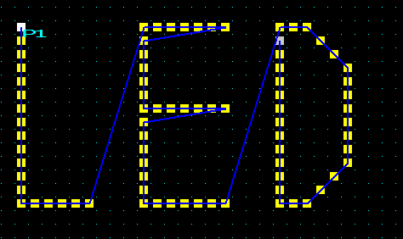

3. For the wrong layout light, click the "Select" button; click / box to select the wrong light (the light will turn red), click the "Delete" button to delete.
4. Complete the layout, click "Lock", then close the page and return to the main interface.

三、Automatic layout:
Automatic layout is generally used when editing test programs or when the actual fixtures are installed in a regular arrangement;
1. Click the “Automatic layout” button：
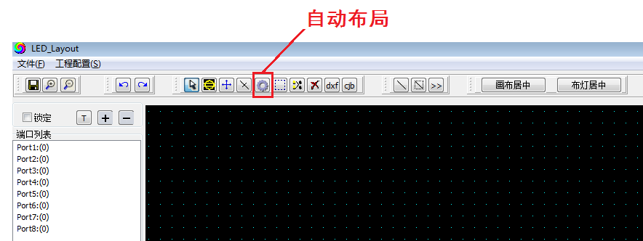
2. After selecting "Auto Layout", an "Auto Layout" dialog box will pop up to set the wiring connection mode, the width/height of the cloth, and the maximum number of lights on the port:

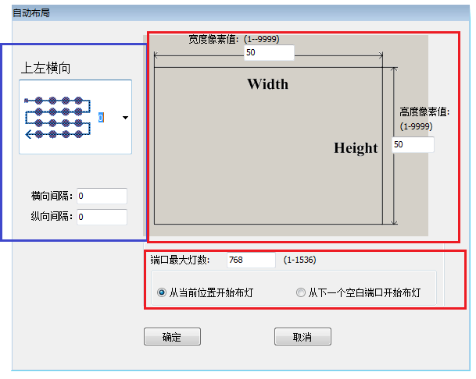
Note 1: The wiring connection mode, the starting point of the port and the line direction (Z-shaped/S-shaped).
Note 2: The width/height set the number of length and width pixels of the rectangular layout should be the same as the actual cloth.
Note 3: The maximum number of lights on the port is combined with the number of long and wide pixels.
Example 1: The upper left horizontal direction, the width pixel point 32, the height pixel point 32, and the maximum load port of the port are 512 points. The layout is as follows:

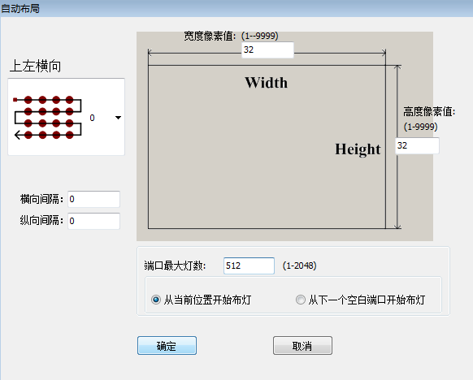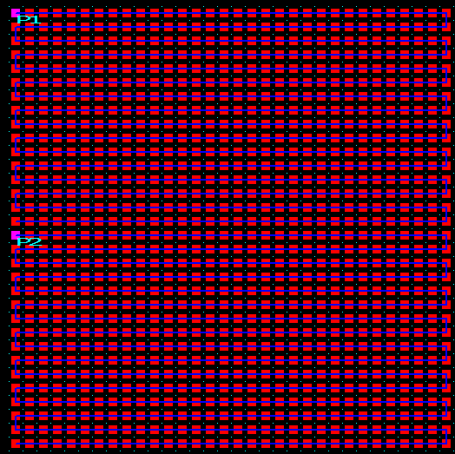
例2：上左横向、宽度像素点32、高度像素点32、端口最大带载1024点，布局图如下：
控制器端口P1，端口带载1024。
Example 2: The upper left horizontal direction, the width pixel point 32, the height pixel point 32, and the maximum port load of 1024 points, the layout is as follows:
Conctroller port P1, support 1024 pixels.
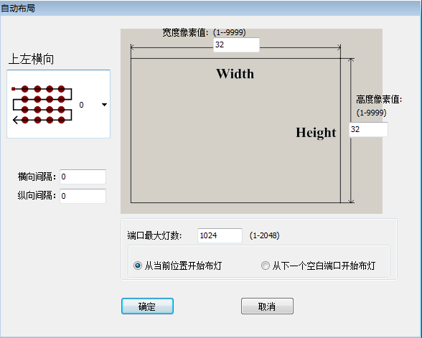
3. For the wrong layout light, click the "Select" button; click / box to select the wrong light (the light will turn red), click the "Delete" button to delete.
4. Complete the layout, click "Lock", then close the page and return to the main interface.

四、Import .dxf files
Import the tiled diagrams that have been connected in CAD or CorelDRAW directly:
1. Click the dxf icon and select the .dxf lighting diagram to import.

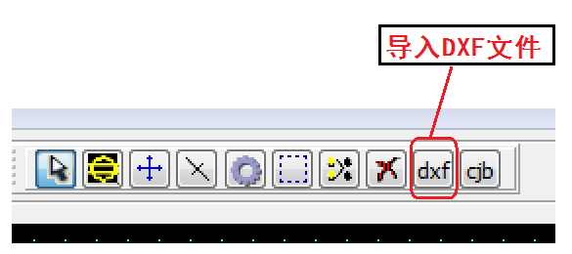
2. The software jumps out of the selection pop-up window and selects the import mode; after importing, the number of imported lights will be displayed. If the displayed light points are not connected, the dxf drawing needs to be modified until all the imports are successful.

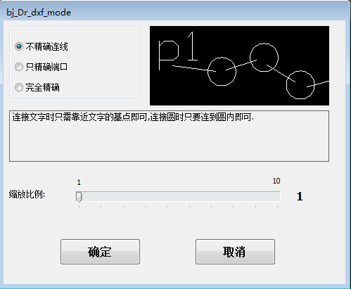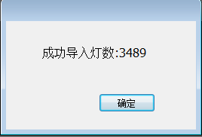

① Inaccurate continuous: Just connect the text to the base point of the text, just connect the circle to the circle
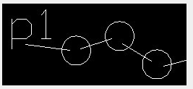
② Accurate port only: When connecting text, you must connect it to the base point of the text. Just connect the circle to the circle.
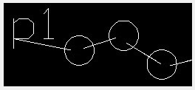
③ Fully accurate: the text must be precisely connected to the base point of the text, and the circle must be precisely connected to the center of the circle.
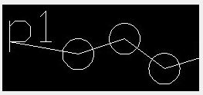
Remarks
1. Importing a CAD .dxf file requires that the diameter of the circle inside the CAD be greater than 1 mm, and the controller port must be represented in lowercase single-line text. In the single-port controller, P1 represents the first controller, P2 represents the second controller, and so on; in the 8-port controller, P1 represents the first port of the first controller, and P2 represents the first controller. Port.........P9 represents the first port of the second controller, and so on;
Note
2. The X and Y of the ellipse in the CorkDRAW .dxf file must be greater than 10.0mm*10.0mm. You need to use the pen tool when connecting. After the connection is completed, you need to save it as a .dxf file.
3. For the wrong layout light, click the "Select" button; click / box to select the wrong light (the light will turn red), click the "Delete" button to delete.
4. Complete the layout, click "Lock", then close the page and return to the main interface.

五、 Import .cjb files
The cjb suffix file is the cable lighting software independently developed by our company. The biggest advantage is that after the layout of the lamp is arranged, we can use our software to drag and connect. It is more convenient and quicker compare with the CAD or CorelDRW one point to one point connection, especially for the special shaped lights.
1、Click on the cjb icon and select the .cjb to import directly:

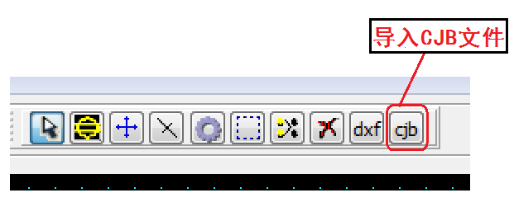
2. For the wrong layout light, click the "Select" button; click / box to select the wrong light (the light will turn red), click the "Delete" button to delete.

六、Lock the layout
1. Lock the light layout: After the lighting diagram is OK, click on the lock, the lock or the light pattern will not change. If you need to change the layout, please unlock the lock.
This step is to prevent the lamp diagram from changing after the lamp diagram is determined.
2. Complete the layout, click "Lock", then close the page and return to the main interface.
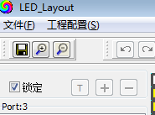

七、Hot key
Shortcut operations that can be used during layout
① CRTL+A : Select all (all fixtures and connections on the canvas in the layout)
② CRTL+C : Copy (copy selected fixtures and connections)
③ CRTL+X : Cut (cut selected fixtures and connections)

八、Enable debugging
1、Select Enable Debugging function, and you can debug the luminaire point by point after selecting.
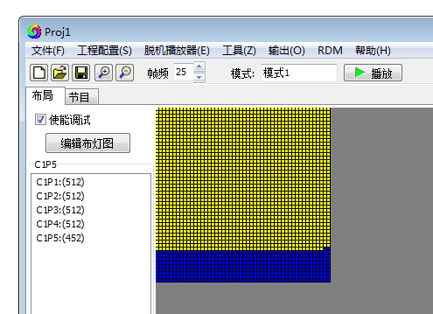
2、Point-by-point debugging
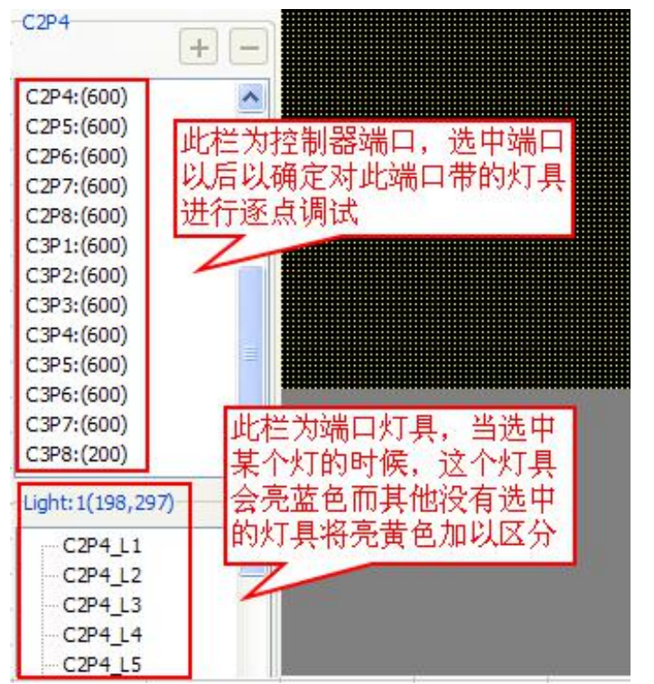
。Note 1: This function is especially useful when using DMX 512 luminaires. When the engineering luminaire is written with an address, you can use this function to check if the address of the luminaire is correct.
Remark 2: When the lamp has a misalignment, you can use this function to compare whether the installation diagram of the fixture is consistent with the layout diagram on the computer, or whether has difference in the number of lamps.

Charpter Four Parameter setting

一、Computer network IP settings
1. Enter the computer network and sharing center
Method 1, A. Right click on the network connection icon in the shortcut bar of the computer desktop, and then click "Open Network and Sharing Center"
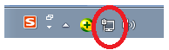

Method 2. Click on "Network and Internet" in the control panel to enter the network and sharing center.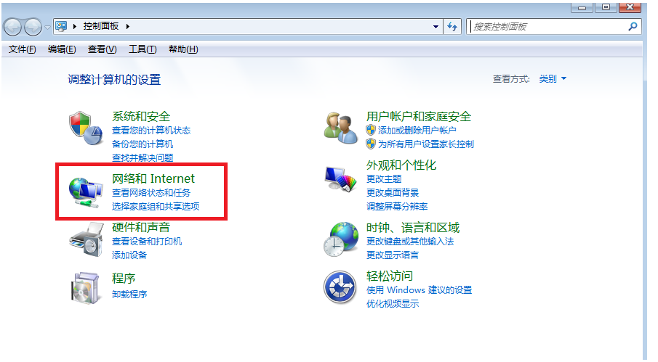

2. Go to Change adapter settings
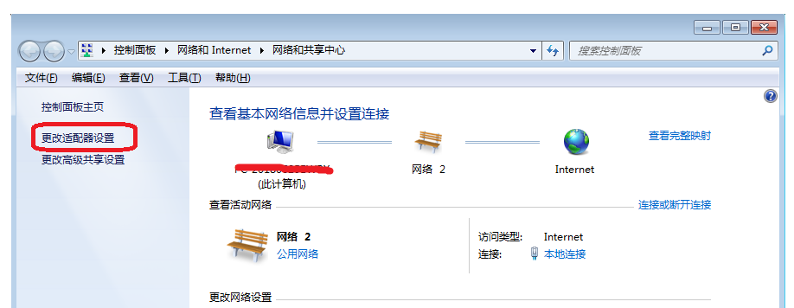

3. Click Change Adapter Settings to go to Network Connections
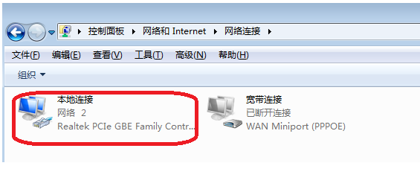

4. Right click on the local connection and click on the right-click menu "Properties"
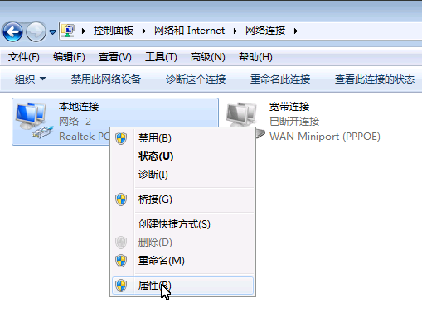

5. Click <Internet Protocol Version 4 (TCP/IPV4)> 6.Change IP address
IP：192.168.60.8
Subnet mask：255.255.255.0

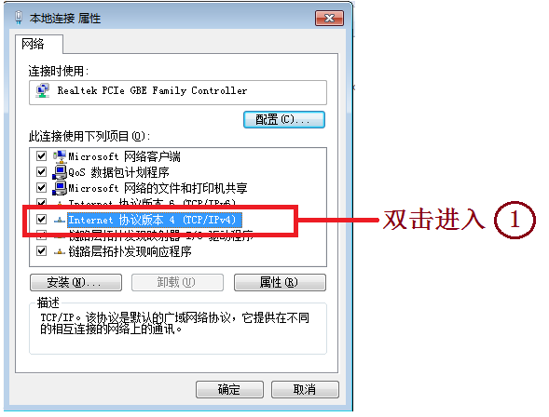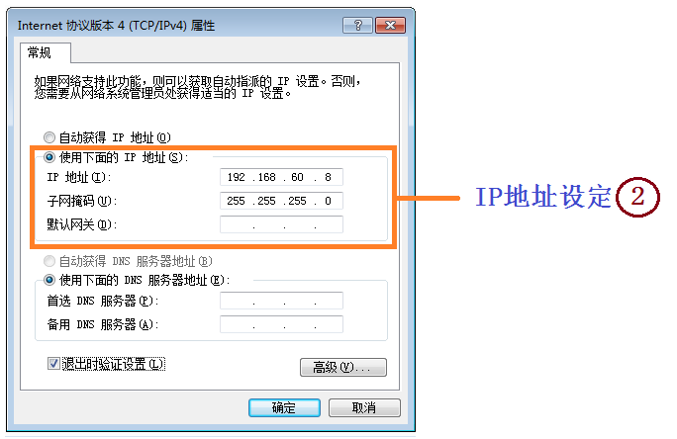

二、Network monitoring panel
1. “Program Interface”, click “Network Monitoring Panel”, and pop up the pop-up window as shown on the right:
2. Controller C1/C2/......; The module displays red as disconnected; yellow indicates normal connection; green indicates normal playback.
3. The yellow display is normal, the controller and the computer are connected normally, and the next step can be performed; otherwise, it is necessary to check the connection status between the controller and the computer.

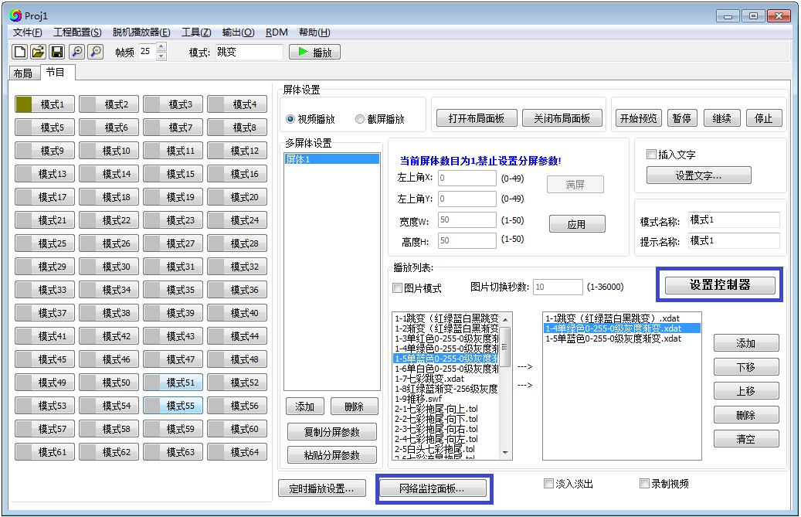

三、Controller setting
1. "Program Interface", click "Set Controller", pop out the pop-up window as shown below:
① Hardware setup page
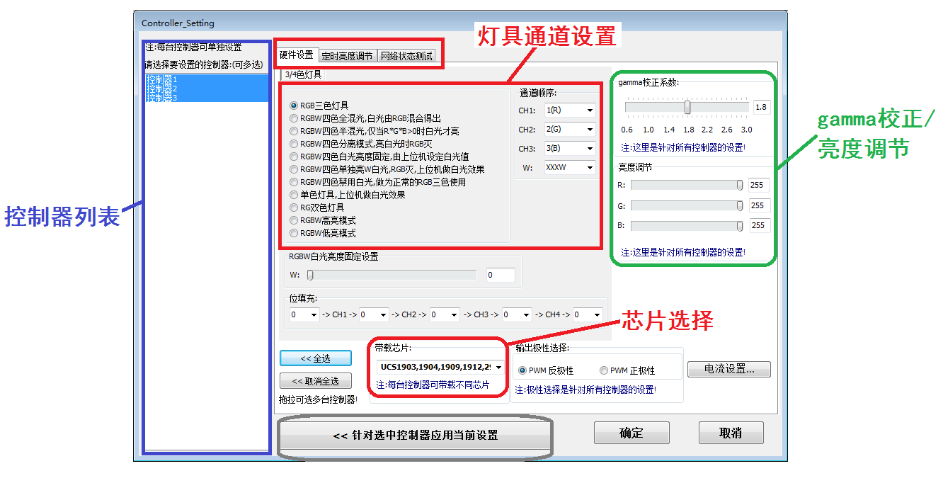
1. Select the controller and select the controller in the “Controller List” on the left to set it (if the controller is equipped with the lamp IC and the channel is the same, select the controller)
2. Set the lamp channel mode, channel sequence, on-load IC model, brightness, gamma value correction, etc.
3. Click "Apply current settings for selected controllers" to confirm the settings.

② Timing brightness adjustment page:
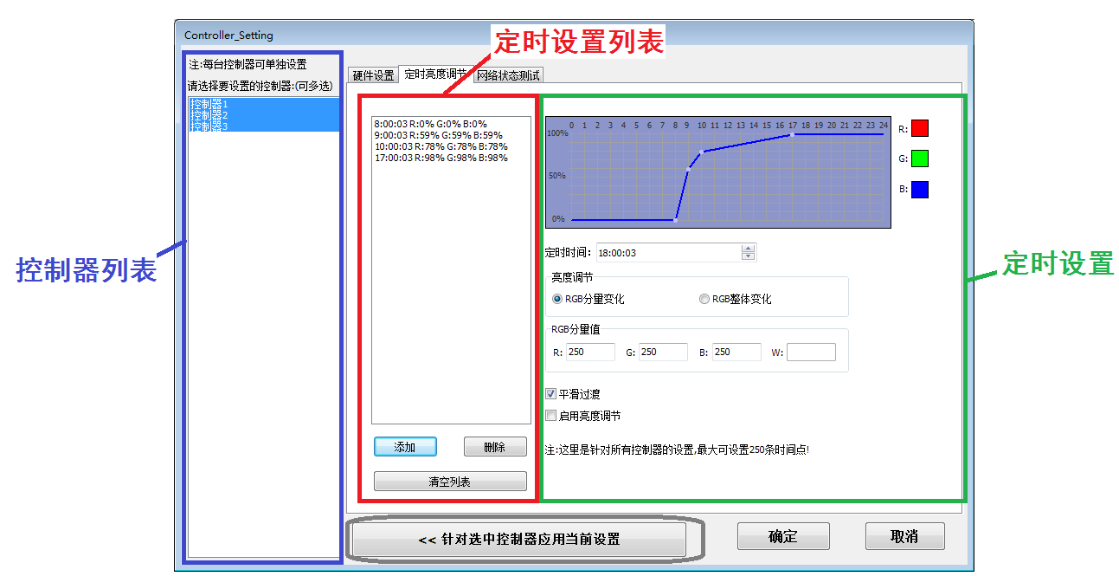
1. Select the controller and select the controller in the “Controller List” on the left to set the timing (can be set for a single controller or all controllers)
2. Set 00:00---23:59 any time period, the brightness of each color lamp of the lamp; after the setting is completed, there will be setting items in the setting list and.
3. Click "Apply current settings for selected controllers" to confirm the settings.
③ Network status test：
As a connection test data packet loss rate reference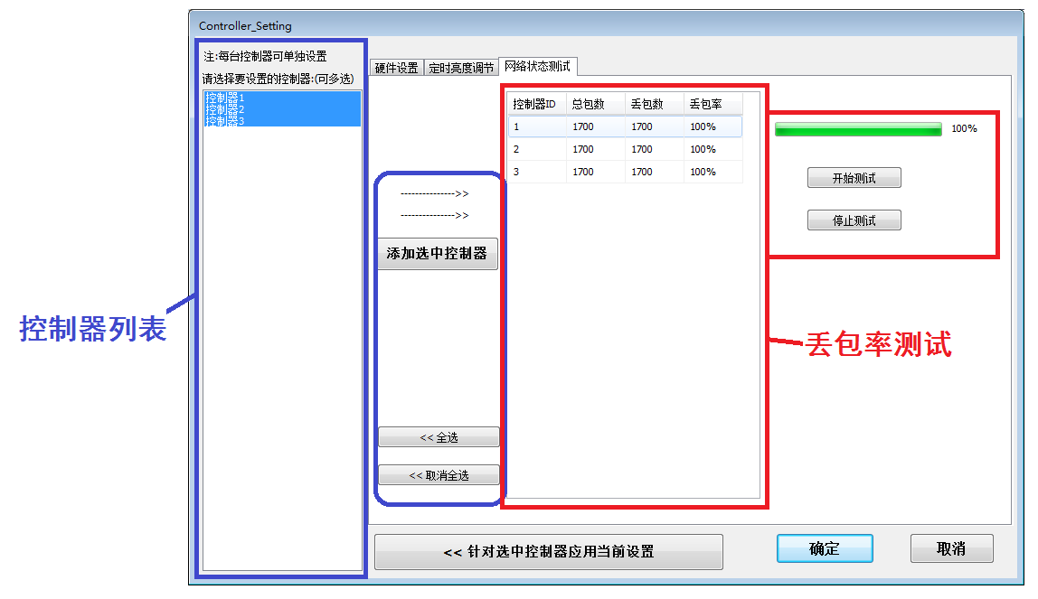
1. Select the controller, select the controller in the "Controller List" on the left, click and add to the test list on the right.
2. Click to start the test, the computer sends a signal to the controller through the software, the controller will feedback the resulting signal; the two signals can be compared to test the packet loss rate.
3. The packet loss rate is 0, indicating that the connection status is good. If the packet loss rate is less than 1700, the connection is abnormal. The packet loss rate is 1700, indicating that all the lost connections are abnormal.
4. Click "Apply current settings for selected controllers" to confirm the settings.
2. DMX512 luminaire online address and parameter setting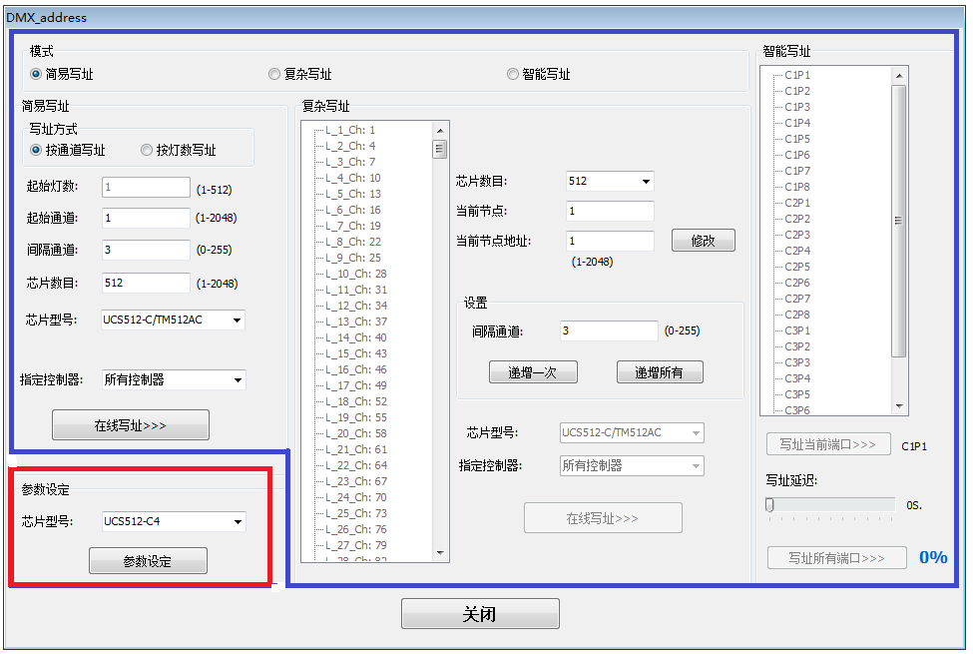
1. Simple address: For the installation of the lighting channel, you can use simple address
2. Complex write address: Inconsistent fixture channels installed for a single controller port, complex write address can be used
3. Intelligent address writing: Inconsistent lighting channels installed for multiple controller ports, intelligent write address can be used
3. Parameter setting
1. Special function settings for each type of DMX512IC;
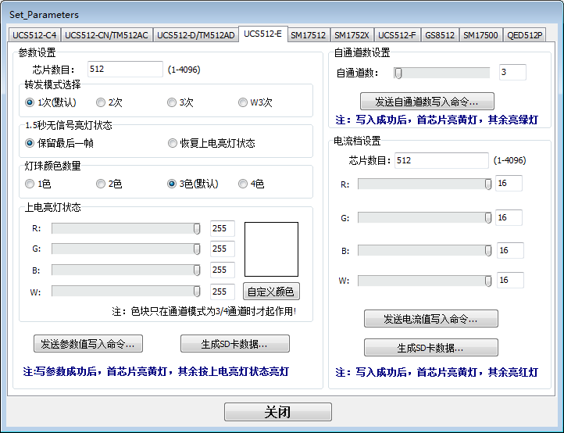
2. After the parameter is set, the controller/chip can be written online; the .Led file can also be generated and downloaded to the SD card, and the SD card is written on the main control.

4. Complete the parameter setting and return to the program interface recording effect playback.

Charpter Five Program Recording

一、Program Recording
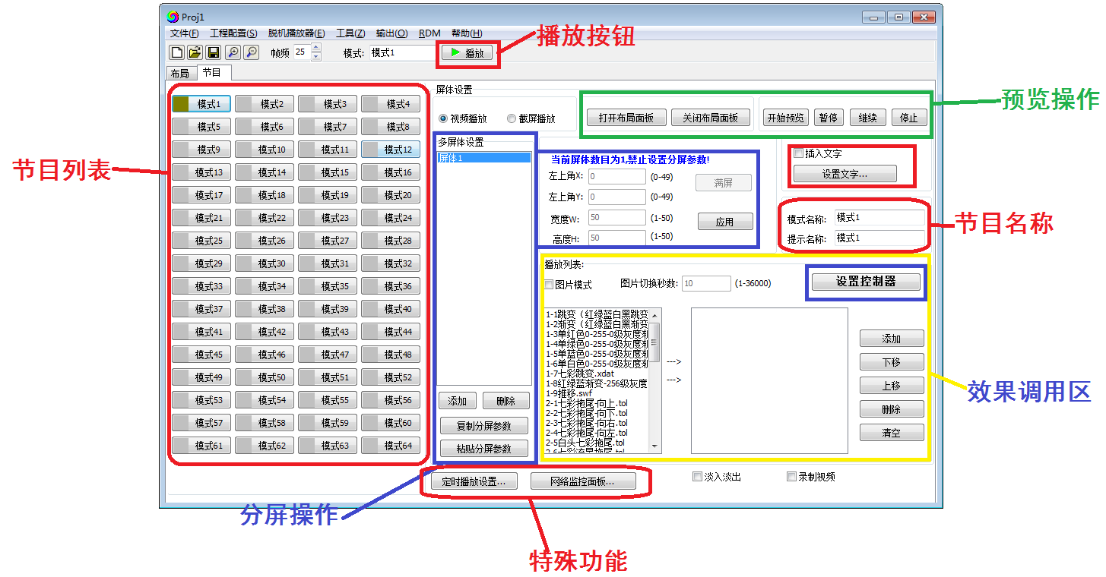
1. Program list and program name
1. Program list: There are 64 modes to create 64 separate effects, each mode can add call effect file / video file / picture / screenshot effect.
2. Program Name: Click on any mode and change the name and prompt name at the program name. As shown below:
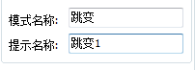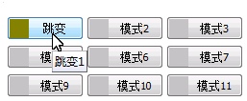
2. Effect Recording----Video Playback
1. The software library file in the effect call area: the built-in part of the software effect can be called; double-click the effect, the effect will appear in the right list box; click to start preview to preview the effect in the layout interface.
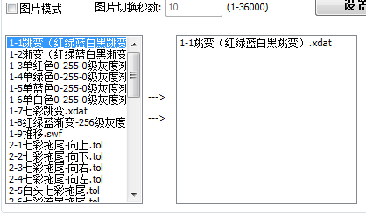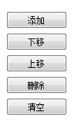

Click Start Preview to preview the effect on the layout interface;
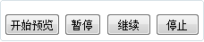
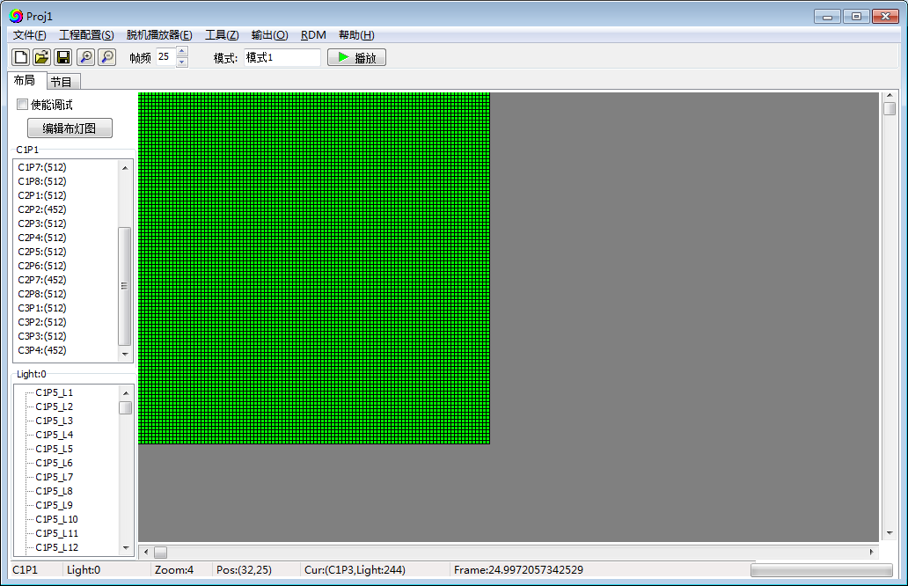
Click the play button and the computer screen will play.
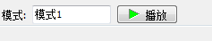
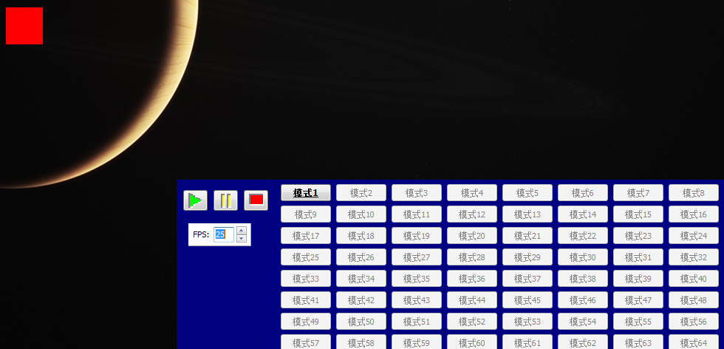

2 . Add video file: Click Add in the operation button on the right side of the effect call area to call the video file (SWF/AVI/MP4 format video file), the video name will appear in the right list box, click the play button to have the computer screen The effect is played.
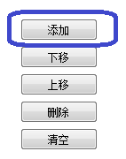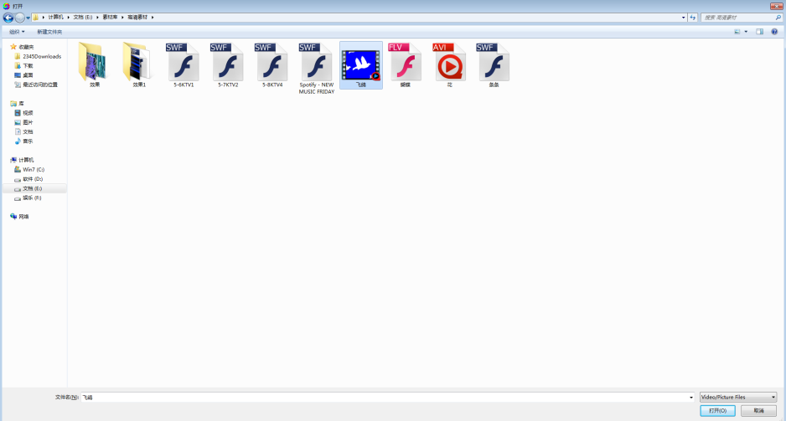

3. Play picture: Check the picture mode, click Add in the operation button on the right side of the effect call area, you can call the picture, the picture name will appear in the right list box; set the switching time, then click the play button to play the picture on the computer screen.
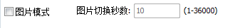

3. Effect Recording----Video Playback-Split Screen
1. In the video playback interface, use the split screen function to split the layout to play different videos.
2. Click “Add”. The spilt screen list will appear split screen 1/ spilt screen 2. The screen on the right side will display the coordinates of the upper left corner of the display body, the width of the screen, and the high pixel.
3. Drag the screen to change the position of the screen, and stretch the screen to expand the size of the screen; you can also change the position, width, and height of the screen by changing the coordinate values in the split screen parameters.
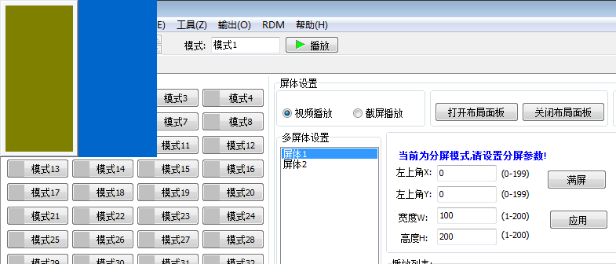

4. Click on screen 1 and select the effect call; select click on screen 2, select to call other effects, click on the “Play” button, the display is as follows:
4. Effect Recording----Screenshot Play
1. Click to select the screen capture, and then click to open the layout panel, you can observe the size of the fixture, intercept the coordinates of the upper left corner of the screen (0,0); you can click the layout panel to move the panel to any position, the coordinates of the upper left corner will change accordingly.

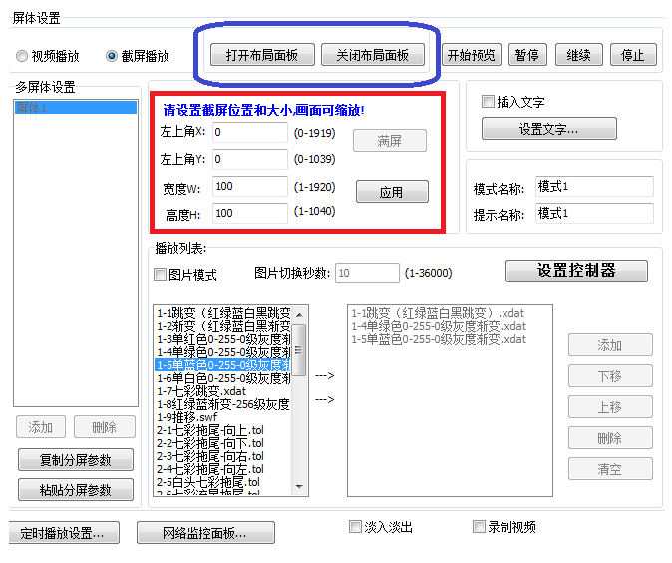
2. Click the Playback Button, intercept computer display content.

5. Text indicator
① Enable text input: Check the ”Insert text” function to be effective.
② Click “Set text” to enter the edit page.
③ Enter text in the text box, select monochrome/full color text; horizontal scroll/vertical scroll (different directions, different text layout directions).
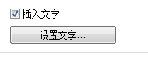
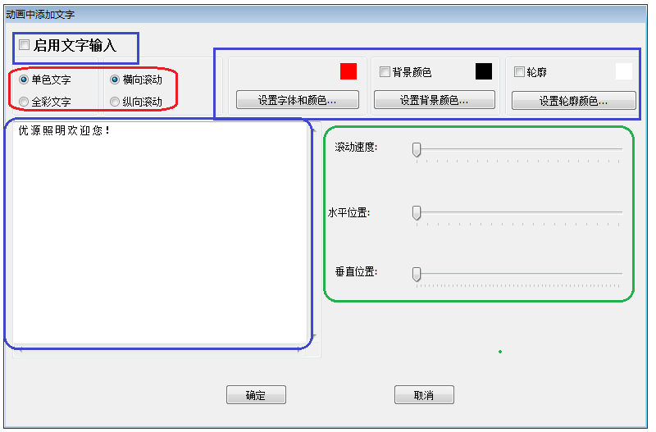
④ Text color/font settings ⑤ Background color / outline: check the box is valid, the color is optional

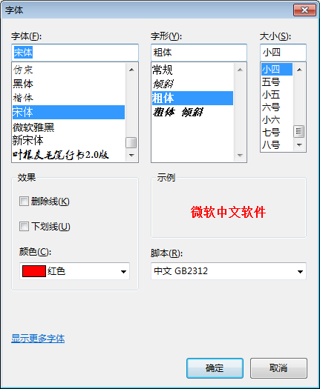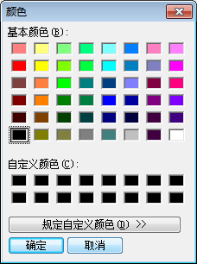

⑥ Text scroll speed adjustment / horizontal position adjustment / vertical position adjustment
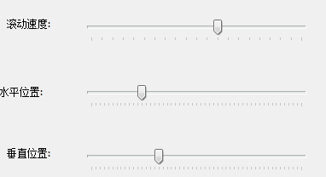
⑦ The program interface records the animation effect, and the text will be automatically loaded into the effect, as shown below.

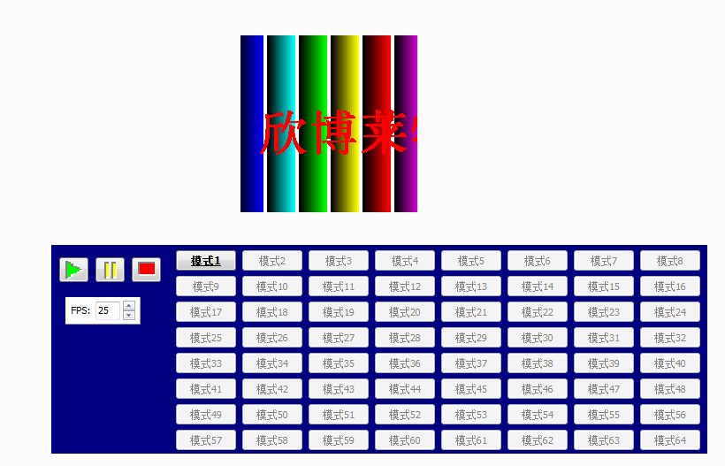

二、Timed playback Loop playback
1. Timing setting interface
1. Click on the "Timed Playback Settings" in the lower middle of the program interface.
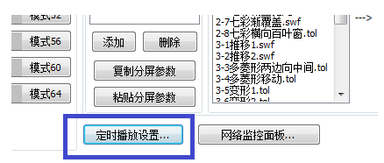

2. Timing playback(click the box is effective)
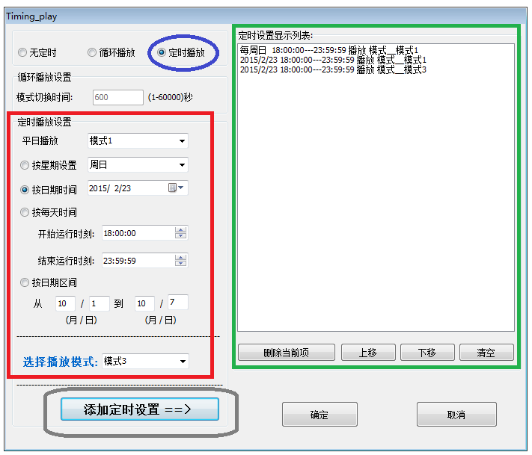
①Click the timed playback selection(The timed playback function will change from gray to black)
②Time settings
（1）Setting timed playback-playback mode;
（2）Setting the timed items(By week/date/moment/holiday)
Note: For multiple timing plans, the priority is the highest in the list, and the others are lower.

3. Loop playback(select the box is effective)
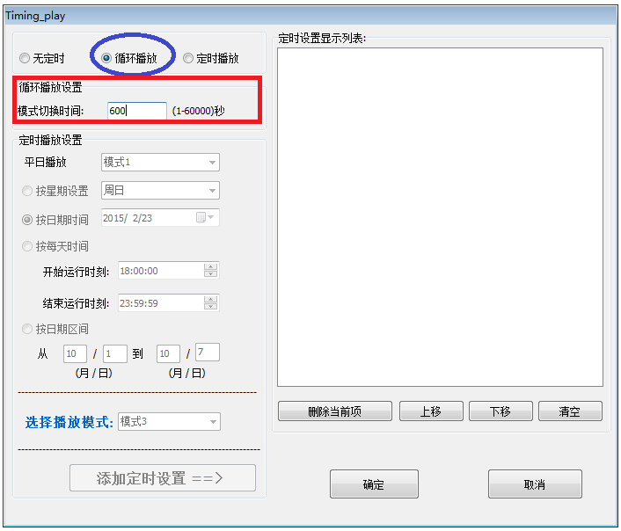
①Click the loop playback selection(the loop playback function from gray to black)
②Time switch setting
（1）设置循环播放切换时长；

Charpter Six Other functions setting

一、 Point-by-point correction
Click "Point by Point Correction" in "Project Configuration"
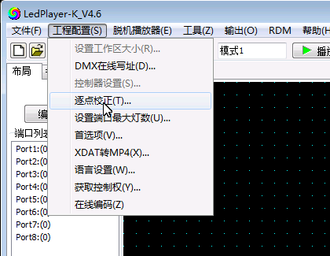
1. Set brightness for single controller/single port/single pixel.
2. Click the “Point by Point Correction” button to enter the point-by-point calibration interface.
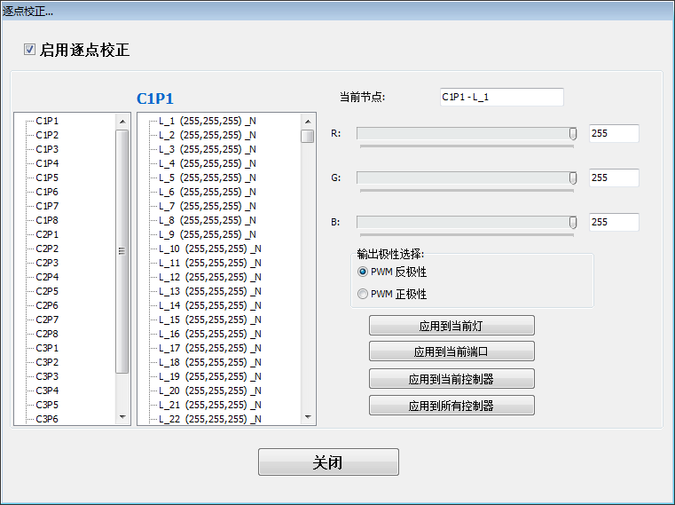
3. Setting the parameter
（1）Select a controller/port
（2）Select a pixel
（3）Setting the red, green and blue brightness of the pixel
（4）Click the application(Complete the setting)

二、Online coding
Click the ‘’online coding ’ in the “project configuration”.
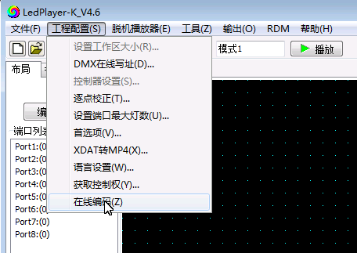
1. Connect the computer and controller with net cable(Adopts the international standard TCP/IP net agreement, the network cable is 568B straight through).
2. Click “Online coding.
3. Setting controller Starting number, click the number button to start numbering.
4. Complete online coding, test controller number.
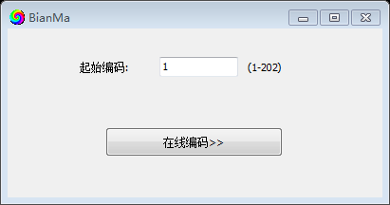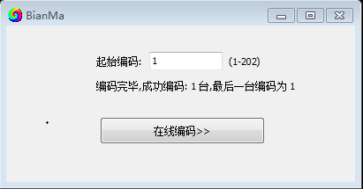

三、 Configuration parameter(Controller parameter, Encrypt decode)
Configuration parameters: used for controller display model modification, controller encryption and decryption
1. Click “Tool” and then configuration setting
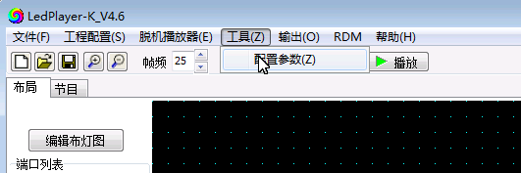
2. Enter the password(xb)
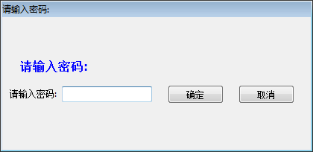
1.3 Configuration parameter interface (blue box for controller display model modification / red box for controller encryption and decryption)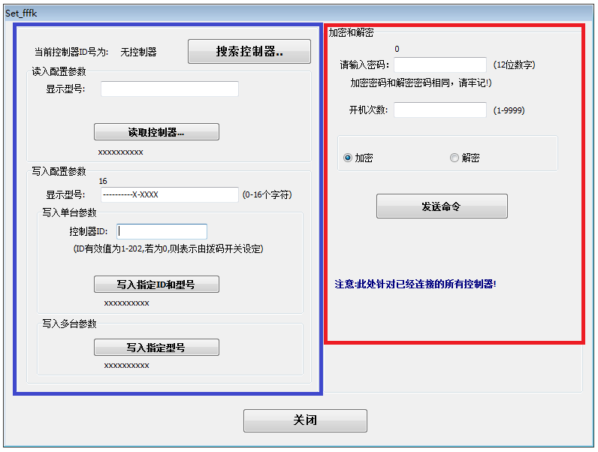
1.4 Controller display model modification
① Search the controller and check that the controller is connected to the computer;
② Read the controller, the controller currently displays the model and content;
③Fill in the model content that needs to be displayed by the controller; select the controller number to be written;
④ Write (modify) the controller display model.
1.5 Controller encryption
① Enter the 12-digit password and the number of bootes, and click on Encrypt.
② Online write command
1.6 Controller decryption
① Enter the 12-digit password and click on Decrypt.
② Online write command

Charper Seven Computer boot software starts automatically

一、 Software setting
Set the project file to automatically load and run when the software starts.
- program production
① New=》layout =》program;
② Normal program production, recording effect mode.
2. First Choice
① Click on "Preferences" in "Project Configuration"
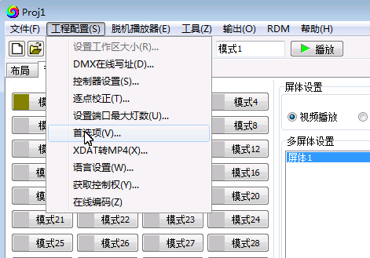
② Jump out of the preferences pop-up window, load the path of the program (pjbn file); check "Automatically load project files when the program starts"
③ Click the "Confirm" button to complete the setup.
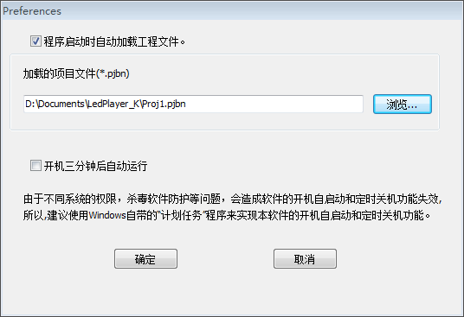

二、 Computer setting (Windows7/10)
Set the LedPlayer-k.v4.6 software to automatically load and run when the computer starts.
1. Click "Start" in the lower left corner of the computer - "All Programs" (take Windows 7 as an example)
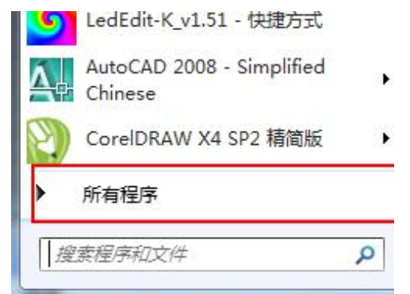
- Right click on "Start" and select "Open"
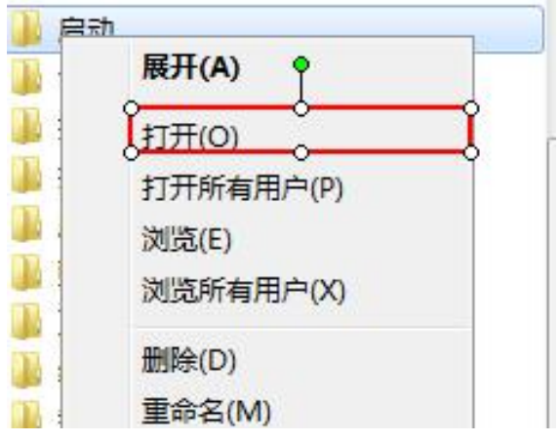
3. As shown below, there is currently no self-starting project set manually:
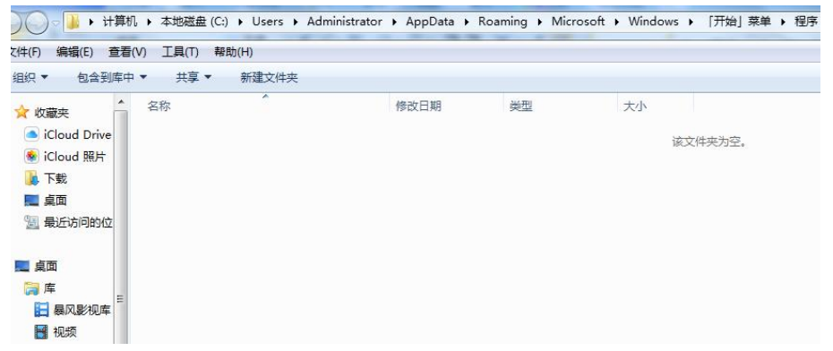

4. Copy the shortcut for "LedPlay-K":
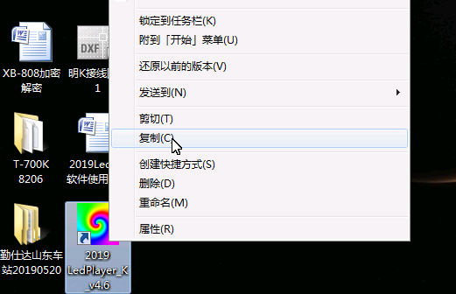

5. Paste the shortcut below the "Startup" folder:
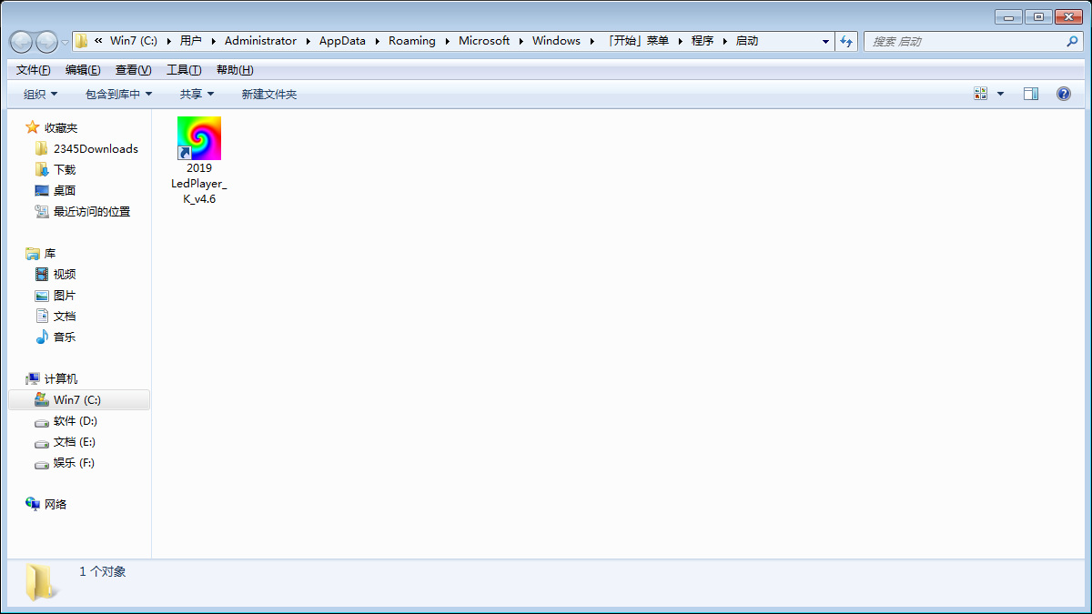

6. Click: "Restart" verification results:
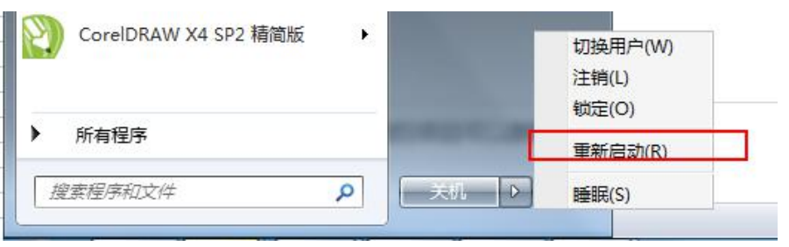

三、 Computer setting (Windows XP)
1. Start----All Programs---Accessories---System Tools---Task Schedule
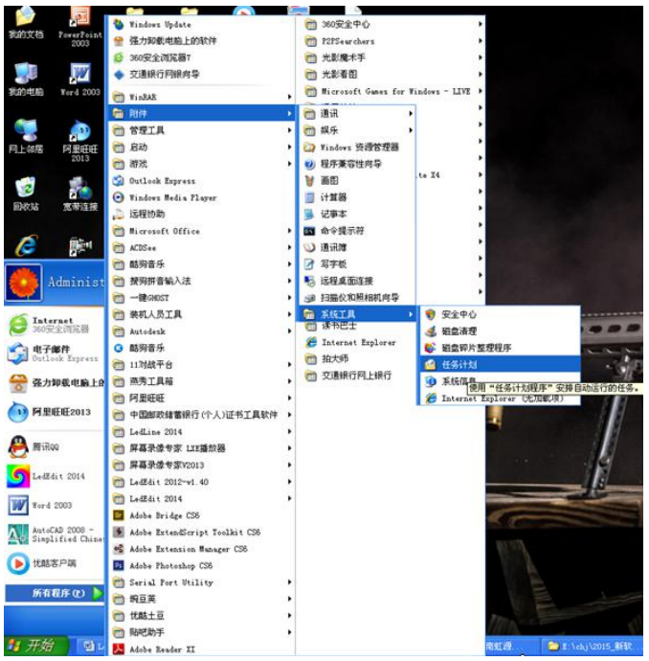

2. Click Add Task Plan;
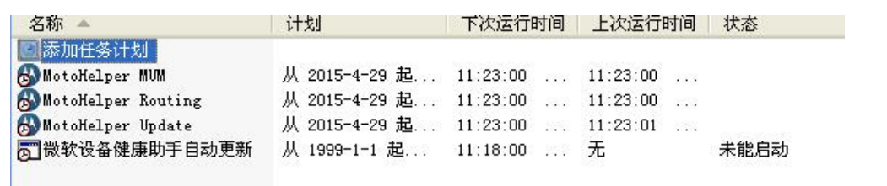

3. Click the NEXT;
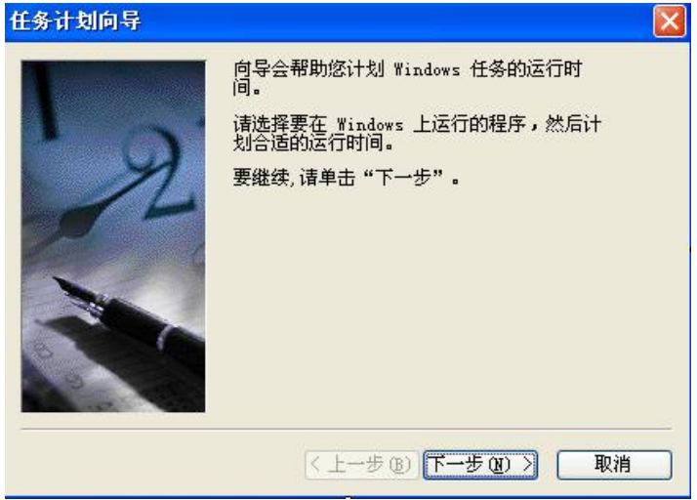

4、Browse and add LedPlayer-k_v4.6.exe
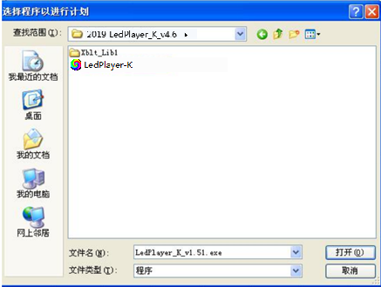

5. Select the start setting
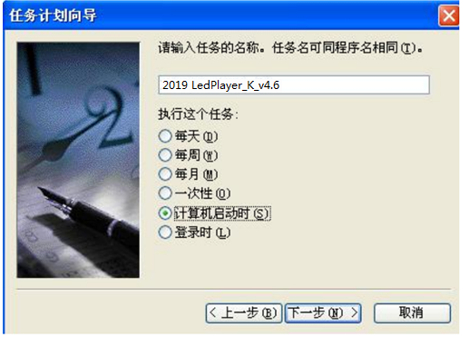

6、Enter the login password (if you don't need this step to skip it), click Next to complete.