2019LedEdit-K operation manual
V1.0

LedEdit-k v4.6 is our latest program editing software, compatible with WindowsXP, Vista, Win7, Win8, Win10. At the same time, it is perfectly combined with mainstream design software Auto, CAD, CoreIDAW, Flash, and provides a powerful and convenient software for LED lighting. This manual is intended for software beginners who are familiar with the use of software and hope to be helpful to beginners.

2019
Technical department
Shenzhen Singba Light Technology Co., Ltd
2019/1/1

Catalogue
Chapter One Software installation and uninstallation 2
一、Software installation 2
二、Sofetware uninstallation 4
Chapter Two New Project 5
一、New project 5
二、Parameter setting 5
Chapter Three Layout 6
一、Layout interface 6
二、Manual layout 7
三、Automatic layout 7
四、Importing .dxf files 9
五、Importing .cjb files 10
六、Hot key 10
七、Lock the layout 10
Chapter Four Program recording 11
一、Programs 11
二、Animation 12
三、Customize 17
四、Split screen 19
Chapter Five Engineering output 20
一、Engineering parameter setting 20
二、Effects download 24

Chapter One: Software installation and uninstallation

一、Software installation
1. Package decompression
Right click on the archive and extract the file; generate a software folder.
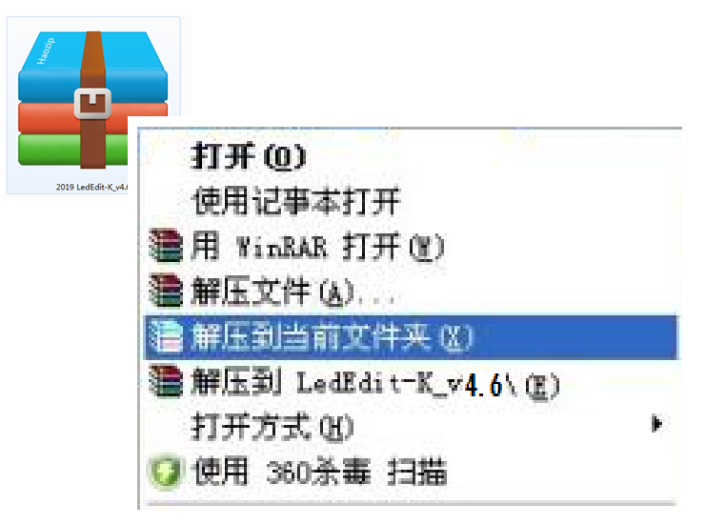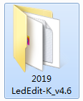
2. Double left click on the 2019 LedEdit-K-v4.6 folder to open the folder.
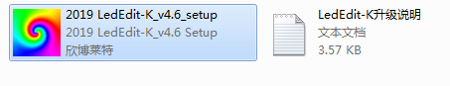
3. Double-click the setup file (setup) to start the installation.
① Select the installation language and click Next.
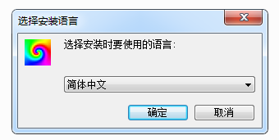
②Click NEXT；
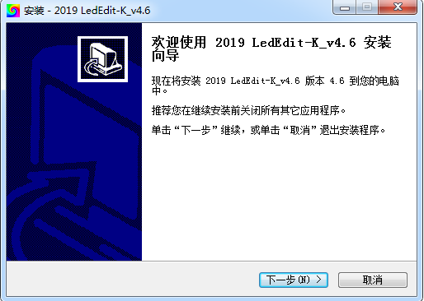
③ Select the installation save path and click Next.；
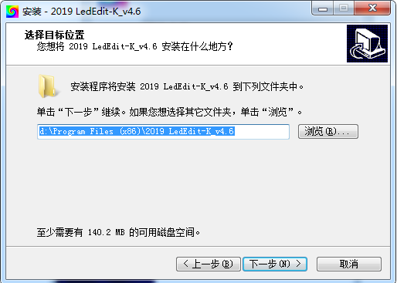
④ Select the start menu (effect file) storage path and click Next.；
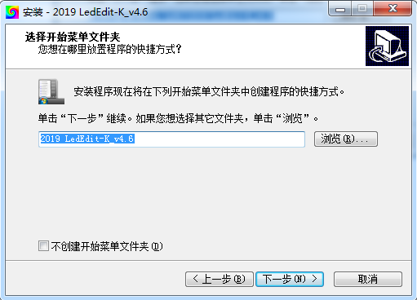
⑤ Select an additional shortcut and click Next；
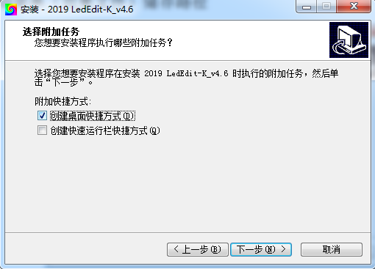
⑥ Check the previous settings and click Install；
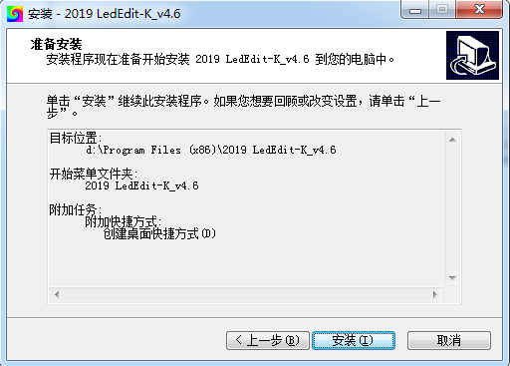
⑦ Software installation, please wait for the progress bar to complete
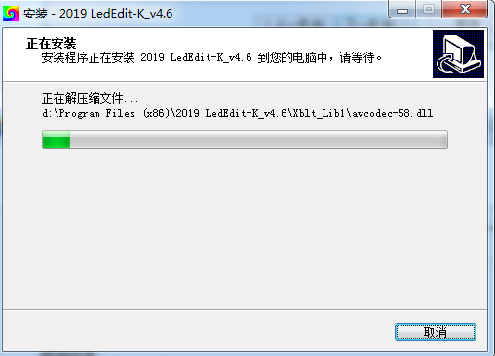
⑧ Finish the installation and click Done.
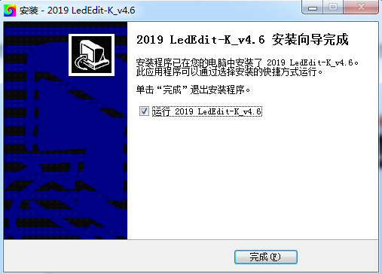

二、Sofetware uninstallation
1. Open "Control Panel" == "Programs and Features" == "Uninstall Software"
2. Left click to select 2019 LedEdit-K-v4.6, right click on Uninstall.
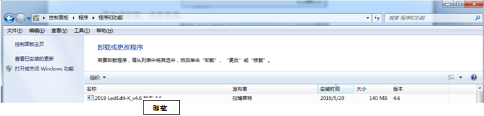

Chapter Two: New project

一、New project
The File (F) menu contains New, Open, and Exit.
New ------ choose to use when the new project first edits the effect;
Open ------- need to re-edit, preview, add, change the existing effect, by directly finding the save path of the original file
Open (you must find the save path of the original file, open the *.PJB file inside the file)
Exit ------- exit editing state, software is closed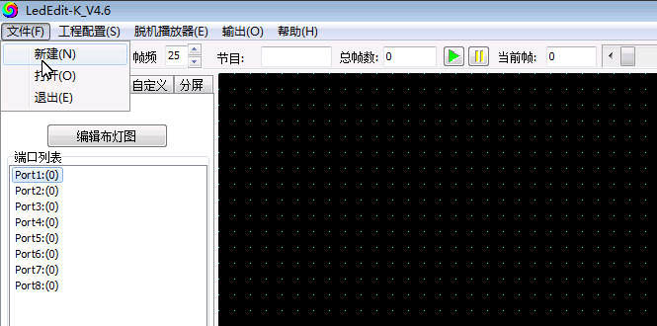

Click "File"; then click "New" to jump out of the new popup.

二、Parameter setting
In the new popup window, after setting each selection, click OK.
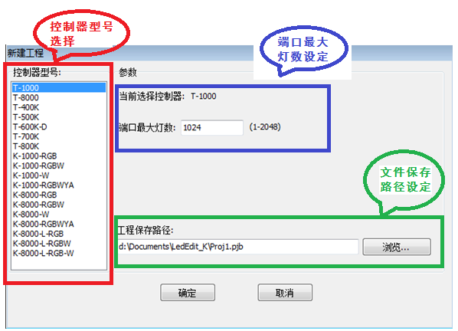
Note 1. Controller model selection: online controller model / offline controller model + lamp channel; where the lamp channel: RGB three channel / RGBW four channel / W single channel / RGBWYA multi channel.
Note 2. The maximum number of loaded lamps on the controller port does not exceed the range in parentheses.
Note 3. Project save path: It is the path where the source file is saved. You can click “Browse” to re-select/set the save path.

Chapter Three: Layout

一、Layout interface
1. Click the "Edit Light layout" on the layout interface.
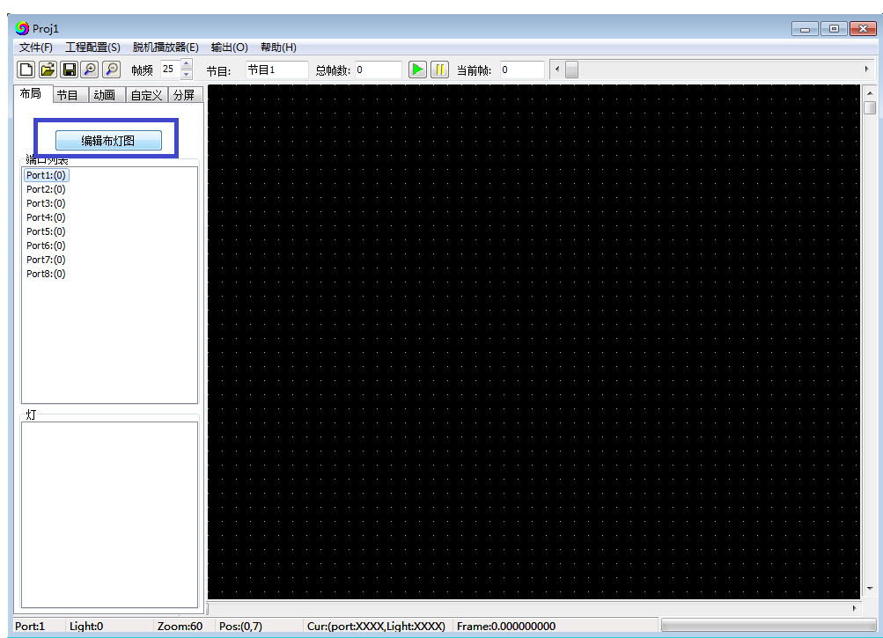
2.Enter the light layout interface
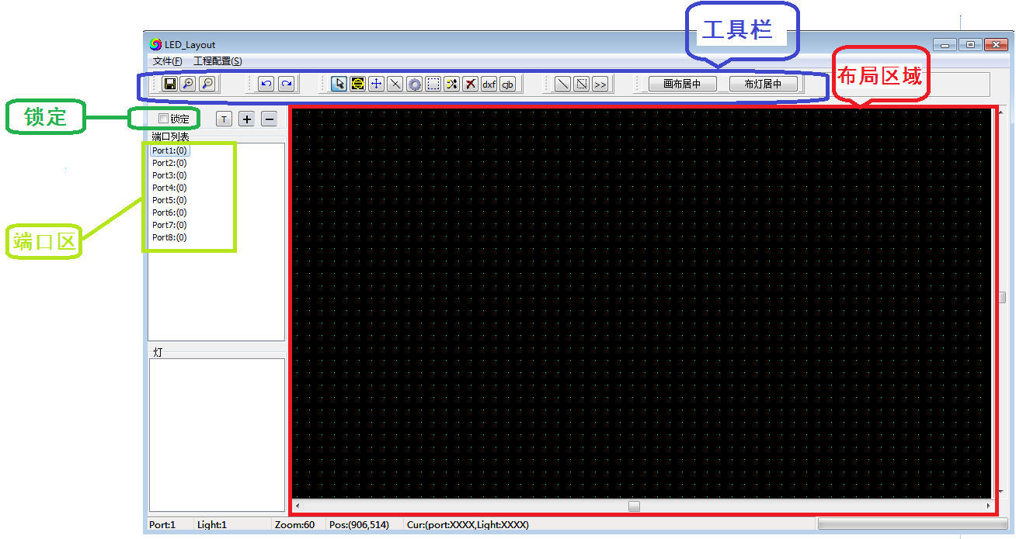
Layout area: the black zone, layout and operation.
Port Area：Display the layout port conditions, can click to display the port/pixels location.
Toolbar: Operation tool list, the definiation name of each tool as below:

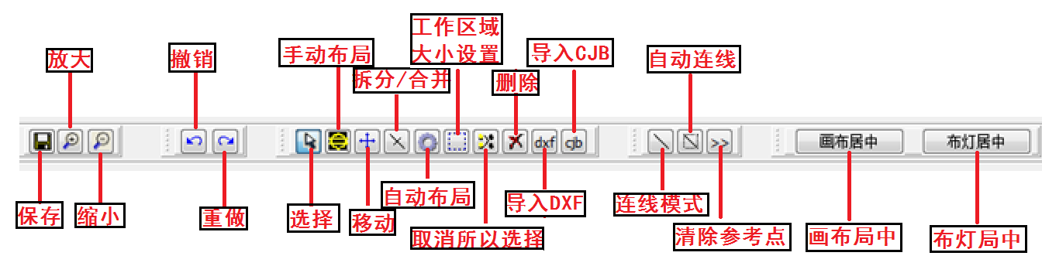

The lighting diagram can be implemented in any of the following four ways, as follows:

二、Manual layout
For profiled, simple fixture layouts, manual layout is available.
1. Click the "Manual Layout" button
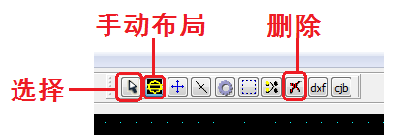
2. Clicking on the layout area with the left mouse button will generate a pixel; or you can press the left mouse button to drag in the layout area and consecutive pixels will appear on the canvas.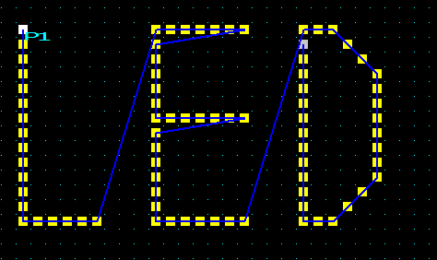

3. For the wrong layout light, click the "Select" button; click / box to select the wrong light (the light will turn red), click the "Delete" button to delete.
4. Complete the layout, click "Lock", then close the page and return to the main interface.

三、Automatic layout
Automatic layout is generally used when editing test programs or when the actual fixtures are installed in a regular arrangement;
1. Click the “Automatic layout” button：
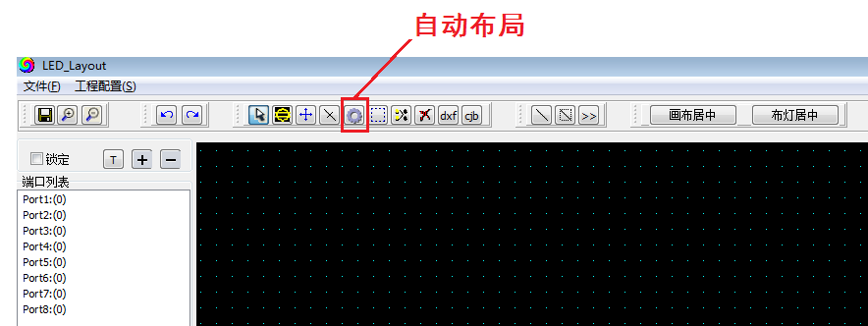
2. After selecting "Auto Layout", an "Auto Layout" dialog box will pop up to set the wiring connection mode, the width/height of the cloth, and the maximum number of lights on the port:
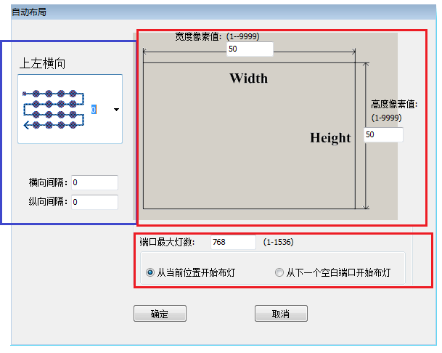
Note 1: The wiring connection mode, the starting point of the port and the line direction (Z-shaped/S-shaped).
Note 2: The width/height set the number of length and width pixels of the rectangular layout should be the same as the actual cloth.
Note 3: The maximum number of lights on the port is combined with the number of long and wide pixels.
Example 1: The upper left horizontal direction, the width pixel point 32, the height pixel point 32, and the maximum load port of the port are 512 points. The layout is as follows:
Need two ports P1.P2
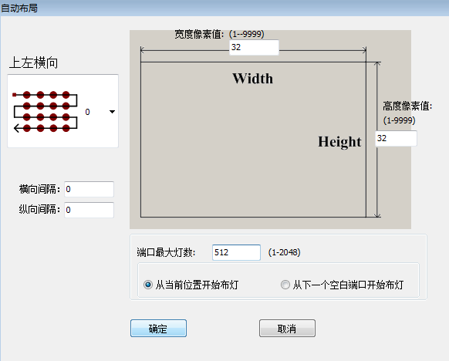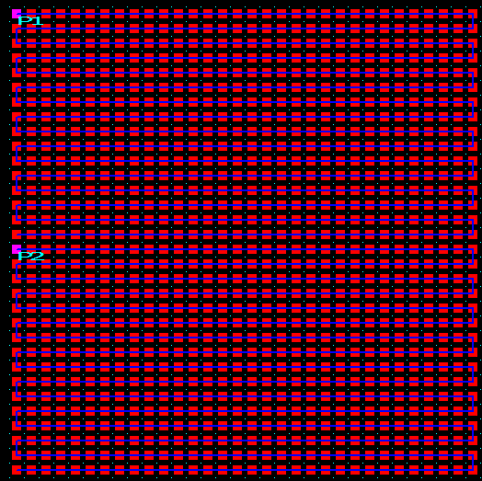
Example 2: The upper left horizontal direction, the width pixel point 32, the height pixel point 32, and the maximum port load of 1024 points, the layout is as follows:
Need a port P1
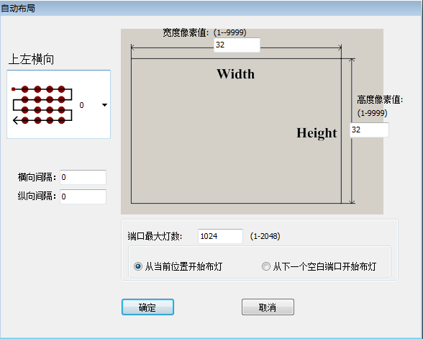
3. For the wrong layout light, click the "Select" button; click / box to select the wrong light (the light will turn red), click the "Delete" button to delete.
4. Complete the layout, click "Lock", then close the page and return to the main interface.

四、Import .dxf files
Import the tiled diagrams that have been connected in CAD or CorelDRAW directly:
1. Click the dxf icon and select the .dxf lighting diagram to import.

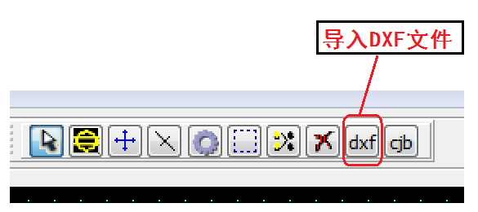
2. The software jumps out of the selection pop-up window and selects the import mode; after importing, the number of imported lights will be displayed. If the displayed light points are not connected, the dxf drawing needs to be modified until all the imports are successful.
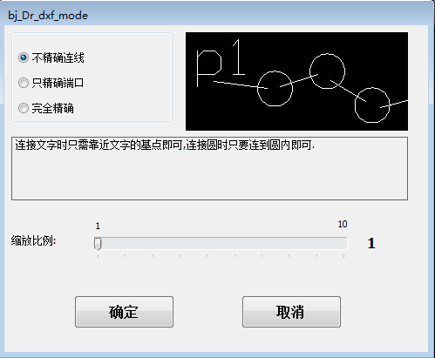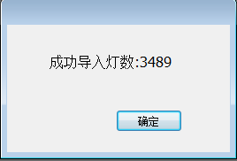

① Inaccurate continuous: Just connect the text to the base point of the text, just connect the circle to the circle
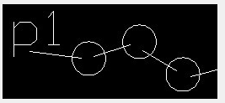
② Accurate port only: When connecting text, you must connect it to the base point of the text. Just connect the circle to the circle.
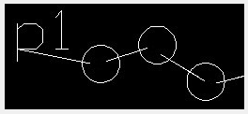
③ Fully accurate: the text must be precisely connected to the base point of the text, and the circle must be precisely connected to the center of the circle.
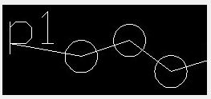
Remarks
1. Importing a CAD .dxf file requires that the diameter of the circle inside the CAD be greater than 1 mm, and the controller port must be represented in lowercase single-line text. In the single-port controller, P1 represents the first controller, P2 represents the second controller, and so on; in the 8-port controller, P1 represents the first port of the first controller, and P2 represents the first controller. Port.........P9 represents the first port of the second controller, and so on;
Note
2. The X and Y of the ellipse in the CorkDRAW .dxf file must be greater than 10.0mm*10.0mm. You need to use the pen tool when connecting. After the connection is completed, you need to save it as a .dxf file.
3. For the wrong layout light, click the "Select" button; click / box to select the wrong light (the light will turn red), click the "Delete" button to delete.
4. Complete the layout, click "Lock", then close the page and return to the main interface.

五、Import .cjb files
The cjb suffix file is the cable lighting software independently developed by our company. The biggest advantage is that after the layout of the lamp is arranged, we can use our software to drag and connect. It is more convenient and quicker compare with the CAD or CorelDRW one point to one point connection, especially for the special shaped lights.
1、Click on the cjb icon and select the .cjb to import directly:
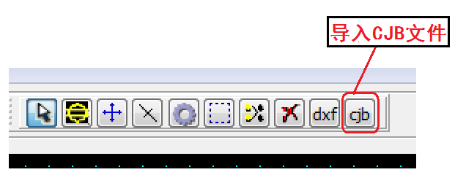
2. For the wrong layout light, click the "Select" button; click / box to select the wrong light (the light will turn red), click the "Delete" button to delete.

六、Hot key
Shortcut operations that can be used during layout
1 CRTL+A : Select all (all fixtures and connections on the canvas in the layout)
2 CRTL+C : Copy (copy selected fixtures and connections)
3 CRTL+X : Cut (cut selected fixtures and connections)

七、Lock layout
Complete the layout, click "Lock", then close the page and return to the main interface.
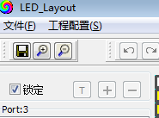

Chapter 4 Program Recording

一、Programs
1. Enter the program editing screen, you can add, delete, preview the program.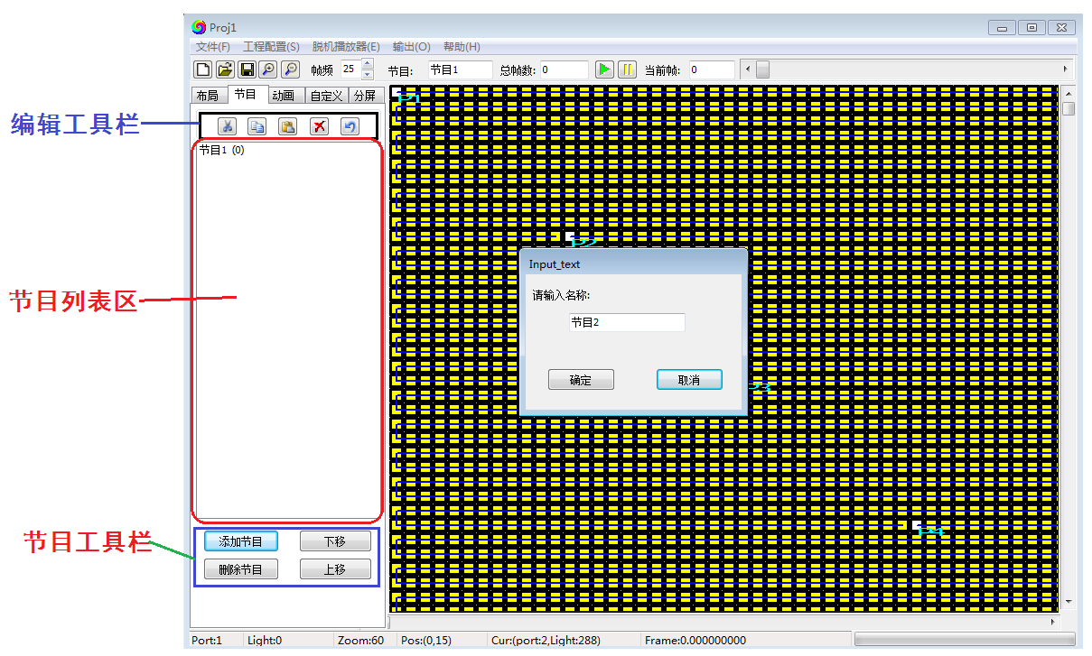
2. Edit Toolbar: Modify the effect of the recorded program (cut/copy/paste/delete/cancel the last operation)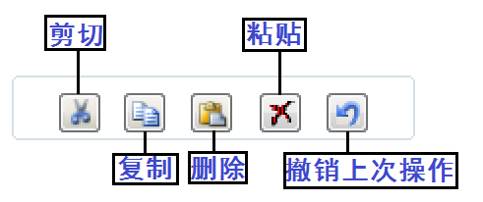
3. Program list area: store the program

4. Program Toolbar: Add, delete, and move programs.

二、Animation
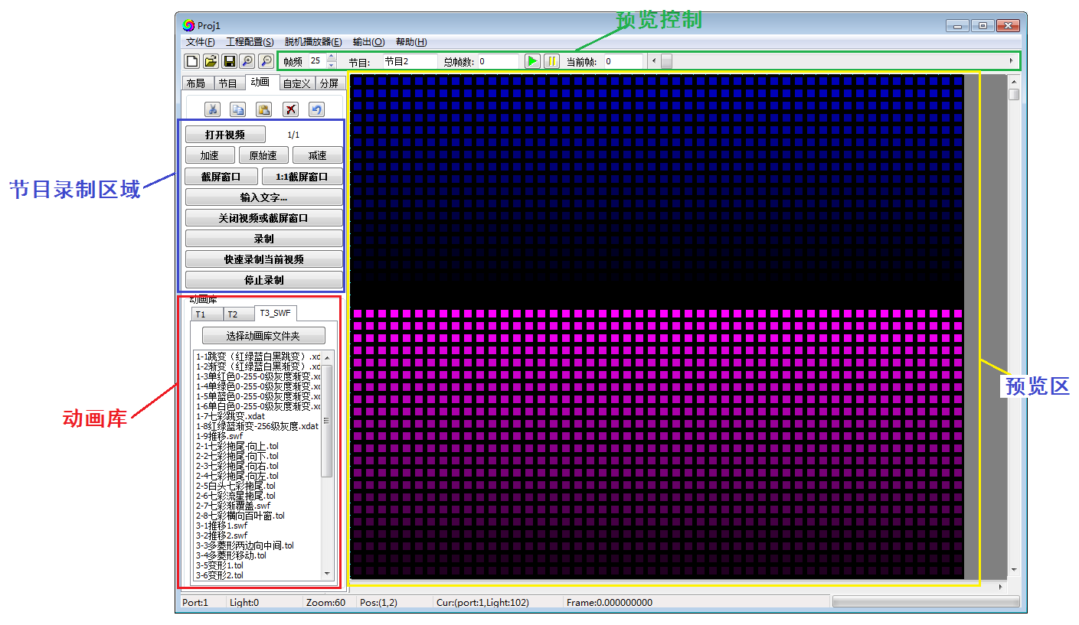
1. Animation library:
The software comes with an animation library (you can also load a personal animation library)
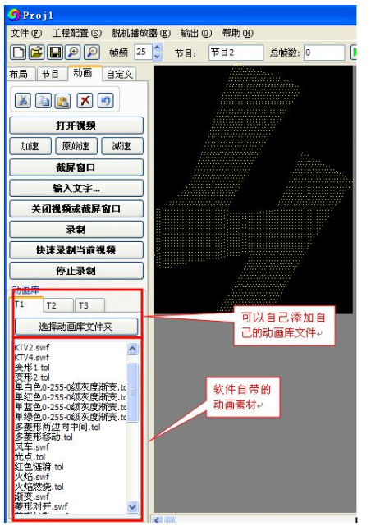
2. preview area：
Display the preview area to see the program.
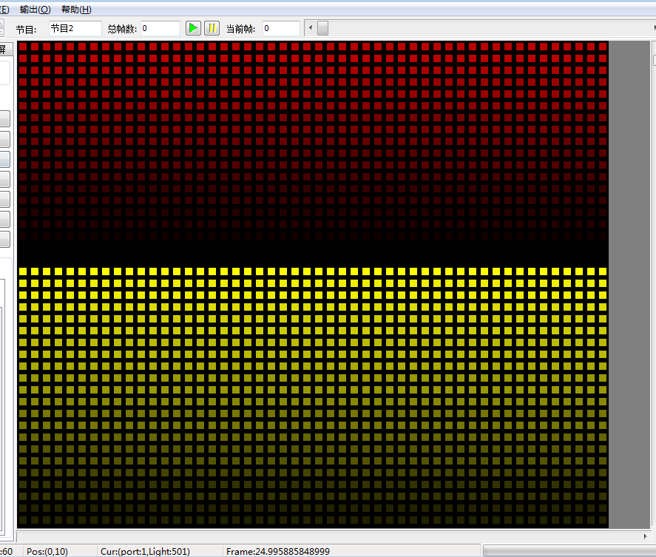
3.Preview control:
This area displays the animation playback speed, program number, total number of frames, current frame number, play button, stop button, and frame number slider.

4.Program recording area:
This area is the program recording operation area, which can record effects, add text, call video, and capture video.
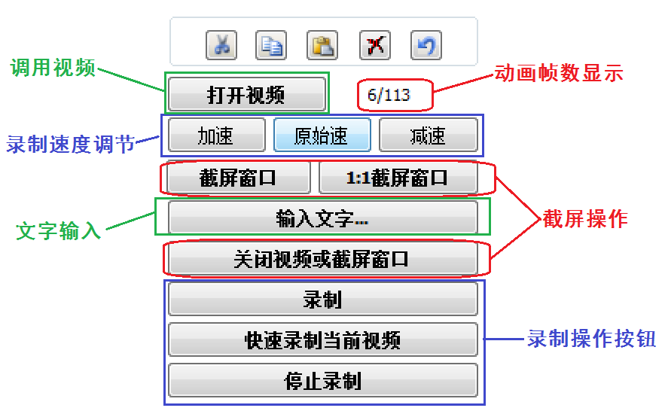

5. Program recording process
5.1 Calling animation: There are 4 ways
①. Software Animation Library: Double-click the effect in the animation library to display it in the preview area.
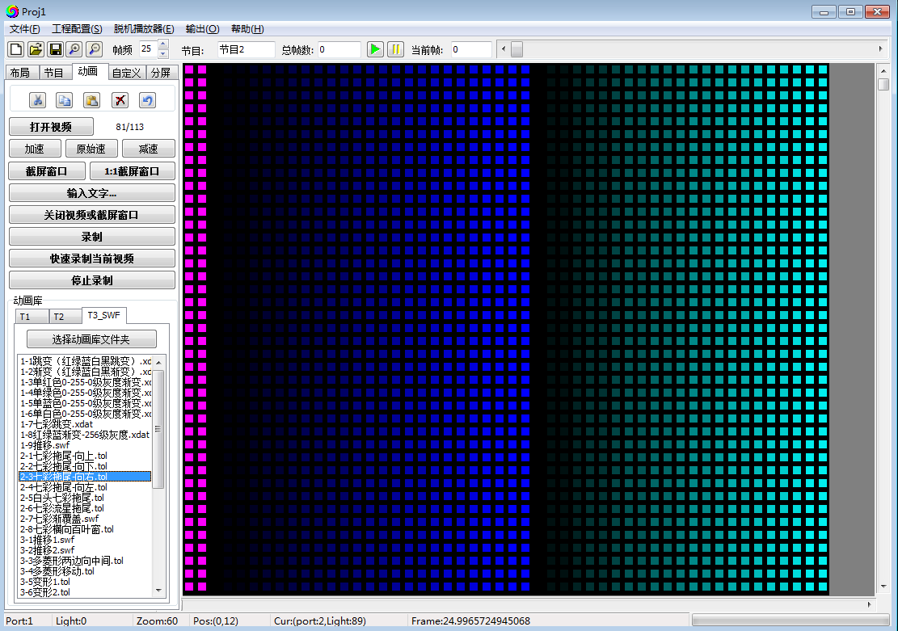
②. External video: Click the “Open Video” button to externally call the video and display it in the preview area.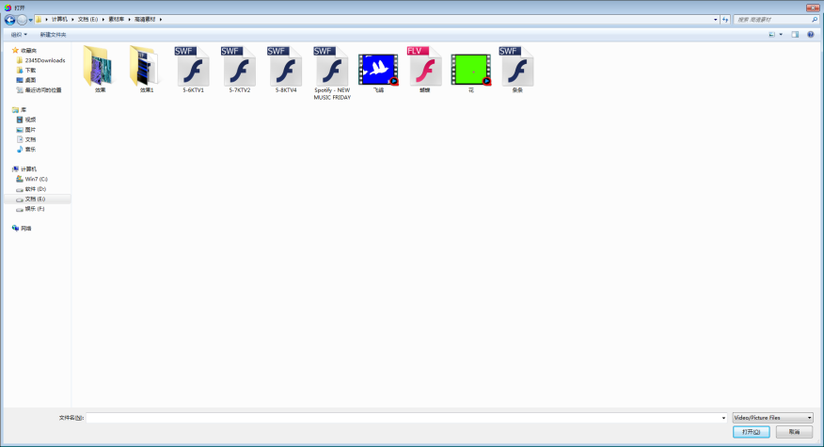
③. Computer screen capture:
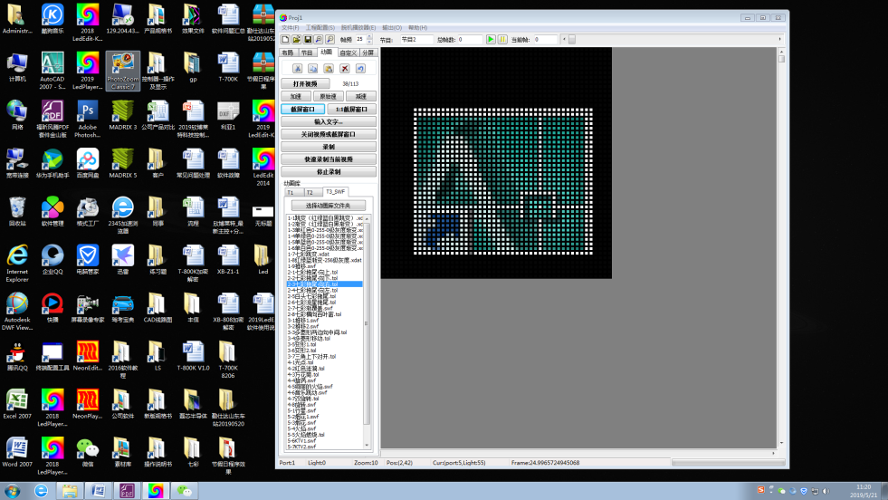
(1) Click “Screen Capture Window”, the computer will display the screen capture box, move the screen frame position, click the screen capture effect, and display it in the preview area.
(2) Click “1:1 Screen Capture Window”, the coordinates (0,0) in the upper left corner of the screen capture window, the zoom out and move position cannot be enlarged.
After completing the screencast recording, you can click "Close Video or Screen Capture Window".
5.2 Effect recording
① Record/stop recording: Click Record start to stop recording end (part of the video)
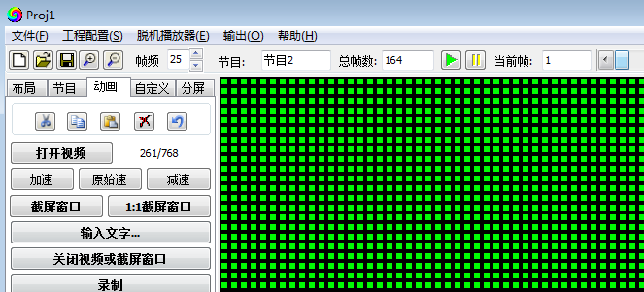
② Quickly record current video: Record all frames of the current video.

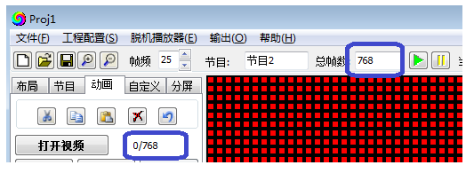
5.3 Complete effect recording
Every program needs to record the completion effect (no phenomenon that the program has no effect is not allowed)

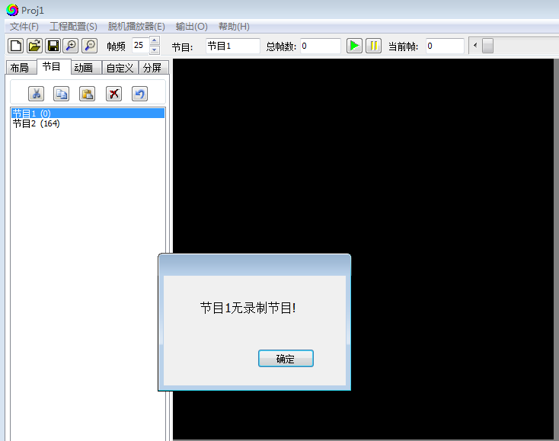
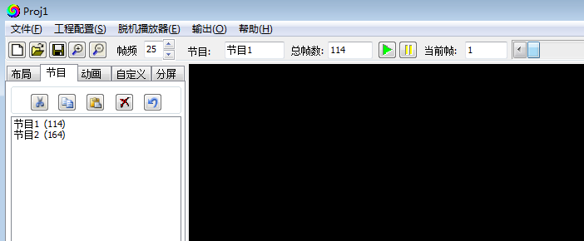

6. Text Add: Loads text into the animations recorded by the software.
6.1 Click "Enter text..." to enter the text editing interface.
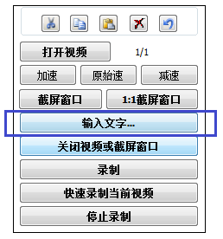
6.2 Text editor
① Enable text input: check the function will be effective
② Enter text in the text box, select monochrome / full color text; horizontal scroll / vertical scroll (different directions, text layout direction is different)

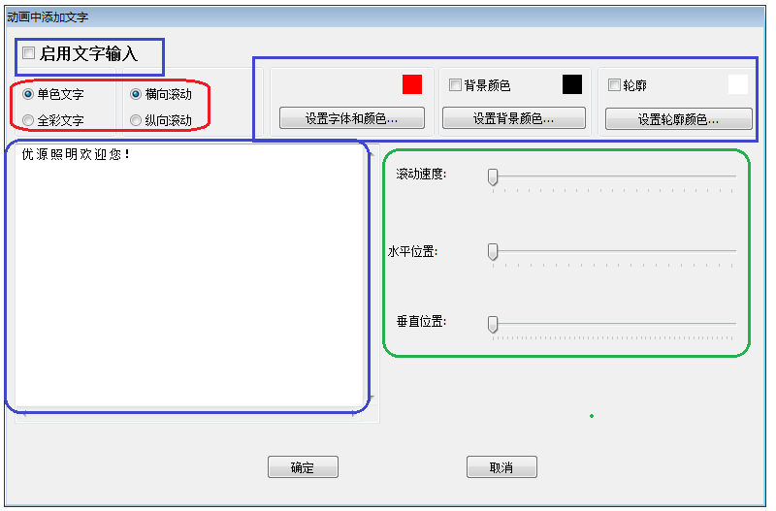
③Text color/font setting ④ Background color/outline: check the box is valid, the color is optional

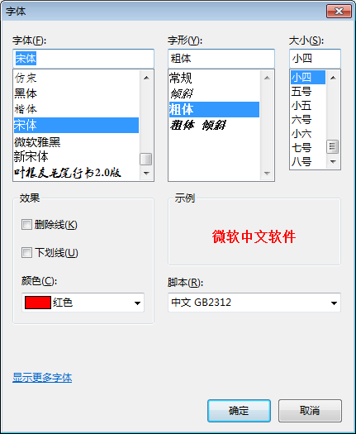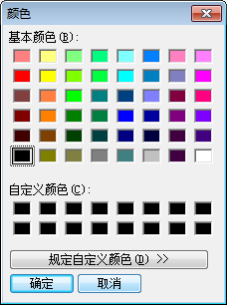

⑤ Text scroll speed adjustment / horizontal position adjustment / vertical position adjustment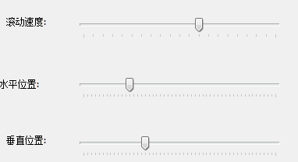
6.4 Drag the text editing interface to the side; the animation interface will record the animation effect, and the text will be automatically loaded into the effect.
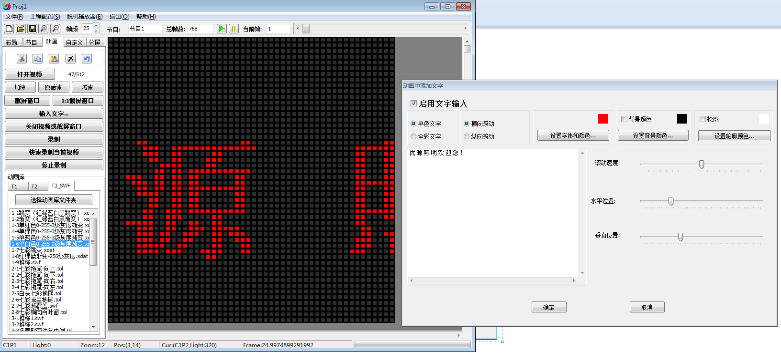

三、Customize
1.Customize: The software operator designs the animation effects themselves, and records, modifies, and previews them.
In the program interface, click on a program; then go to the custom interface operation.
2. Color wheel : select color, color order
2.1 Click the color wheel button, enter the color wheel interface (8 gray degree/16 gray degree/32 gray degree /64 gray degree /128 gray degree /customize）
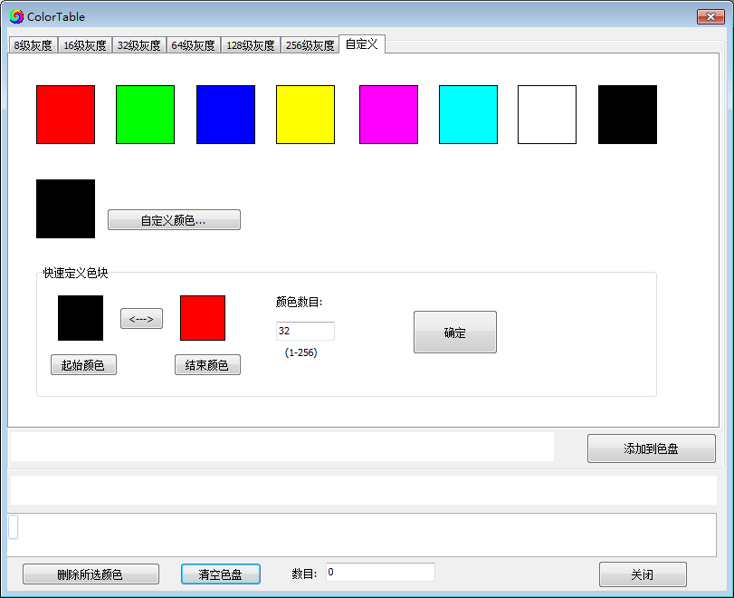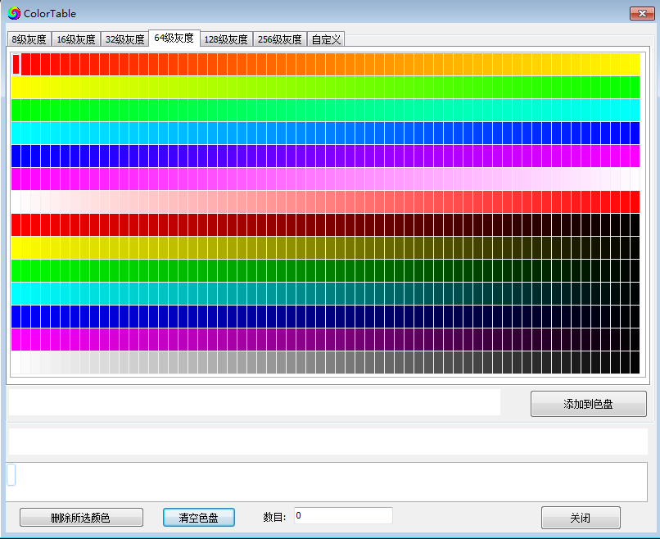
2.2 Click the color
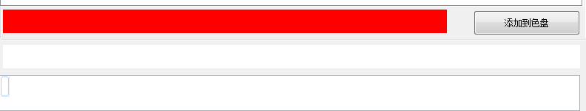

2.3 Click”Add to the color wheel”, the color close-up and quantity displayed on the color wheel;
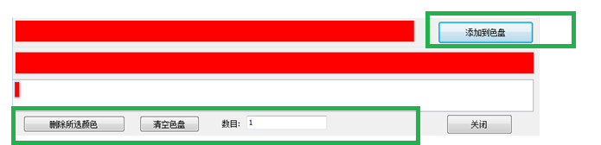

Delect the selected color; can delect the choosen color;
Empty the color wheel: Delete all selected colors;
Close: will go to the custom interface.
3. Customize effects recording
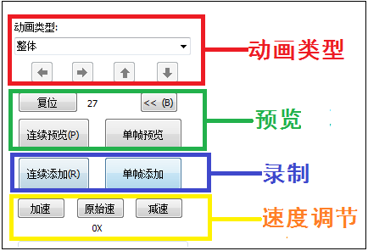

① Animation type: Click the drop-down button to select ----- Overall / Shift / V-type / Interlace / Oblique / Symmetrical / S-type / Diffusion / V-symmetric / Luminaire Scan / DMX Test
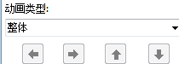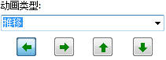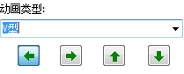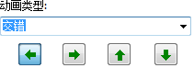
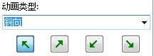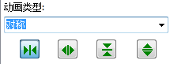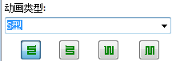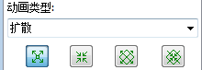
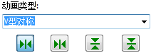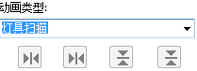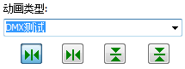
② Preview: The color block runs and see if the effect meets the design requirements/animation first runs part of the frame, for recording the next frame.
Continuous preview: use the left mouse button, click the "continuous preview" button to keep still, the animation continues to run; release the left button to stop.
Single frame preview: Use the left mouse button and click the “single frame preview” button to move the animation one frame.

③ Add: Record an animation
Continuous addition: use the left mouse button, click the "Continuous Add" button to keep still, the animation is continuously recorded; release the left button to stop.
Single frame addition: Use the left mouse button and click the “single frame add” button to record a frame.

④ Speed adjustment: Acceleration / original speed / deceleration recording (maximum multiple acceleration 20 times / deceleration 20 times)
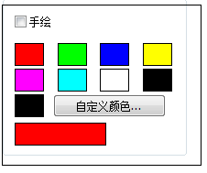
4. Hand drawn
4.1 Adjust the slider/arrow of the preview bar to call up the single frame
4.2 Click on the “Hand-painted” box to perform a recorded animation of a single frame image to add and modify colors.

四、Split screen
1. Split screen: Divide a layout into multiple independent display blocks so that they display different effect content (the split screen effect is in one program)
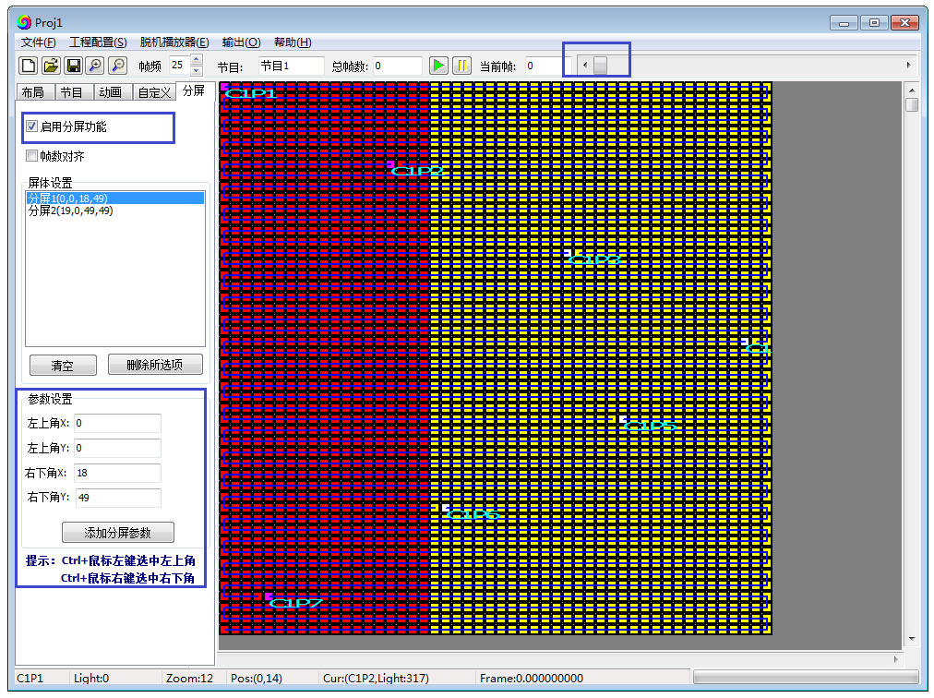
2. Split screen operation process:
2.1 Check "Enable split screen function"
2.2 Set the split screen parameters / mouse click on the split screen (two points on the plane to determine a face)
Set the split screen parameters: set the top left and bottom right coordinates of the split screen
Click on the split screen: CTRL + left mouse button to select the upper left corner; CTRL + right mouse button to select the lower right corner.
2.3 Adding a split screen
Set the completion screen split coordinate parameters, click "Add Split Screen Parameters"; the split screen list will display the split screen information.
2.4 Long operation, set all split screens.

3. Recording effects
3.1 Click on a split screen in the split screen list to record the effect on the animation interface or custom interface.
3.2 Complete a split screen effect recording, return to the split screen interface, click on the other split screen; pull the slider of the preview bar back to 0 frames, and then record the effect on the animation interface or the custom interface.

Chapter Five Project output

一、Project parameter setting
1. Click the "Output" button to enter the project output menu, click "Generate effect file.led/Bin..." or "Generate and export the effect file.led/Bin..."
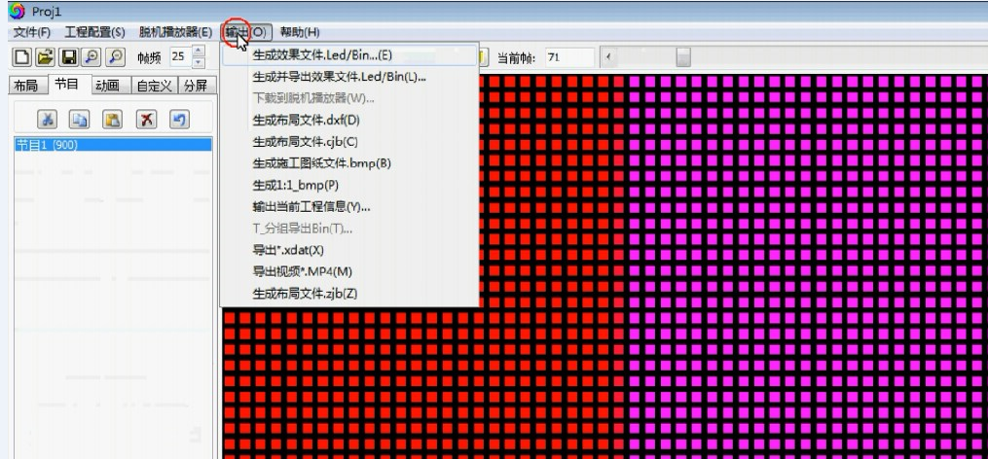

2. Output parameter setting
2.1 Off-line T series
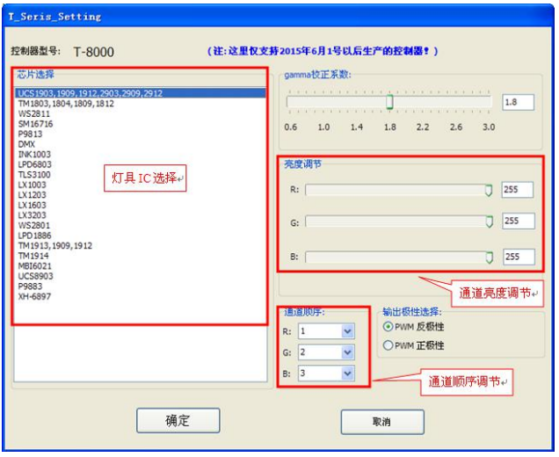
Paramter setting items:
① Select the controller model and the on-board chip model
② Select the lamp channel mode and the correct channel sequence
③ Gamma value correction / brightness adjustment

2.2 Off-line K series
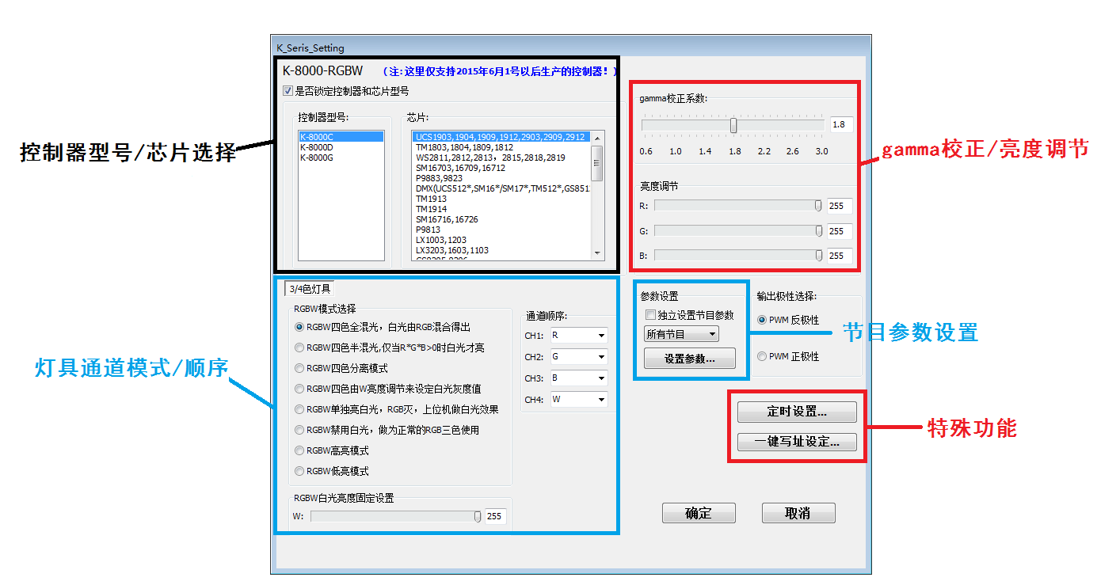
Parameter setting items:
① Select controller model and the light support chips model(Check and locking)
② Select the lamp channel mode and the correct channel sequence
③ Gamma value correction / brightness adjustment
④ Independ program parameter setting
⑤ Special function (Timing/ DMX512 one click address)

2.3 On-line controller
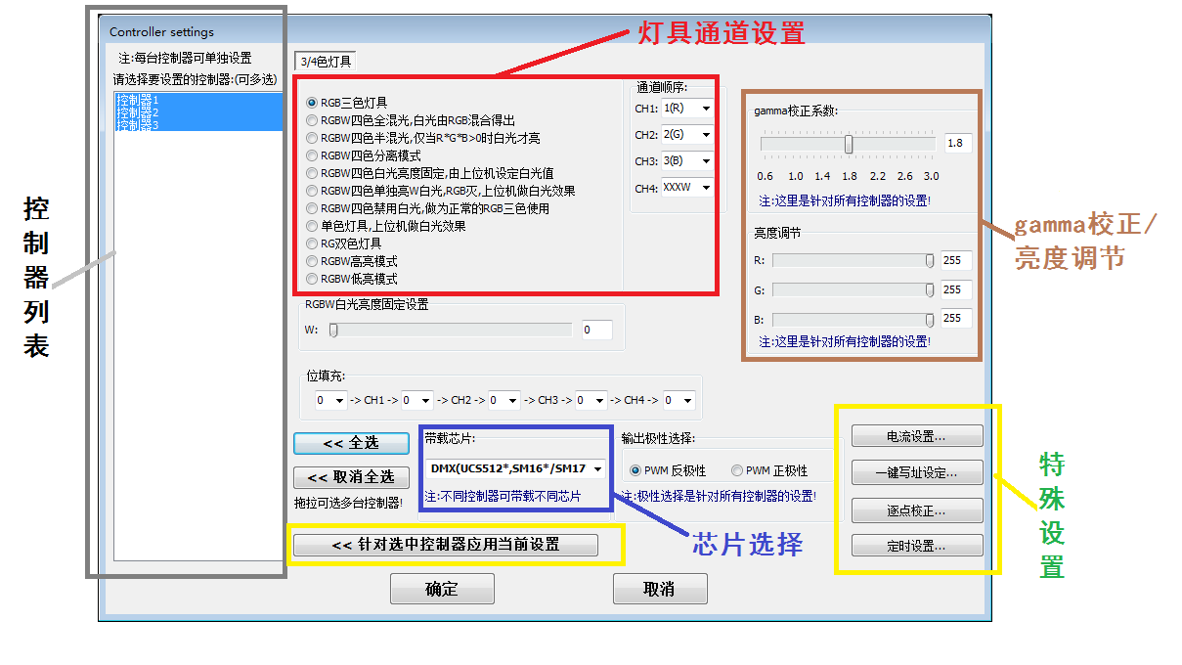
Parameter setting items:
① Select all controller model and the light support chips model(Check and locking)
② Select the lamp channel mode and the correct channel sequence
③ Gamma value correction / brightness adjustment
④ Independ program parameter setting
⑤ Special function (Current setting/ DMX512 one click address/point-by-point correction/timing setting)

3. Timing setting
3.1 Timing setting for controller (K-1000C/K-8000C and unitless controller)
3.2 Click the “Timer Settings” button to enter the timing setting interface.
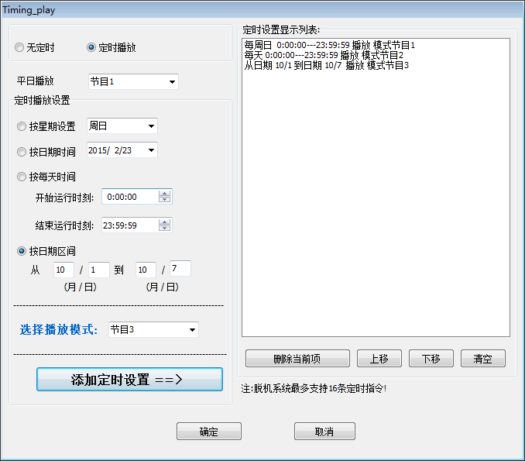

3.3 Click on the timed play option (the timing function turns from gray to black)
3.4 Time setting
(1) Set the usual play - program
(2) Set timing items (by week/date/time/holiday)
Note: For multiple timing plans, the priority is the highest in the list, and the others are lower in order.

4. One-click address
4.1 For DMX512 luminaires for easy addressing, one-click address setting allows for quick and easy address writing.
4.2 Click the “One-click address” button to enter the one-click address interface.
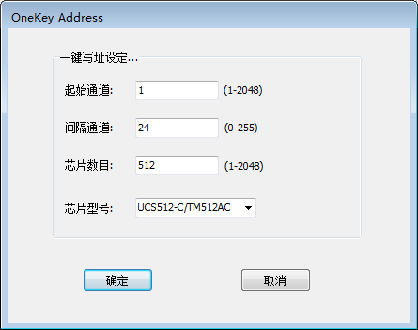
4.3 Setting parameters
(1) Start channel: default is 1
(2) Interval channel: Actual interval channel number
(3) Number of chips: Default 512
(4) Chip model: Actual loaded chip model (selected in the drop-down menu)

5. Current setting (Use this function cautiously)
5.1 Increase/decrease lamp current for actual needs
5.2 Click the “One-click address” button to enter the one-click address interface.
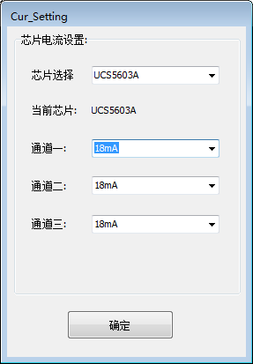
5.3 Setting parameters
(1) Chip selection: Actual loaded chip model (selected in the drop-down menu)
(2) Channel current: 3-48mA

6. Point-by-point correction (check the box)
6.1 Set the brightness for a single controller/single port/single pixel.
6.2 Click the “Point by Point Correction” button to enter the point-by-point calibration interface.

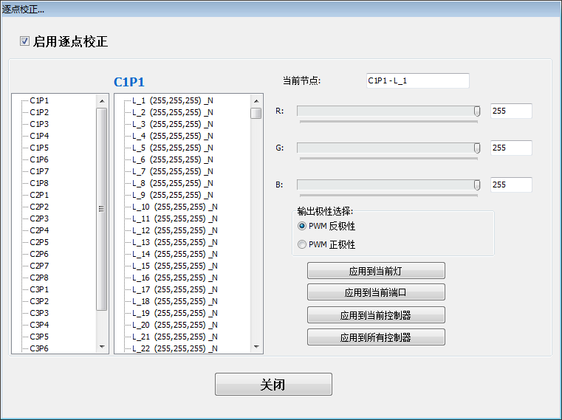

6.3 Setting parameters
(1) Select a controller / a port
(2) Select a single pixel
(3) Set the red, green and blue brightness of the pixel
(4) Click on the application (complete the settings)

二、Effects download
1. Files generation
1.1 K series controller - software output is completed, generate led folder, double-click folder; select corresponding controller folder; K-1000.led/K-8000.led is the effect file.
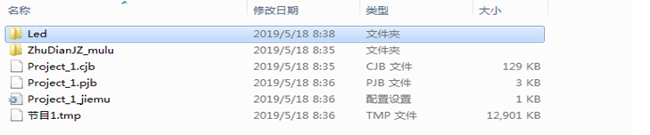
1.2. Online controller - software output is completed, generate bin folder; double-click folder, suffix .bin file instant effect file.
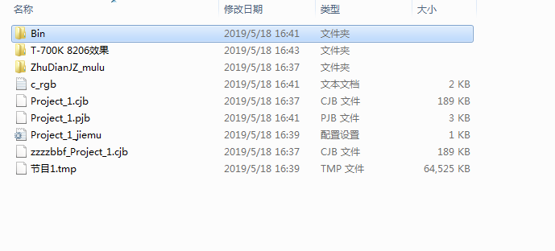
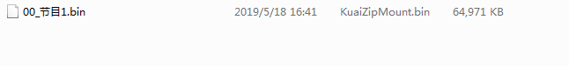
1.3. Copy the bin file to the SD card.
1.4. Insert the SD card into the controller and the controller will boot normally.
2. SD card formatting
2.1 The SD card must be formatted before copying the file to the SD card (note that it is formatted before each copy).
2.2 Formatting process
①SD card settings - "File System", "FAT" format (SD card capacity ≤ 2G) or "FAT32" format (SD card capacity ≧ 4G).
②SD Card Settings - "Assign Unit Size", click the drop down button to select "Default Configuration Size" or click the "Restore Device Defaults" button.
③ Start formatting.
As shown below:
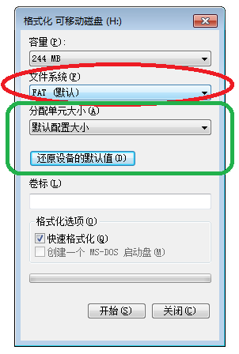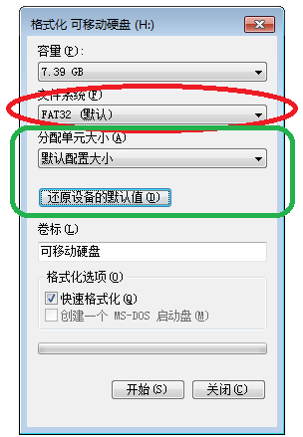
2.3 The SD card cannot be hot swapped, that is, the power of the controller must be disconnected each time the SD card is inserted or removed.

