ARTNET to DMX Controller
Client
Project
Order Code
QTY

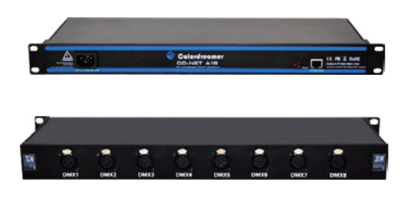
TITAN A8

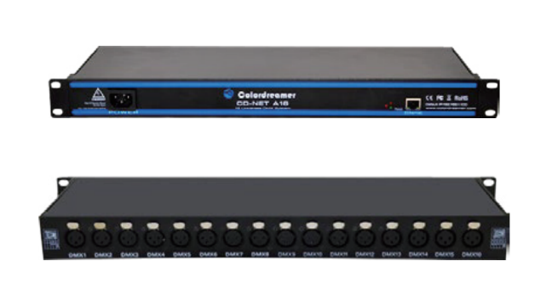
TITAN A16
2Versions are available: Titan A8 and Titan A16

Thank you for purchasing the Colordreamer Titan Artnet to DMX Controller!
Our manual will describe the installation and mounting of the product as well as description of how to use it. Please read and understand this manual in its entirety before using the product.

Package Contents:
1XTitan
1XPower Cord
1XRJ 45 Cable
1XThis Technical Manual

Product Warranty is void if product is not installed as per installation instructions and in compliance with all local and provincial codes.

SAFETY RECOMMENDATIONS AND WARNINGS
Only use this device in dry environments (indoor use)
Do not make modifications or alter the product
Keep away from flammable material.
Do not use any silicone or other chemicals on outside surface.
Do not use chemicals or abrasives to clean the device as this many voids the warranty.
Ensure installation complies with local electrical rules and regulations.
Ensure mains input power is surge protected
Do not connect or disconnect the device while the power is connected.
Connectors are to be kept clean and dry at all times.
Input Voltage range 100-240VAC
Power off the device during service or when not in use.
Twisted pair cable is recommended for data transmission
Avoid unwanted voltage on the DMX cables at all times.
Do not remove any parts from the unit including the plug ground pin or connect to an ungrounded circuit.
Do no connect the unit to LEDs that are switched on.
To supply this unit with power, first connect the provided power cord to the unit and then to a suitable power outlet.

Product Overview
Colordreamer Artnet Controller converts Art-Net data from Ethernet network to DMX512.
Colordreamer Titan Family Artnet Controller has 8Universes (Titan A8) and 16Universes (Titan A16) available.
Perfect synchronization between each Universe.
Take full advantage of pixel mapping and voxel mapping, easy to install.
The Artnet controller device is ready within seconds after start-up. An HTP Merge is automatically available for two Art-Net sources. If required, you can access and change specific device settings using the built-in web configuration tool.

Product Specification
Models | TITAN A8 | TITAN A16
Electrical
Input Voltage | 100-240VAC  50/60Hz | 100-240VAC  50/60Hz
Power Consumption | 5W | 5W
Control
Network Protocols | Art-Net | Art-Net
DMX Outputs | 8X512 DMX Channels | 16X512 DMX Channels
Ethernet | RJ45 | RJ45
Default IP | 192.168.1.100 | 192.168.1.100
Default Subnet | 255.255.255.0 | 255.255.255.0
Physical
Housing Material | Metal | Metal
Finish Color | Black | Black
Connector | 3pin/5pin xlr female | 3pin/5pin xlr female
Dimensions(LXWxH) Body | 440×136.6x44mm | 440×136.6x44mm
Dimensions(LXWxH)Brackets | 483×136.6x44mm(1U) | 483×136.6x44mm(1U)
Weight
Environment
Operating Temperature | -10℃ to +50℃ | -10℃ to +50℃
Storage Temperature | -20℃ to +70℃ | -20℃ to +70℃
Humidity | 0-80% non-condensing | 0-80% non-condensing
IP Rating | Dry, Indoor IP20 | Dry, Indoor IP20
Certification and Safety
Certification | CE | CE
Warranty | 2Years Limited Warranty from the Date of Manufacture  Contact us if you need extended warranty

Connectivity
EF
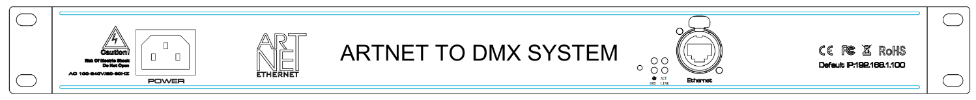
A BCD G

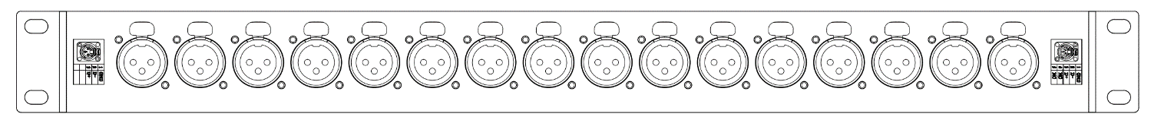
H
A: Power Socket B: Reset Button C: Spare LED, no detection function so far
D: Status LED for Ethernet Link E: Status LED for Power F: Status LED for Ethernet Activity
G: RJ45 Ethernet Port H:XLR Ports: DMX1-DMX8/16
Titan A16 is used above as example. Titan A8 has similar layout and function.
Description of Status LED:
E: Status LED for Power
Status | Description
Powered Off | Power cable not connected. The device has no power
Permanently Green: | Connected to Power. Power is on.
D: Status LED for Ethernet Link
Status | Description
Powered Off | Ethernet not connected
Permanently Red: | Connected to ethernet
F: Status LED for Ethernet Activity
Status | Description
Powerer Off | No data received over ethernet
Permanently Green or  Blinking Green | Communicating over Ethernet. Receiving data over ethernet
3-Pin And 5-Pin XLR Connector Layout
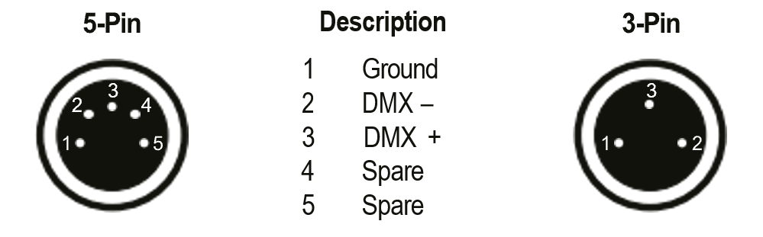
Device Configuration Through A Web Browser
You can access all settings and information of Titan Artnet Controller by using the built-in web configuration tool.
Step 1) Connect Titan Artnet Controller and your computer to the same network.
Artnet Controller Default IP 192.168.1.100
Step 2) Assign correct network settings for your computer in the operating
system. (Recommended default settings:
IP address 192.168.1.XXX/ Subnet mask 255.255.255.0)
Step 3) Open your web browser and enter the IP address of Artnet Controller
192.168.1.100
Step 4) The web configuration tool will be launched.
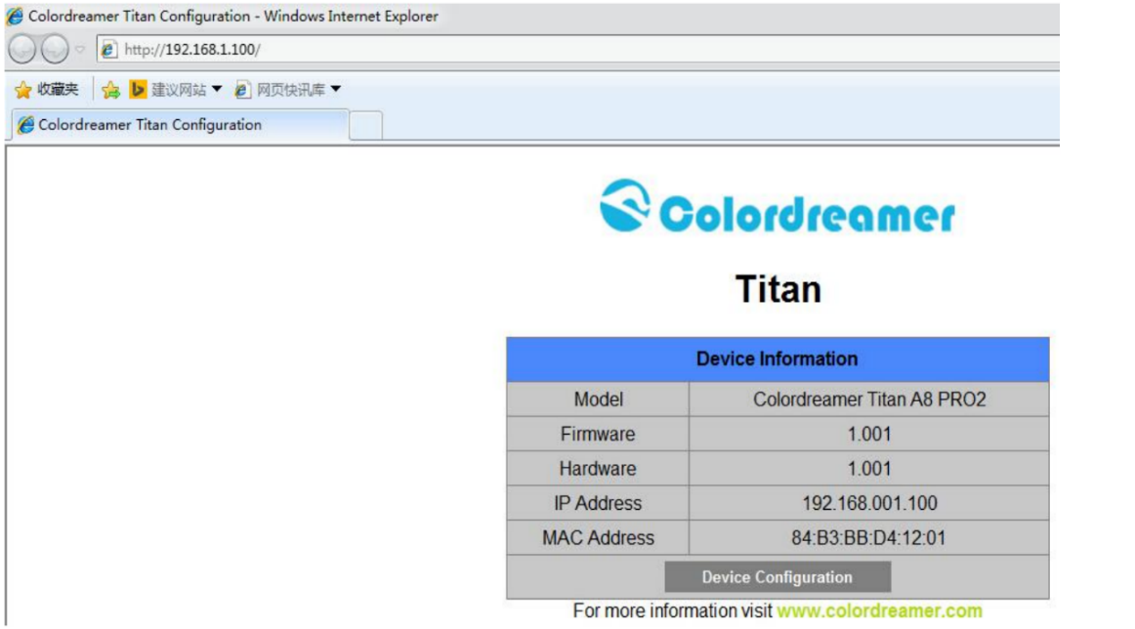
Step5)You can change IP address and save this configuration
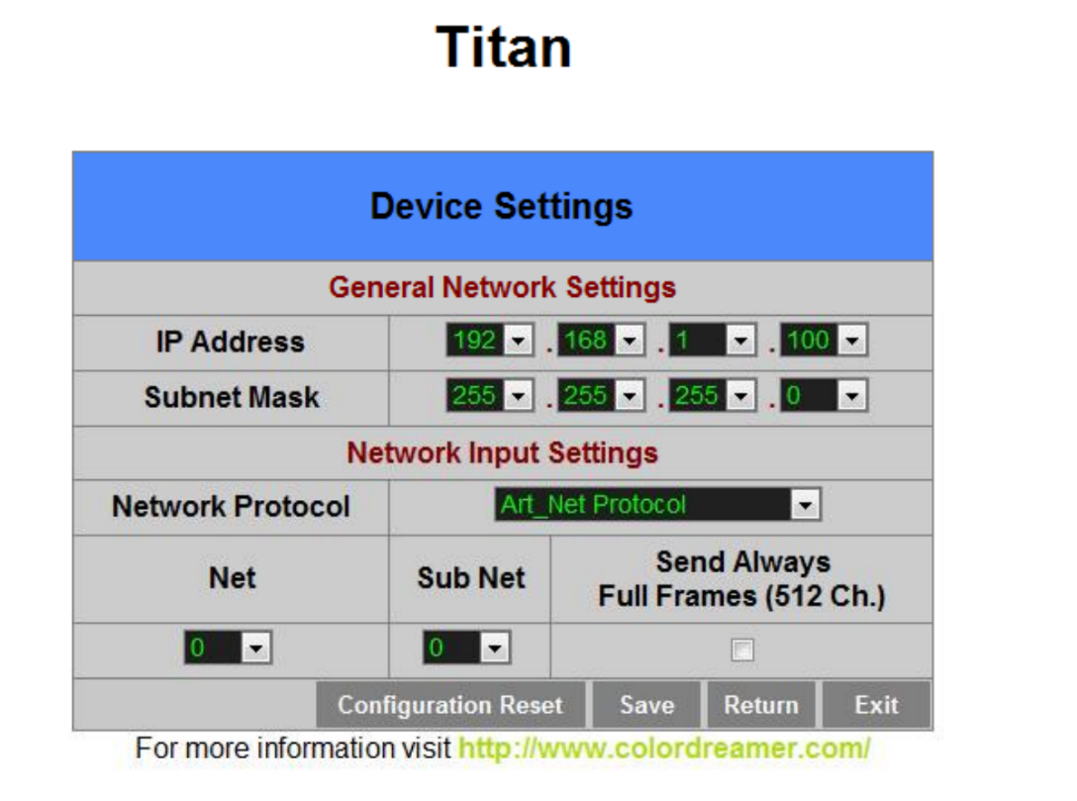
Step6）After saving all setting,reboot the system to apply the new setting.after reboot,this window will be closely automatically.
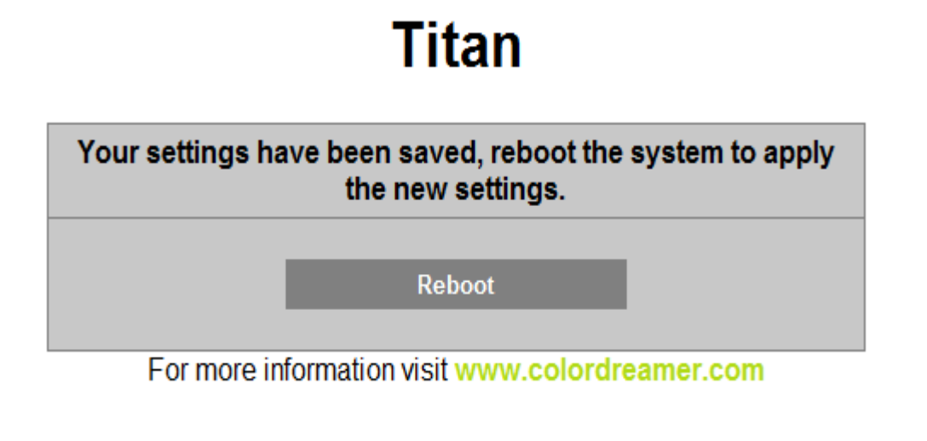

Reset to Factory Default Settings
Step 1) Disconnect the device from power.
Step 2) Use a suitable tool to press the reset button.
Step 3) Continue to press the reset button and connect to power again.
Step 4) Continue to press the reset button and wait until all status LEDs of the device flash repeatedly or wait 5 seconds.

