1. Features

(1). Four ports control maximum 4096 pixels (for example WS2812). But for DMX512, each port outputs 512 channels.

(2). Support ArtNet protocol, 4 universes(each 512 channels) output when H802RA works with Madrix.

(3). Allocate address for DMX512 chips (for example UCS512, TM512)

(4). Controlled by master controller or PC.

(5). Transmission distance between two controllers is up to 100 meters.

2. Supported Driver Chips

DMX512, HDMX, LPD6803, LPD8806, LPD1882, LPD1889, LPD1883, LPD1886, TM1812, TM1809, TM1804, TM1803, TM512, TM1926, TM1913, TM1914, TM1814, UCS6909, UCS6912, UCS1903, UCS1909, UCS1912, UCS512, UCS8904, APA102, APA104, P9813, WS2801, WS2803, WS2811, WS2812, WS2821, SM16716, SM16711, INK1003, LX1003, MY9221, MBI6021, MBI6024, LD1510, LD1512, LD1530, LD1532,etc.

Note: H802RA supports more than the chips listed above(for example UCS2903 has the same sequence diagram with UCS1903, H802RA supports them all).

3. Product Display

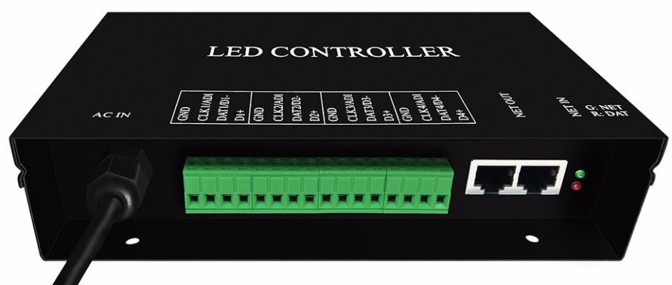

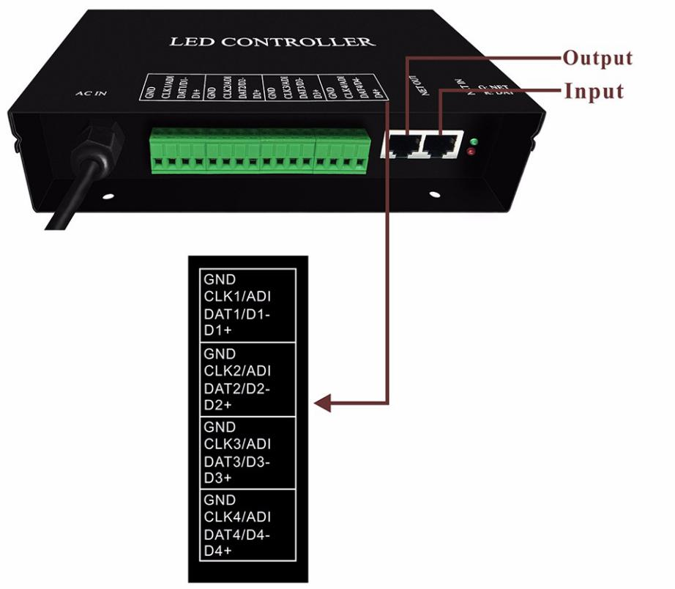

GND and DAT are for chips like TM1812, WS2811, WS2812.

GND, CLK and DAT are for chips like APA102, LPD6803.

GND, D- and D+ are for DMX512 chips like TM512, UCS512.

ADI(address input) is address line for DMX512 chips.

4. Working Mode

(1). Connect to master controller, software is LED Build. Programs are stored in SD card.

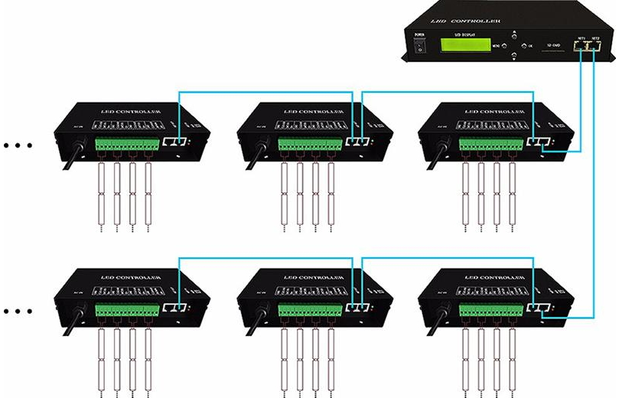

LED Build download link:
https://drive.google.com/open?id=0B1gzqyV6hfOgN2pkMV8yMFozYzQ

LED Build Tutorial Video: https://drive.google.com/open?id=0B1gzqyV6hfOgUnFjeG9EM3VRZjA

(2). Connect to computer, software is LED Studio(our software) or other software that supports Art-Net protocol.

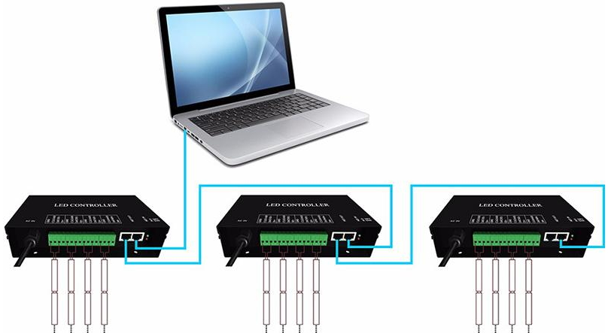

LED Studio download link:
https://drive.google.com/open?id=0B1gzqyV6hfOgNEtYT2o0LWdDNG8

H802RA to PC manual:
https://drive.google.com/open?id=0B1gzqyV6hfOgeGI1M2JaYi1URW8

5. Basic Working Procedure for MADRIX

Configurations before MADRIX (if you use other software, these configurations are also essential)

(1). Connect H802RA to PC, allocate an IP address for H802RA.

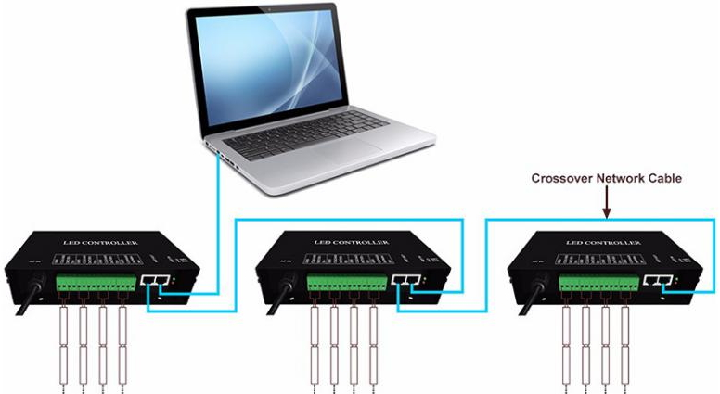

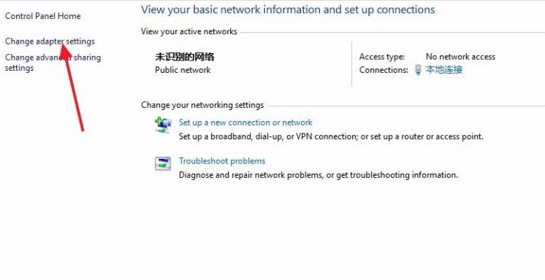

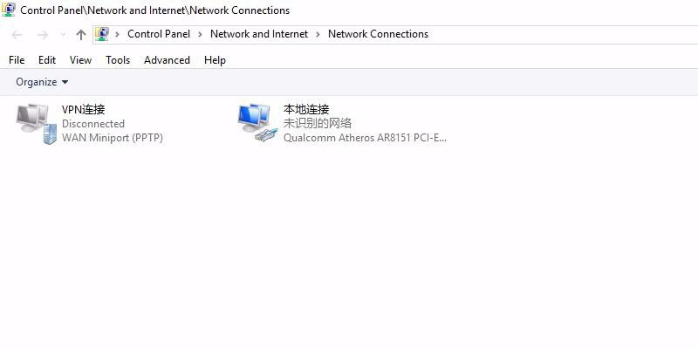

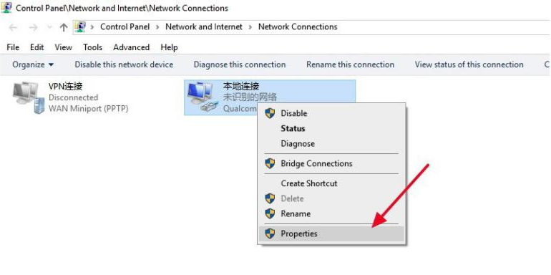

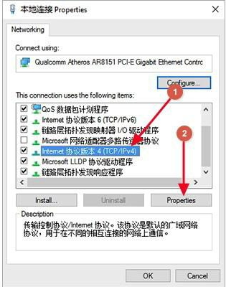

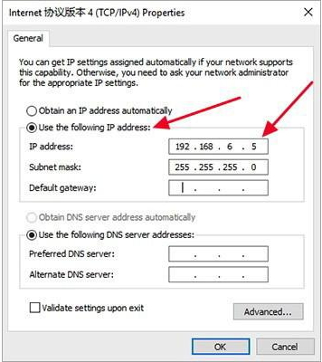

(2). Open LED Studio, click “setting” -- “H802RA setting”, pops up the following dialog box.

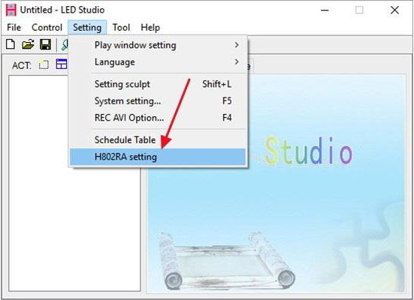

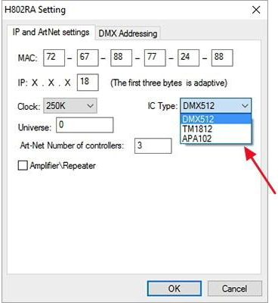

Note:

(1). "DMX512" includes UCS512, WS2821, TM512.

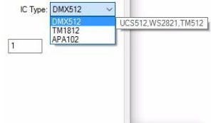

(2). "TM1812" includes P9883, TM1804, TM1809, UCS1903, UCS1909, UCS1912, WS2811, WS2812, SM16703, SM16709, SM16712, INK1003, LX1003.

Normally, if you choose "DMX512", Clock should be 250K, if you choose "TM1812", clock should be "750K".

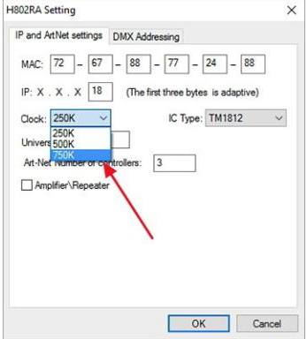

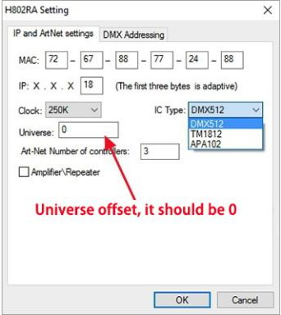

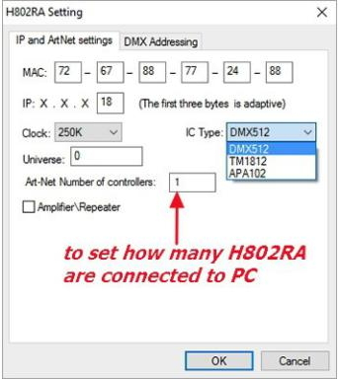

MADRIX Configurations

Assume you connect one H802RA to PC, each universe controls 170 WS2812 pixels (1 pixel includes R,G,B, 512/3=170)

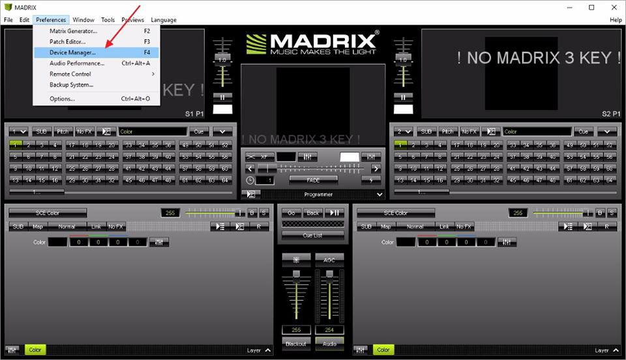

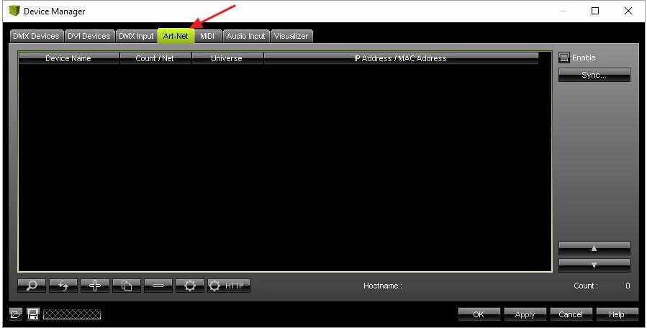

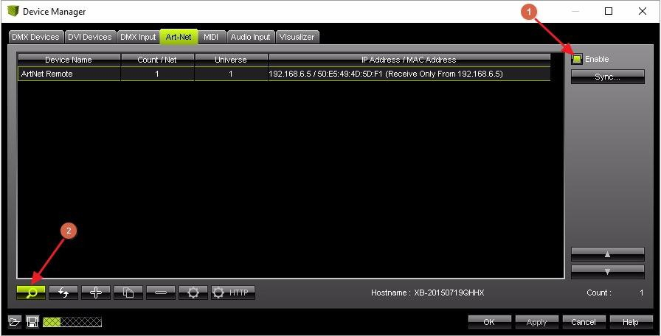

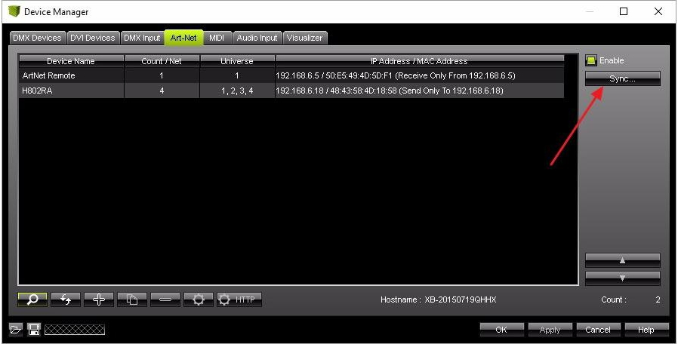

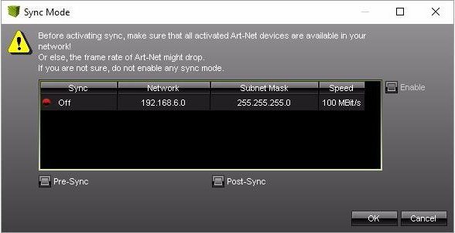

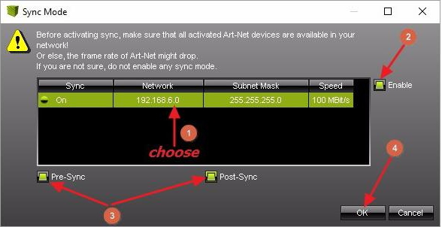

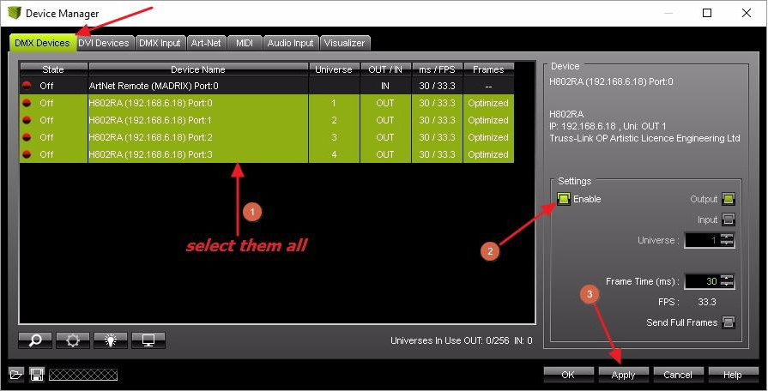

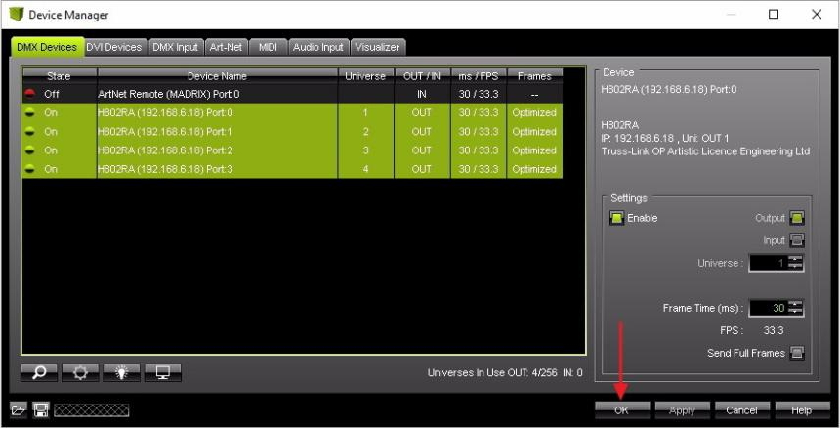

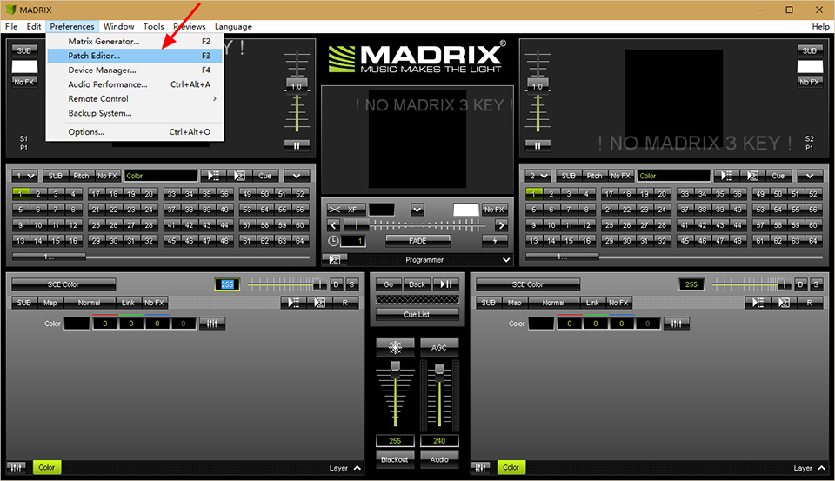

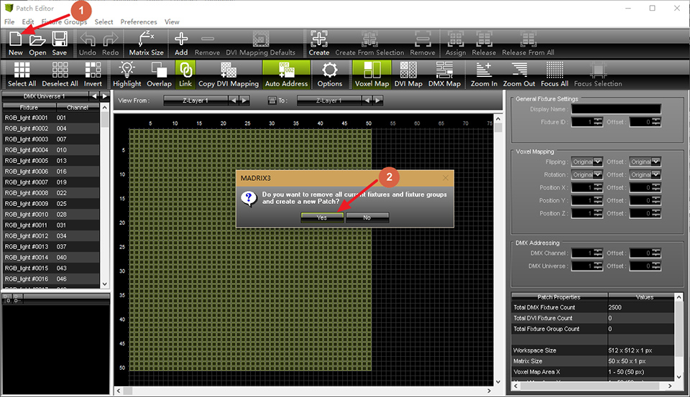

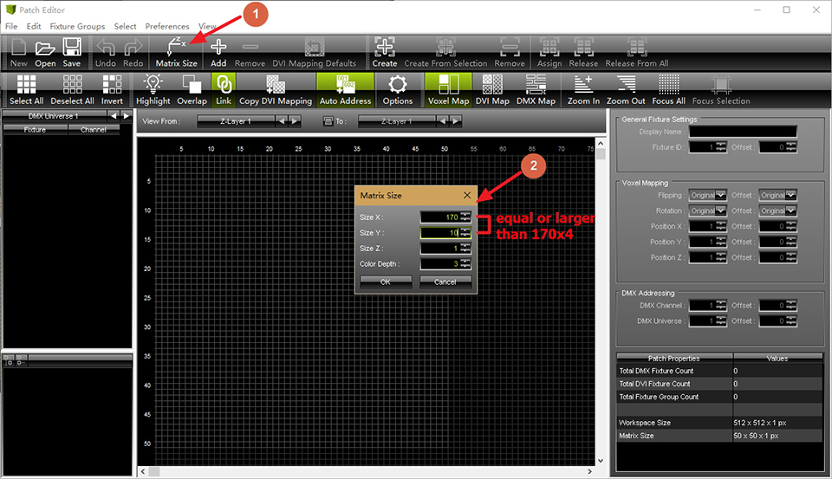

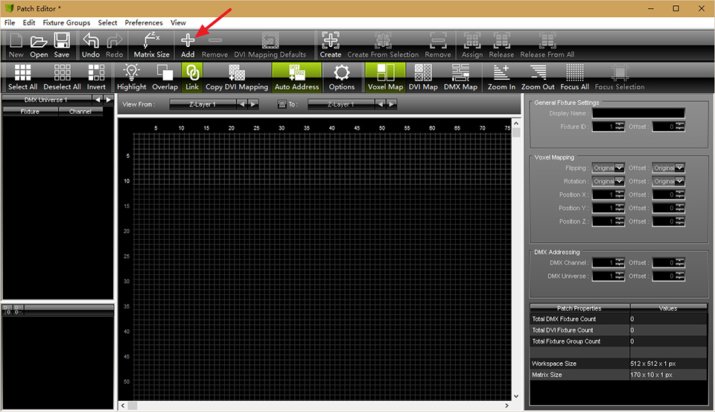

Add Fixtures to universe 1

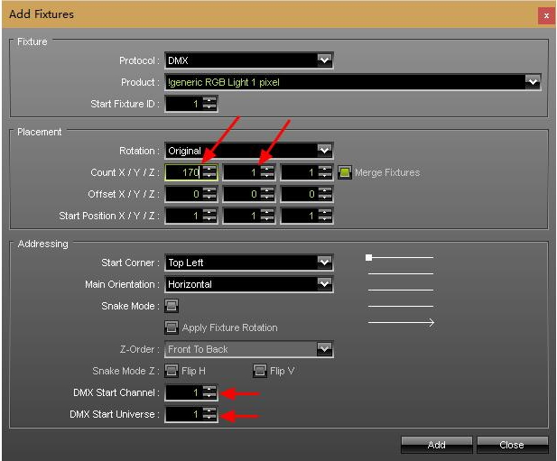

Add Fixtures to universe 2

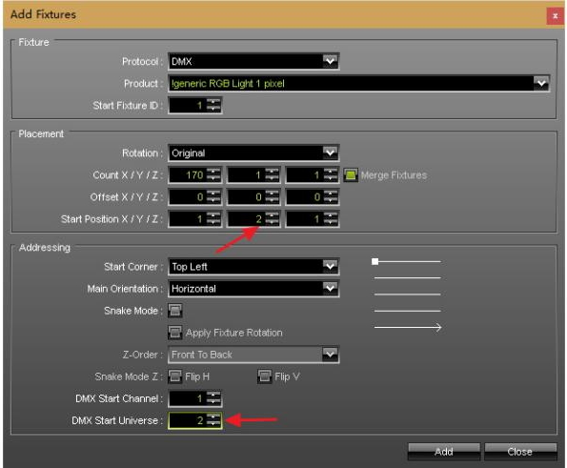

Use the same way to add fixtures for the rest of two universes

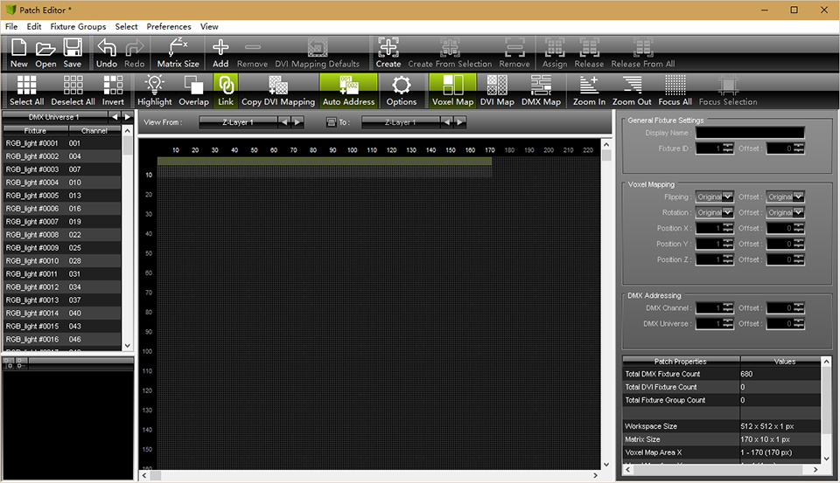

Save patch, then go back to main window, you can control lights with MADRIX!!!

6. Basic Working Procedure for Jinx!

Note: before this, you should allocate an IP address for H802RA and configure H802RA in LED Studio, which has been showed above.

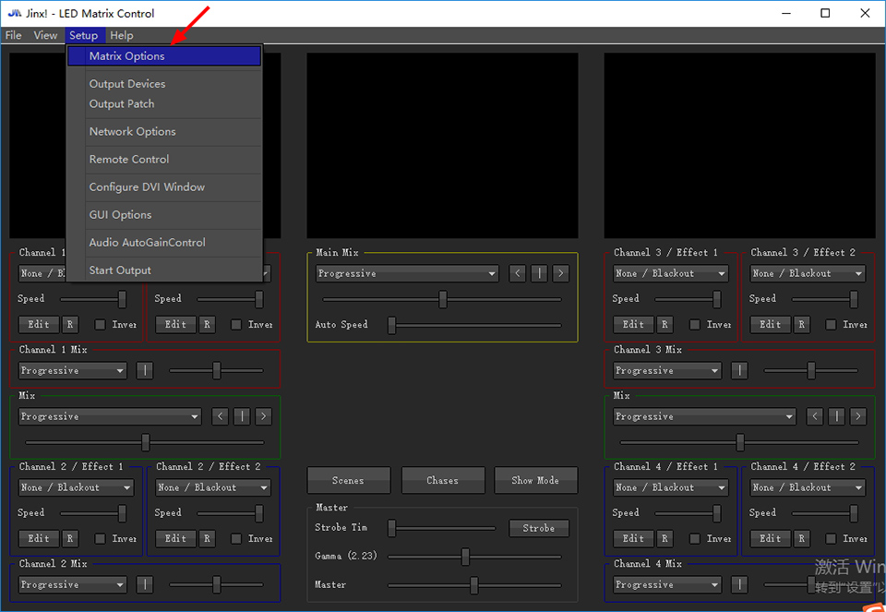

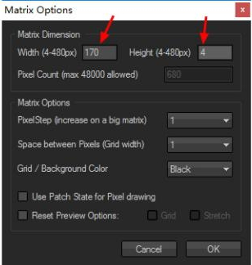

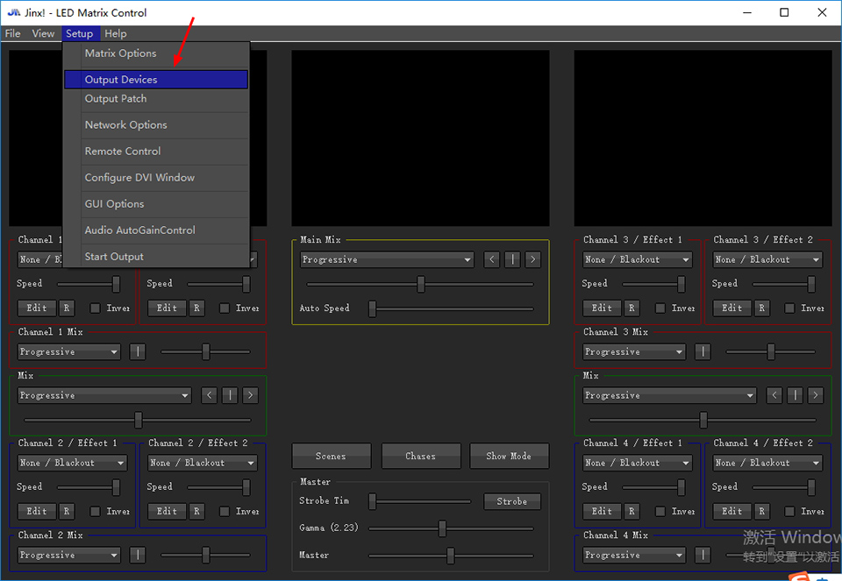

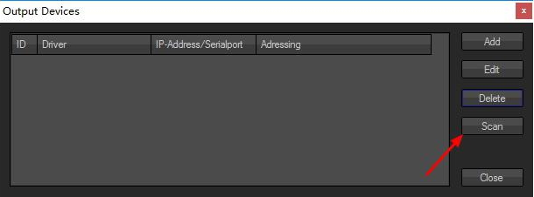

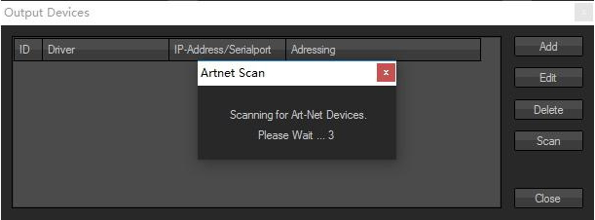

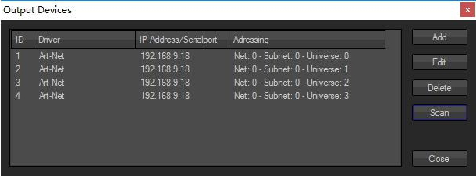

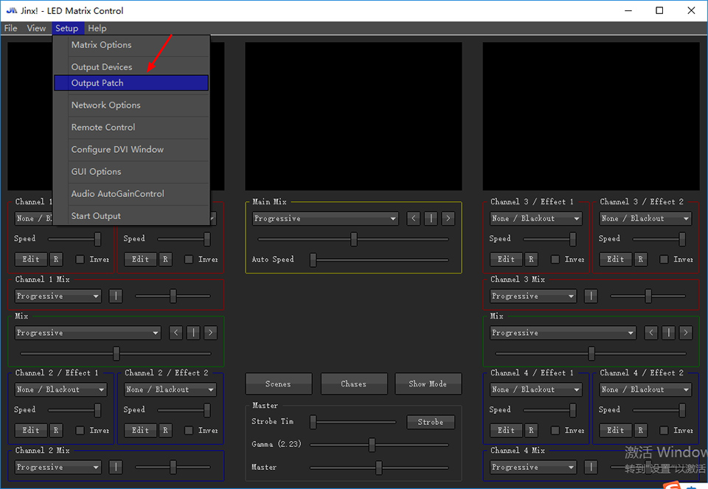

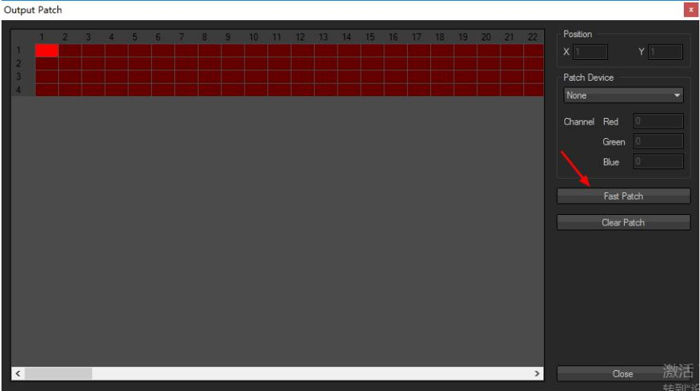

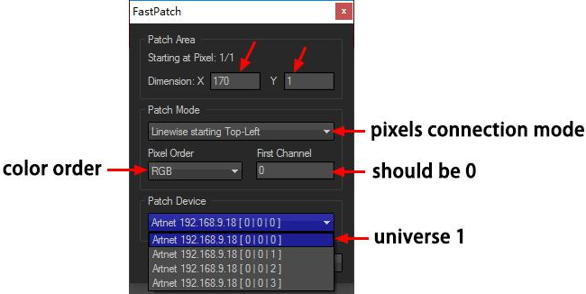

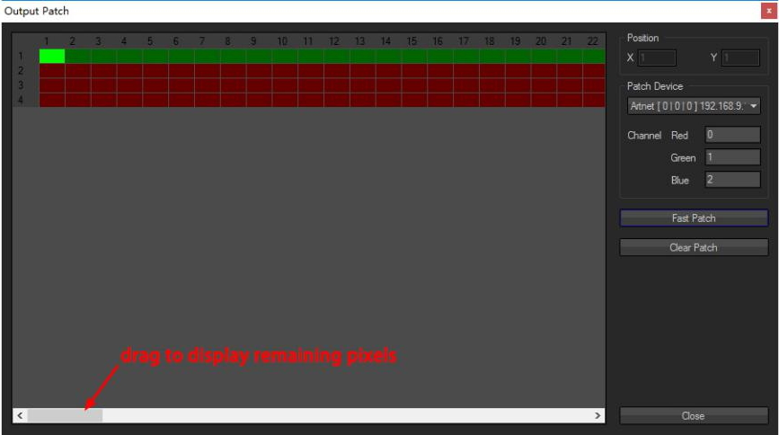

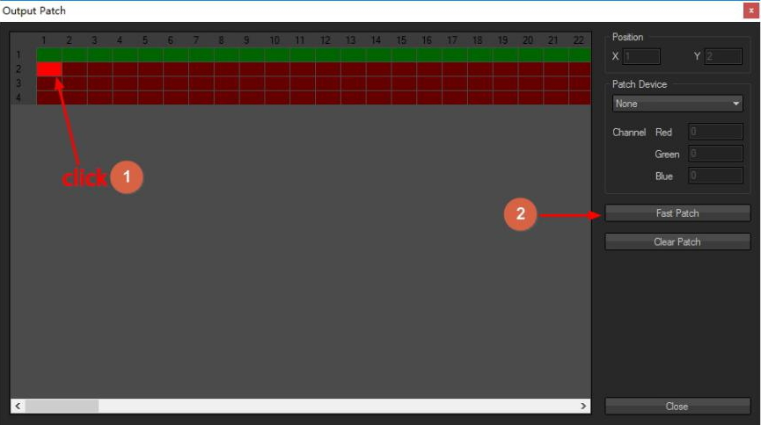

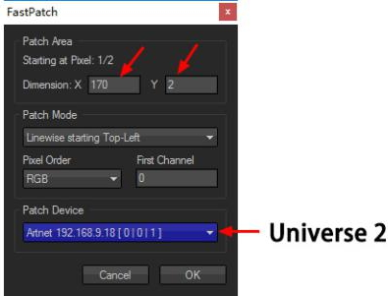

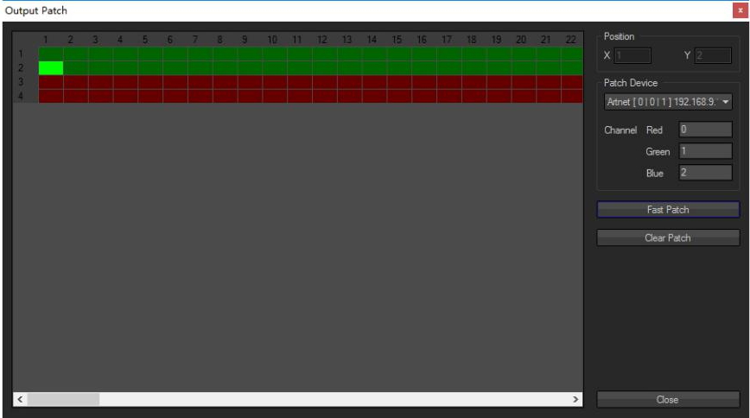

Use the same way to add pixels to the rest of two universes

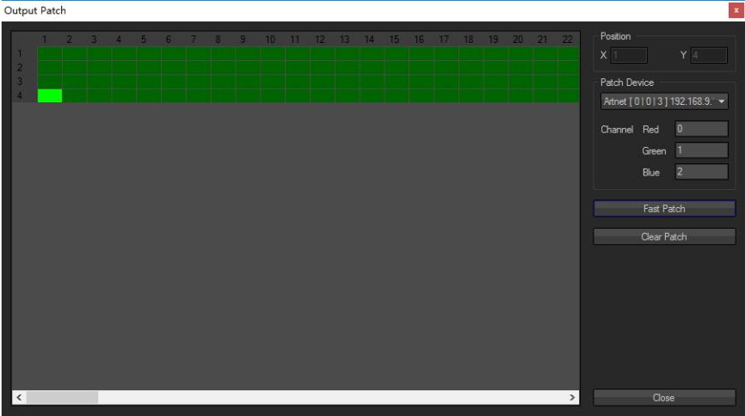

Then

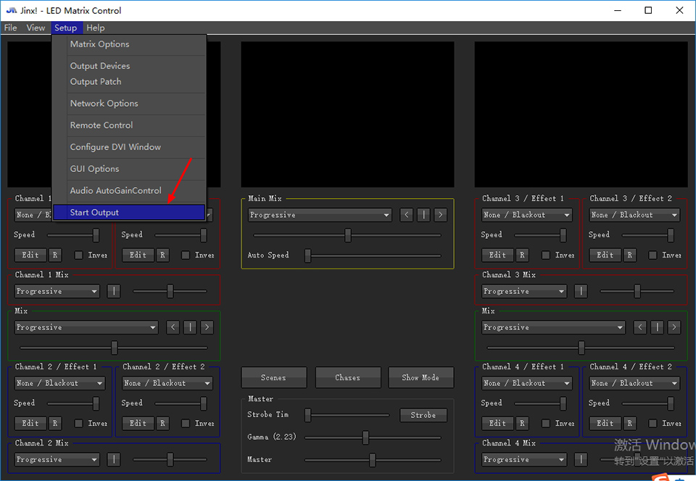

Choose "Audio Auto Gain Control" if you need music effect

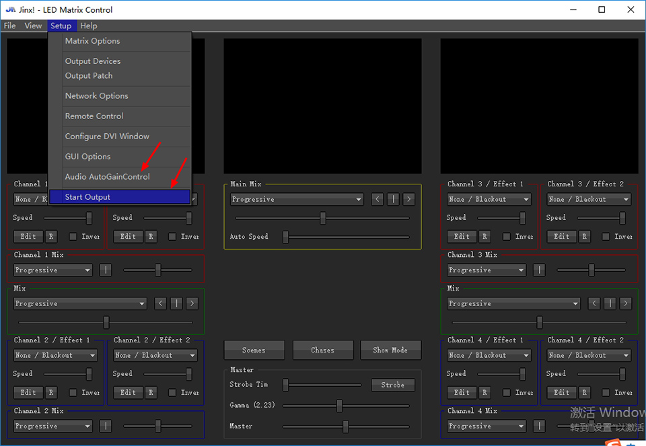

You can use Jinx! to control lights !!! The following is just for example

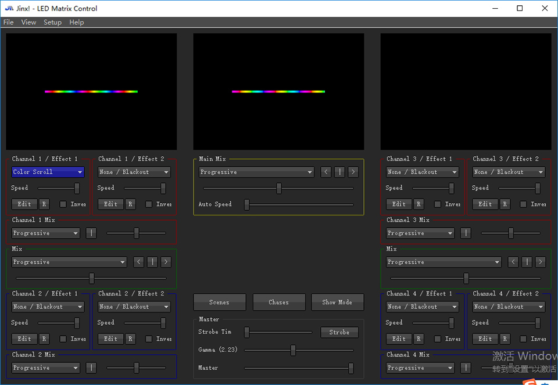

7. Basic Working Procedure for Led Studio
Place Pixels
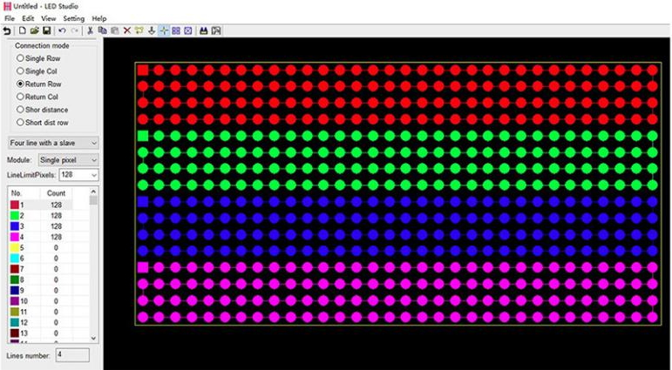

Slave setting
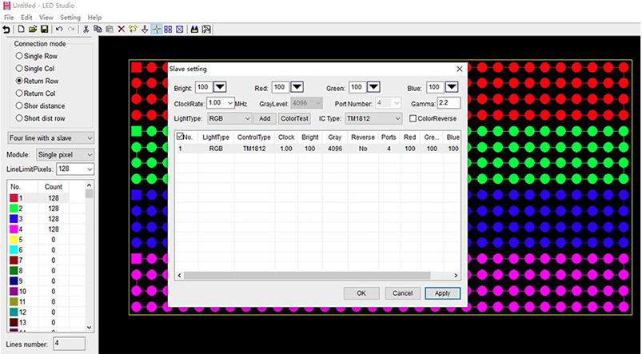
Note: many chips use one option
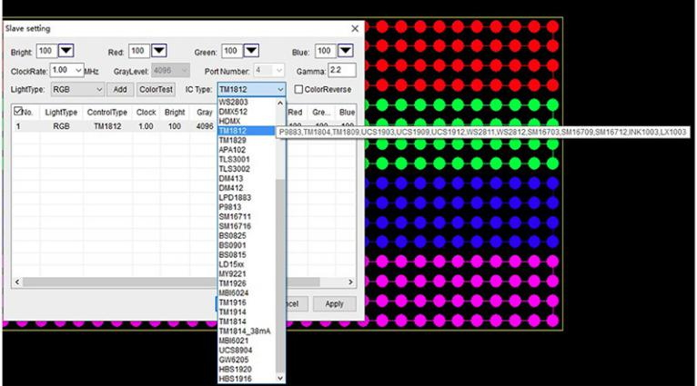
Allocate controller for the specified IP address.

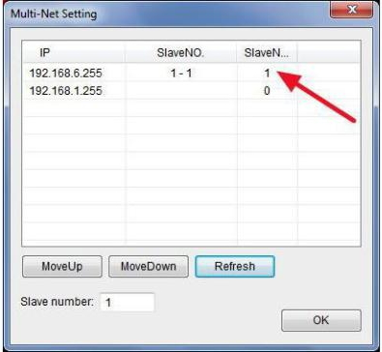
Make Animation
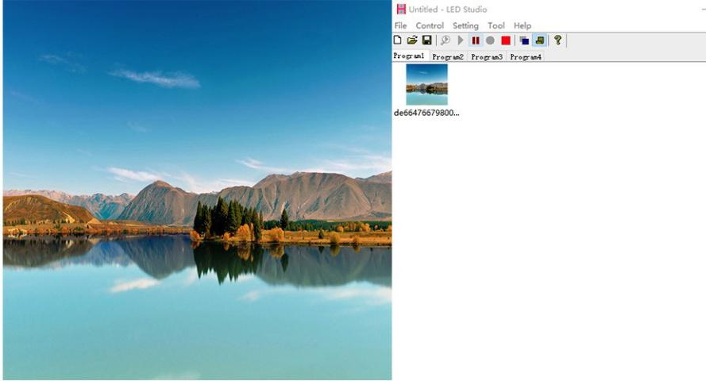

8. Set Address for DMX512 chips

(1). Please connect your lamp to controller according to the connection method i post above(under PCB Layout).

(2). In LED Studio, click "Setting" -- "H802RA Setting".

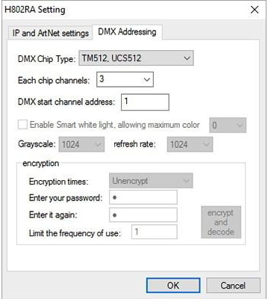

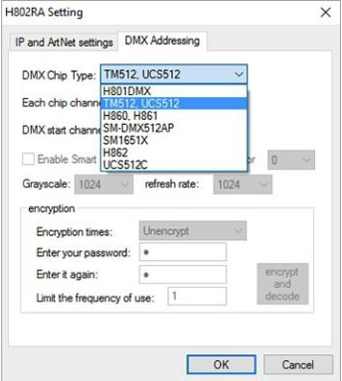

After several seconds, lamp will turn white then green, please repower the lamp.

H802RA can address for maximum 1024 pixels.

9. Specifications
Input Voltage: Customized
Power Consumption: 1.3W
Drive Pixels Number: 4096
Weight: 1KG
Dimension: L163 x W155 x H54
Carton Size: L205 x W47 x H21

